

Case Report

Acute Lupus Myocarditis with severe bradyarrhythmia: chaotic complications of a young man with SLE

A. Rohman¹, K. A. Nugraha¹

¹RSAL Samuel J Moeda

Background:
Systemic lupus erythematosus (SLE) as one of the most common systemic autoimmune diseases, was more often seen in female especially in young age. Our case report designated an uncommon severe cardiac manifestations of cardiogenic shock and severe bradyarrhythmia in newly diagnosed SLE. Moreover, this great imitator disease making diagnosis difficult and challenging especially in low resources area.

Case illustration:
A 21 years old male patient, admitted to the emergency room with complaint of chronic fever, vomitus, weakness, and loss of weight. The physical examination showed normal blood pressure and slow regular heart rate with no other abnormality. The ECG revealed junctional rhythm with rate of 40-50 bpm. We found severe pancytopenia from the blood sampling. The patient rapidly developed into severe hypotension and cardiogenic shock later. We administered sulfas atropine followed with continuous dopamine infussion and adequate fluid therapy but the vital sign remains deteriorated during our observation. The echocardiography revealed severely hypokinetic of the left ventricle with reduced ejection fraction (EF) to 36% and a grade III diastolic dysfunction. Following laboratory examination showed positive ANA-IF, elevated CRP, and elevated Troponin I. Diagnosis of SLE was made and confirmed with the 2019 EULAR/ACR criteria. The patient showed a signifficant improvement after administration of corticosteroid concomitantly with the innotrope agents supporting his failing heart. After a week of hospitalization, he was discharged and continued his medication as an outpatient.

Brief conclusion:
In case of young patients with unexplained signs of acute heart failure, the presence of autoimmune myocarditis must be considered as a differential diagnosis. Complexity of SLE diagnosis was simplified using the 2019 ACR/EULAR criteria, especially in a limited resources facility.

Keywords: Acute Myocarditis, Lupus Myocarditis, Cardiogenic Shock

Echocardiography examination showed A. Severely enlarged left ventricle with mitral regurgitation. B. Pericardial effusion
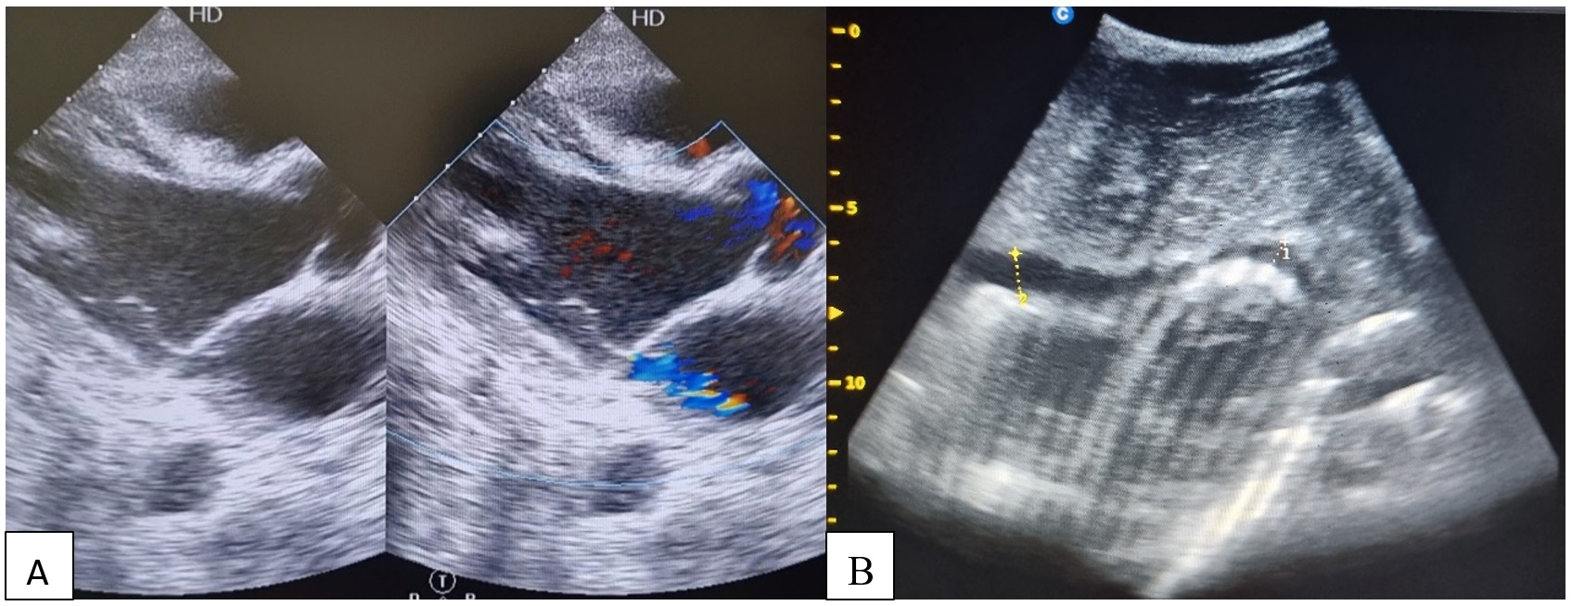

Pulmonary Embolism Management , Challenges in Diagnostic and Treatment, of 81-Year-Old Man in The Setting of Rural Area with Limited Resources : A Case Report

A. S. M. S. Siagian¹, S. L. Purwowiyoto²

¹Talisayan General Hospital, Berau, East Borneo
²Siloam Heart Diagram Hospital, Jakarta

Background:
Pulmonary embolism is a cardiology emergency with a high mortality rate that is hard to diagnose for its symptoms may mimic other cardiovascular diseases. The adequate diagnosis of pulmonary embolism requires advanced laboratory and imaging facilities which are not widely available in Indonesia. The lack of facilities and pharmacological availability is an important problem for the delay of treatment and diagnosis of Pulmonary embolism will increase the mortality number.

Case illustration:
A-81-year-old Man came with sudden dyspnea and hemoptoe. His physical examination showed mild tachycardia, a drop of blood saturation, and signs of right heart failure. His ECG showed deep S wave in lead I, Q wave in lead III (McGinn-white sign), P pulmonary in lead II, III, aVF, inverted T in inferior and anterior lead. ECG Changes in Pulmonary embolism is attributed to the right ventricular strain due to the pressure overload and these changes are usually found in severe case of PE. We established the diagnosis by the clinical score and the ECG pattern. The patient showed hemodynamic instability and was included as a high-risk pulmonary embolism, therefore systemic thrombolysis should be the goal therapy for this patient. Due to the unavailability of systemic thrombolysis, we started the systemic anticoagulant therapy using fondaparinux sodium and gave him hemodynamic support. Hemodynamic instability in PE occurs due to the obstruction of the pulmonary arteries that leads to acute right dysfunction. The patient developed refractory shock despite the usage of the hemodynamic support and died after 5 days of hospitalization.

Brief conclusion:
The limitation of diagnostic tools and therapy is one of the biggest challenges in rural hospitals for it can increase the mortality rate of PE Patients. The procurement of diagnostic modalities and pharmacology therapies should be carried out in all hospitals in Indonesia to provide the best management for the patient.

Keywords: Anticoagulant, Electrocardiography, Thrombolysis, Pulmonary Embolism

The ECG in this patient showed deep s wave in lead I, Q wave in lead III, P pulmonal in lead II, III, aVF, and inverted T in lead II, III, aVF, V1-V2 . This ECG Changes implies the Right Ventricular Strain
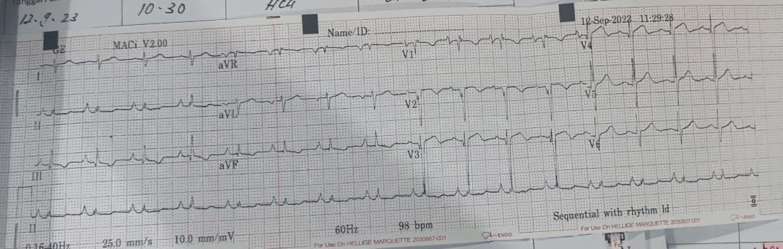

ST Elevations in Young Adults, is it STEMI or Pericarditis?

A. Taufiqah¹, D. S. Prahasti²

¹Dr. Soedarso Pontianak General Hospital

Background:
Pericarditis with ST segment elevation has similar ECG to STEMI. Thrombolytic in underdiagnosed pericarditis could be harmful because it is not solving the problem, yet has a probability of complications.

Case illustration:
18-year-old man and 19-year-old man with chest discomfort, and ST elevation diagnosed with STEMI was referred to our hospital. Coronary angiography showed normal coronary arteries, without thrombus and dissection. Both have an elevated troponin and regional wall motion abnormality during hospitalization. After treatment, the echocardiography came back normal. One patient had given thrombolytic.

Brief conclusion:
Pericarditis has very broad clinical manifestation which could lead to underdiagnose the disease. Due to its similarity to STEMI, approximately 19–25% of patients with acute pericarditis are mistaken for STEMI. This incorrect diagnosis may lead to inappropriate thrombolytic therapy. Patients with pericarditis identified by the presence of a pericardial rub and found patients to have ST elevation in the limb leads. Spodick’s sign in pericarditis specifically described downsloping of the T-P segment. Inferolateral STEMI presents a particular diagnostic challenge as it often has diffuse ST elevation (leads I, II, III, aVF, V<sub>5</sub>, V<sub>6</sub>) which can easily be mistaken for pericarditis. Positive cardiac marker and regional wall motion abnormality show myocardial involvement. The difference of pathology leads to different treatment, but STEMI and pericarditis could happen simultaneously. It is urgently important to do accurate examination, serial ECG to diagnose correctly then treat the patient correctly. The significant difference therapy between them, as STEMI benefits from anticoagulation/antiplatelet therapy and reperfusion, whereas the same therapy risks hemorrhagic pericardial effusion in the pericarditis. Patients in rural area need longer time to reach catheterization laboratory, fibrinolytics has a role to save a life in STEMI, but not in pericarditis.

Keywords: Pericarditis, STEMI, Thrombolytic

Patients' ECG on Admission
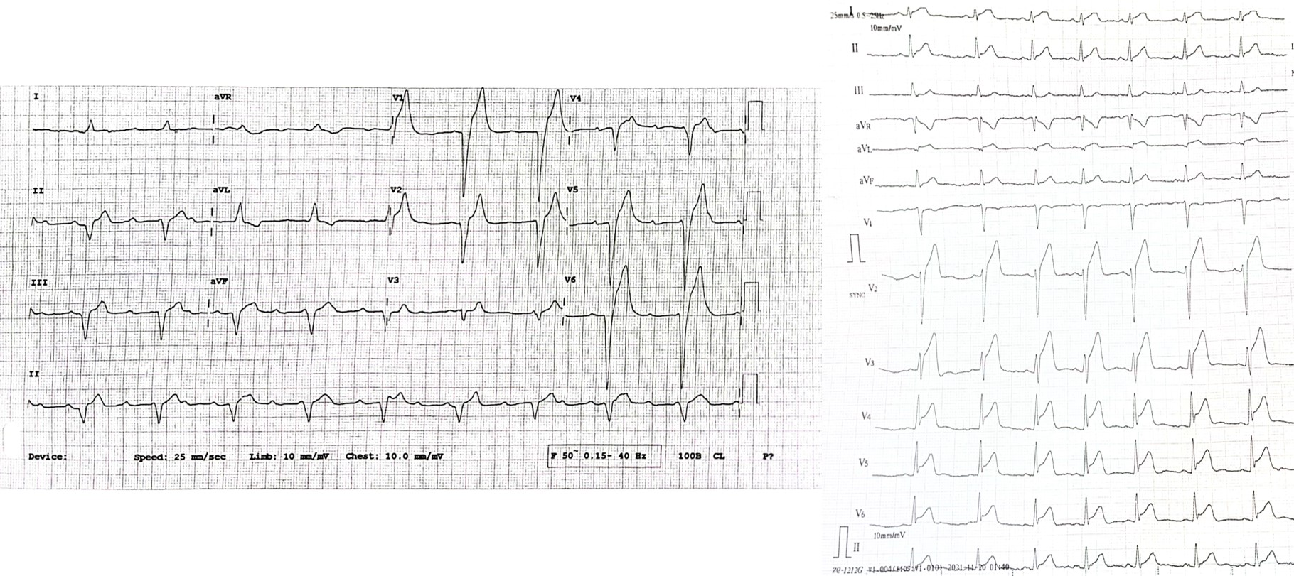

HOW TO TREAT PERICARDIAL EFFUSION LEADING CARDIAC TAMPONADE IN PREGNANCY? A HOPE TO SAVE TWO LIVES

A. R. Ismail¹, H. A. Hafiz², A. Yasa², G. W. Pradipta³

¹Faculty of Medicine, Sebelas Maret University, Surakarta
²Department of Cardiology and Vascular Medicine, Dr Moewardi General Hospital, Surakarta, Central Java
³Faculty of Medicine, Sebelas Maret University, Surakarta

Background:
Pericardial effusion can lead into cardiac tamponade condition. Pericardiocentesis is one of management options for massive pericardial effusion. Imaging tools during pericardiocentesis procedures may include fluoroscopy, echocardiography, and computed tomography. In pregnancy, it is important to consider radiation risk associated with imaging tools. Thus we can prevent and minimize potential side effects from radiation exposure.

Case illustration:
A 25-year-old woman at 27 weeks of pregnancy came to ER with chief complaint shortness of breath for one week. Blood pressure was measured 123/83 mmHg, heart rate 118 bpm, respiratory rate 24 breaths per minute, and SpO<sub>2</sub> 98%. Chest X-ray revealed <em>water bottle sign</em>, and echocardiography confirmed the presence of massive pericardial effusion with anterior size 0.6 cm, posterior size 2.6 cm, apical size 1.9 cm, and lateral involvement 26%. Mitral inflow was 26% and tricuspid inflow was 40%. The decision was made to perform pericardiocentesis with assistance of fluoroscopy. The patient wore apron to prevent and minimize radiation exposure during the procedure.

Brief conclusion:
Pericardial effusion leading to cardiac tamponade is a relatively uncommon occurrence during pregnancy. The use of imaging-assisted pericardiocentesis with fluoroscopy can be employed because fluoroscopy has the lowest ionizing radiation compared others. Utilizing imaging tools in pregnant women poses its own challenges, as we must consider radiation on the fetus. In our case, the combination of fluoroscopy with echocardiography is a simple method that can enhance safety levels and overcome limitations associated with either imaging technique alone. If radiation does not exceed 50 mGy and the patient wears protective gear such as an apron, the use of fluoroscopy can be deemed relatively safe for pregnancy.

Keywords: fluoroscopy, pregnancy, Pericardial effusion, pericardiocentesis

Figure 1 | (A) Echocardiography pre and (B) post pericardiocentesis.
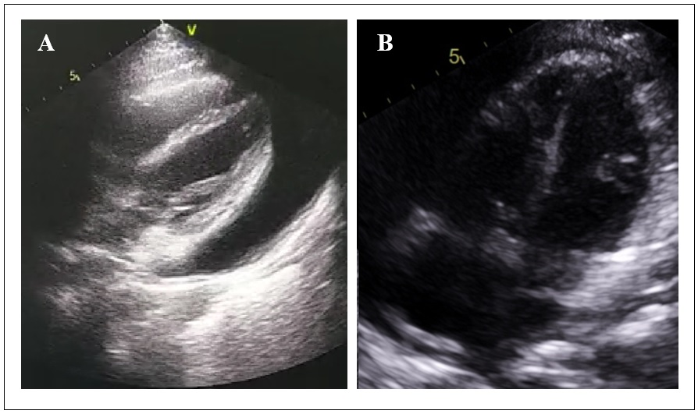

Revascularization Approach of Acute Coronary Syndrome with Suspected Mieloproliferative Neoplasm, Aggressive or can be delay? : a Case Report

A.A Bhaskara¹, A.P Suwirya², N.M.R Anggreni Rena³

¹Faculty of Medicine, Udayana University/ Prof I.G.N.G Ngoerah Hospital, Denpasar, Indonesia
²Cardiology and Vascular Medicine Department, Prof I.G.N.G Ngoerah Hospital, Denpasar, Indonesia
³Hemato-oncology Division Internal Medicine Department, Prof I.G.N.G Ngoerah Hospital, Denpasar, Indonesia

Background:
Acute Coronary Syndrome (ACS) can be present with some comorbidities including hematologic problems. Polycythemia Vera (PV) is a chronic myeloproliferative neoplasm, involving multipotent hematopoietic progenitor cells which increased blood components dominated by erythrocytes, increased hematocrit and hyperviscosity state, stimulate platelets aggregation and thrombogenesis, stiffness and tunica intima proliferation which increase the risk of thrombosis. High risk patients, which older than 60 years old and history of previous thrombosis, has 24-43% risk of arterial thrombosis.

Case illustration:
A 56-year-old man referred due to typical angina pectoris with VAS scale 4/10, since 6 hours prior to admission. Other risk factors was previous heart attack without regular control. Serial ECG showed normal sinus rhythm with ST segment elevation in inferior-posterior wall followed by increase of Hs-Troponin I, platelet and hemoglobin levels. Echocardiography showed reduce of ejection fraction with regional wall motion abnormality. PCI was obtained showed diffuse stenosis in proximal to distal LAD, total stenosis in LCx, and irregular proximal-distal RCA, continue stented at LAD. Phlebotomy and JAK2 examination was planned with closed monitoring of bleeding and residual thrombotic event.

Brief conclusion:
ACS appears due to acute thrombosis in coronary artery. Decision for reperfusion and revascularization should consider the risk of bleeding and recurrent thrombosis. PV increase risk of thrombosis involve by Virchow Triad where hypercoagulable state, endothel injury and abnormal flow initiate thrombogenesis along with bleeding due to increased consumption of Factor VIII in severe thrombocytosis.Decision to perform immediate or delayed revascularization considers the risk of in-stent thrombosis and bleeding. In the state of on-going ischemia, invasive therapy should be performed immediately regardless of platelet values. Some strategies with low-dose aspirin and pegylated IFN-α in low risk and cytoreductive in high risk patient. Monitoring and phlebotomy until Hct <45% and safe platelet level 400-600 x 10<sup style="color: black;">9 </sup>/l for CABG/PCI. <strong style="color: red;"> Hematologic abnormalities especially PV can be a risk factor for the formation of thrombosis events, causing acute coronary syndrome. It is important to closed monitoring and carry out joint management of related disciplines for revascularization decision and anticipate complications and adverse events, especially bleeding and recurrence of thrombosis.

Keywords: Polycythemia Vera, Thrombosis, Acute Coronary Syndrome

HEART AND BRAIN CRISIS: THE UNSEEN DRAMA OF ACUTE CARDIO-CEREBRAL INFARCTION SYNDROME TYPE 1

A. I. Nurudinulloh¹, B. Satrijo², I. Prasetya³

¹Department of Cardiology and Vascular Medicine, Faculty of Medicine, Universitas Brawijaya, Malang, Indonesia
²Invasive Diagnostic and Non-Surgical Intervention Division, Department of Cardiology and Vascular Medicine, Dr. Saiful Anwar Regional General Hospital, Malang, Indonesia
³Intensive and Acute Cardiovascular Care Division, Department of Cardiology and Vascular Medicine, Dr. Saiful Anwar Regional General Hospital, Malang, Indonesia

Background:
Cardio-cerebral infarction (CCI) syndrome type 1 is a very rare condition where acute myocardial infarction (AMI) and acute ischemic stroke (AIS) occur at the same time. The optimal method for diagnosing and treating AMI in patients with AIS remains uncertain. This publication aims to delineate the obstacles associated with the treatment of CCI syndrome.

Case illustration:
A 69-year-old man with the risk factors of hypertension, active smoking, and history of cerebral infarction presented with a new onset of typical angina at rest and left hemiparesis. The patient's electrocardiography revealed sinus rhythm and ST elevation with pathological Q waves in the inferoposterior and RV region. The cardiac enzyme level increased while hs-troponin I was 23.091 ng/L and CKMB was 387 U/L. The brain CT scan demonstrated acute infarcts at lentiform nucleus dextra and corona radiata dextra. Patient was decided to get loaded with dual anti-platelets and anticoagulant and performed Primary PCI after bleeding risk assessment. Coronary angiography showed CAD three-vessel disease and left main coronary artery disease with acute total occlusion at mid-RCA with thrombus appearance. The patient underwent coronary stenting in the proximal-mid RCA using DES Cre8 3.0 x 46 mm. Cineangiography evaluation showed TIMI Flow 3 and no residual stenosis. Patient also was joined care with Neurology department to treat AIS simultaneously. There were no bleeding signs during admission. Patient improved and was discharged on the 7th day of hospitalization.

Brief conclusion:
Effectively managing CCI syndrome poses a significant challenge for professionals. PCI strategy for AMI as the first strategy due to high mortality remains the preferred choice despite the risk of hemorrhagic transformation in AIS.

Keywords: cardio-cerebral infarction syndrome, acute ischemic stroke, acute myocardial infarction

Figure of Primary PCI procedure. (A) Diagnostic coronary angiography showed acute total occlusion at mid-RCA. (B) Cineangiography evaluation post stenting using DES 3.0 x 46 mm at proximal-mid RCA showed TIMI Flow 3 and no residual stenosis.
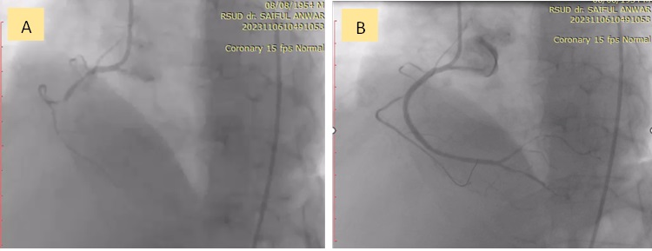

STEMI with stubborn heavy thrombus burden

A. B. Budiono¹, B. Budiono¹

¹Primaya Hospital Makassar

Background:
Massive intracoronary thrombus associated with extremely high risk of a poor procedural result including failed aspiration, unfavorable reperfusion and adverse events at follow-up. The best treatment strategy to deal with heavy thrombus burden in acute STEMI remains unknown, mostly based on operator discretion. We reported a case with heavy thrombus burden during primary PCI which was very difficult to manage.

Case illustration:
A 63 year old female presented with severe chest tightness and diaphoresis about 3 hours before admission. Blood pressure was 130/70 mmHg, heart rate 40 bpm. Body weight 65 kg, height 168 cm. Random Blood Sugar 195 mg/dl, elevated Troponin T, eGFR 71 ml/min/1,73 m2. History of PCI 3 years ago in LAD and intermediate branch.The ECG showed ST Elevation in leads II, III, aVF with no ST elevation in V3R, V4R and First AV Block. Clopidogrel 600 mg, Aspirin 160 mg, Enoxaparin 30 mg (IV), and Atorvastatin 80 mg were given in Emergency Department.Diagnostic angiography showed patent stented segment in LAD &amp; Intermediate branch, and subtotal occlusion in proximal RCA with heavy thrombus load from proximal to distal segment. Thrombuster aspiration catheter failed to cross the critical lesion, a 2.0x15 mm Compliance Balloon at 12 Atm was used to facilitate thrombus aspiration catheter. Repeat angiography showed distal embolization. TIMI-0 flow grade still occurred despite the use of IC 180ug/KgBW Eptifibatide followed by 3 Runs Thrombus Aspiration, likely due to huge thrombus stuck and occluded the residual stenosis. Another 5 runs thrombus aspiration and additional IC 180ug/KgBW Eptifibatide was given but angiography remain TIMI-1 flow grade. Proximal RCA was stented in order to create better coronary flow. After DES implantation, huge distal embolization in distal RCA-RPL was seen. 5 mg IC Alteplase was given in 5 minutes via thrombus aspiration catheter followed with 3 runs thrombus aspiration. Final angiography showed TIMI-3 flow grade.

Brief conclusion:
The best strategy to deal with heavy thrombus burden remains unknown. In some selected cases, combination of thrombus aspiration, GP2b3A inhibitor, and intracoronary thrombolytic could be effective to deal with heavy thrombus burden.

Keywords: STEMI, Heavy Thrombus Burden, Primary PCI

Pre-procedural ECG, Procedural angiographic views depicting sub occluded RCA, Heavy thrombus burden, Final Angiography, and ECG post Primary PCI results.
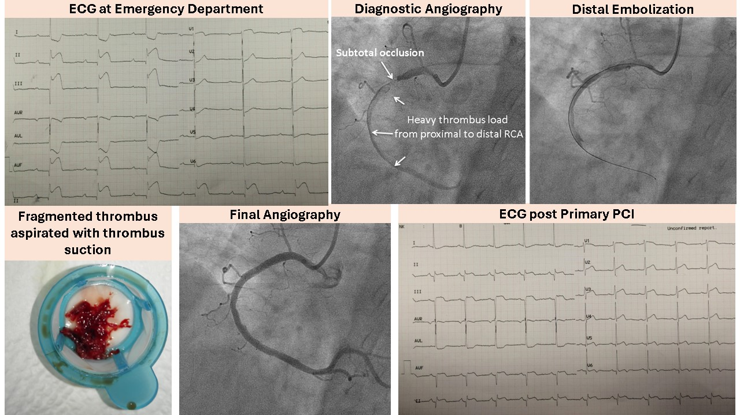

ACUTE STEMI WITH HEAVY THROMBUS BURDEN & GASTROINTESTINAL BLEEDING - TREATMENT DILEMMA

A. B. Budiono¹, B. Budiono¹, A. M. Sarayar²

¹Primaya Hospital Makassar
²Mitra Keluarga

Background:
ST-elevation myocardial infarction (STEMI) is potentially life-threatening and requires immediate treatment with a potent antithrombotic regimen, resulting in an increase of bleeding complications, especially gastrointestinal bleeding which poses significant management challenges and may be associated with poor outcomes. Therefore, treatment strategy should be individualized to reduce bleeding complications. We reported a case with heavy thrombus burden and gastrointestinal bleeding during primary PCI.

Case illustration:
A 35 year old female presented with severe chest tightness and diaphoresis about 3 hours before admission. Creatinine 0.69 mg/dl, eGFR 113 ml/min/1,73 m2. The ECG showed ST Elevation in leads V1-V4. Echocardiography showed LVEF 51% with hypokinetic in anterior and anteroseptal wall. Clopidogrel 600 mg, Aspirin 160 mg, Enoxaparin 30 mg (IV), and Atorvastatin 80 mg were given. Diagnostic angiography showed subtotal occlusion in ostial LAD segment with high thrombus load in proximal to mid LAD segment, normal LCx, and no significant lesion in RCA. From the diagnostic angiography, we assumed that the cause of STEMI in this young lady was most likely due to spontaneous coronary artery dissection. We, planned to perform stand-alone thrombus aspiration.IL-4 guide catheter was used to engage Left main ostium, followed by carefully wiring to cross heavy thrombus in LAD. A 6 Fr compatible Thrombuster was used to suck the thrombus for 6 runs. Final angiography showed TIMI-3 flow grade and ECG showed reduced ST-elevation >50%. The patient had history of black stool with. The patient was consulted for upper gastrointestinal endoscopy examinations and showed Forrest Classification 3 with no helicobacter pylori. 3 bags of PRC blood transfusion were given. Decision was made to give Clopidogrel as a single antiplatelet, PPI and sucralfate, low dose ACE inhibitor &amp; betablocker, and kept patient in CVCU for 48 hours.

Brief conclusion:
In acute STEMI with high thrombus burden without flow limiting residual lesion, stand alone thrombus aspiration is effective strategy. Good flow is the best thrombolytic. Aggressive antithrombotic therapy should be avoided in high bleeding risk patient. Single antiplatelet therapy, Clopidogrel combining with PPI is preferable in such patient. However, there is no clear consensus which antiplatelet should be given.

Keywords: Primary PCI, Gastrointestinal Bleeding, STEMI, Heavy Thrombus Burden

Pre-procedural ECG, Procedural angiographic views depicting heavy thrombus burden and residual thrombus at LAD, Thrombus aspirated from LAD, Final Angiography, and ECG Post-procedural.
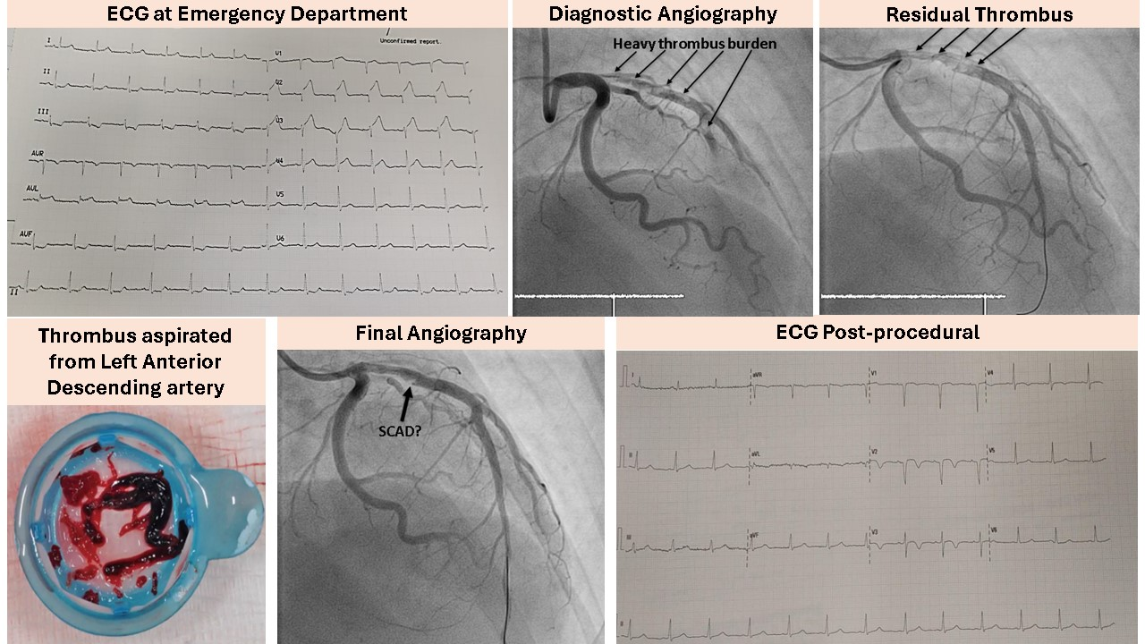

Management Atrial Fibrillation for Patient Post CABG : a Case Report

A. Hendrajaya¹, R. P. I. Maliawan¹

¹RSUP IGNG Prof Ngoerah

Background:
Atrial fibrillation (AF) is a frequent complication of CABG and is associated with prolonged length of stay and higher healthcare costs, increased mortality, and increased cerebrovascular events. Postoperative AF was defined as new-onset AF occurring after surgery during the index hospitalization in patients with no previous history of AF. Mechanical trauma, inflammation and physical stress accompanying major cardiac surgery in the presence of a potentially pre-existing substrate constitute the main pathophysiological basis leading to post-CABG AF.

Case illustration:
The authors report a 65-year-old man who underwent CABG surgery. The patient underwent CABG due to CAD 3 VD. 3 days after CABG the patient experienced atrial fibrillation. The patient was given the management of administering amiodarone as rhythm control to the patient. Patient experienced improvement after administering rate control and rhythm control. <p>

Brief conclusion:
Mechanical trauma, inflammation and physical stress accompanying major cardiac surgery in the presence of a potentially pre-existing substrate constitute the main pathophysiological basis leading to post-CABG AF. Obesity has been associated with a greater burden of AF in the early postoperative period, especially at three days postoperatively, and the duration and number of prolonged AF episodes (>60 minutes) have been reported to be higher in patients with obesity. Epicardial adipose tissue, which correlates with higher BMI, has been hypothesized to play a role in postoperative AF by releasing inflammatory cytokines and adipokines. Rate control should be the initial approach to avoid rhythm control complications and to reduce costs<p>POAF is a common and expensive complication that occurs in 20–55% of cardiac surgery patients and increases the risk of stroke, thromboembolism, and death. The risk factors and etiology of POAF remain poorly understood. The POAF condition usually occurs temporarily due to trauma and inflammation. Rate control therapy takes precedence over rhythm control.

Keywords: Post CABG, Atrial Fibrillation

Symptoms of Acute Gastroenteritis as an Atypical Presentation of ST-Elevation Myocardial Infarction (STEMI) : A Case Report

A. Lawijaya¹

¹Balimed Karangasem Hospital

Background:
ST-Elevation Myocardial Infarction (STEMI) is one of cardiac emergency that has a significant mortality. However several studies concluded that 20 - 33% of myocardial infarction presents with atypical symptoms. Those atypical presentation cases were susceptible to delayed recognition and intervention.

Case illustration:
53 years-old male patient came to ER with vomiting 3 hours before admission without any chest discomfort. Patient also had a diarrhea and epigastric pain. The patient has no known history of common comorbidities such as previous heart disease, hypertension, diabetes, and dyslipidemia, except a history of smoking.Physical examinations were unremarkable except irregular tachycardia and moderate epigastric tenderness. The patient was suspected to have Acute gastroenteritis. Electrocardiogram (ECG) was done as the patient has irregular pulse and surprisingly showed a ST-segments elevation in V2-V6 leads and irregulary irregular rhythm suggestive of atrial fibrillation with rapid ventricular response along with occasional ventricular extrasystole. (Figure 1) Other routine investigation showed leukocytosis (23.84x10<sup>9</sup>/L), mild hyponatremia (132.69 mmol/L), and hypocalcemia (1.91 mmol/L).Dual antiplatelet regimens consist of aspirin and clopidogrel, high dose statin, digoxin as rate control medication, and supportive treatment were given. Then the patient was reffered to center where intravenous fibrinolysis was feasible.

Brief conclusion:
This case revealed an atypical presentation of STEMI which likely to be missed. Precise and careful history taking and physical examination are important, because early diagnosis and intervention can save a life. Furthermore, Chest pain may not be present in myocardial infarction, therefore should be taken into consideration when facing such patients.

Keywords: STEMI , Atypical Presentation, Acute Gastroenteritis

Figure 1. Electrocardiogram (ECG) of the patient.
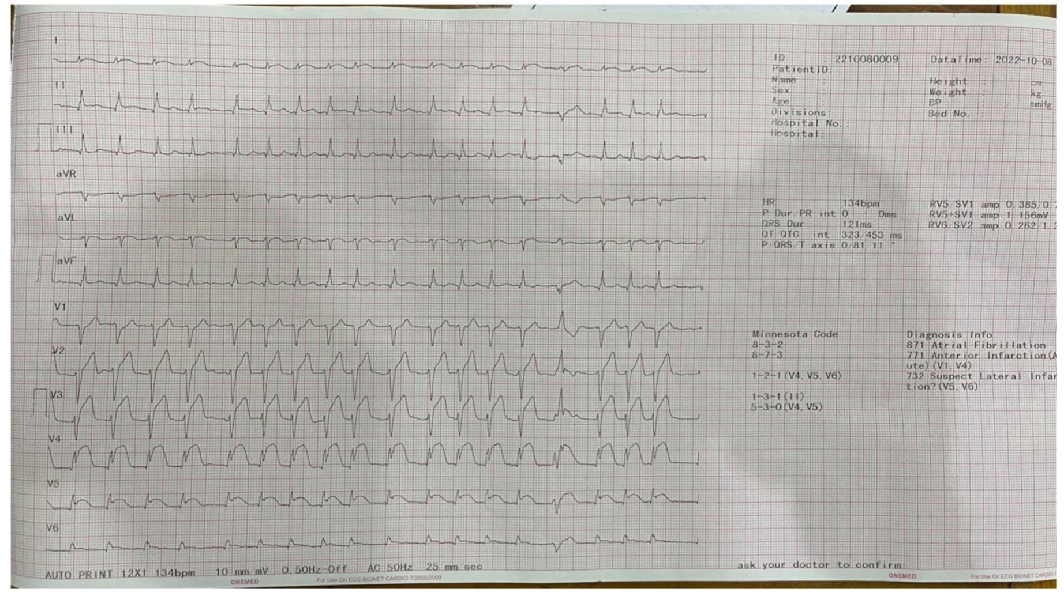

Hyperacute T wave progressed to a new ST-segment elevation myocardial infarction (STEMI) following cardiac arrest at a remote hospital, successfully treated with Streptokinase. Is this accurate?

A. Handini¹, Fikri²

¹General Practitioner, Labuha General Hospital
²Cardiologist, Labuha General Hospital

Background:
ST-elevation myocardial infarction (STEMI) is characterised by a series of ECG wave changes, starting with hyperacute T wave and followed by ST-segment elevation. This case study aimed to highlight the challenge of managing a patient with hyperacute T wave, which may lead to STEMI in a hospital without interventional cardiology services.

Case illustration:
A 53-year-old man experienced a loss of consciousness 10 minutes before being hospitalised and reported feeling chest pain 30 mintes prior. During CPR, the patient's circulation spontaneously returned. The ECG showed a notable increase in T wave amplitude of 11 mm in leads V2 to V6. The patient was administered a loading dose of dual antiplatelet treatment (DAPT), nitrate, intravenous morphine, and statin. Following the initial treatment, the ECG showed an increase in the ST segment of around 2 mm in precordial leads V2 and V3 within 30 minutes due to persistent and unstable chest pain. Thrombolysis may be a viable and effective alternative for reperfusion therapy. The patient underwent thrombolysis with streptokinase and achieved positive results marked by successful thrombolysis.

Brief conclusion:
Early detection of the Hyperacute T Wave pattern on an ECG can help identify the progression to STEMI. Thrombolysis may be appropriate in a rural hospital setting without any contraindications to the procedure.

Keywords: Hyperacute T Wave, Electrocardiogram, Thrombolysis, Streptokinase, STEMI

ECG performed during First Medical Contact (FMC) following the patient's return to spontaneous circulation
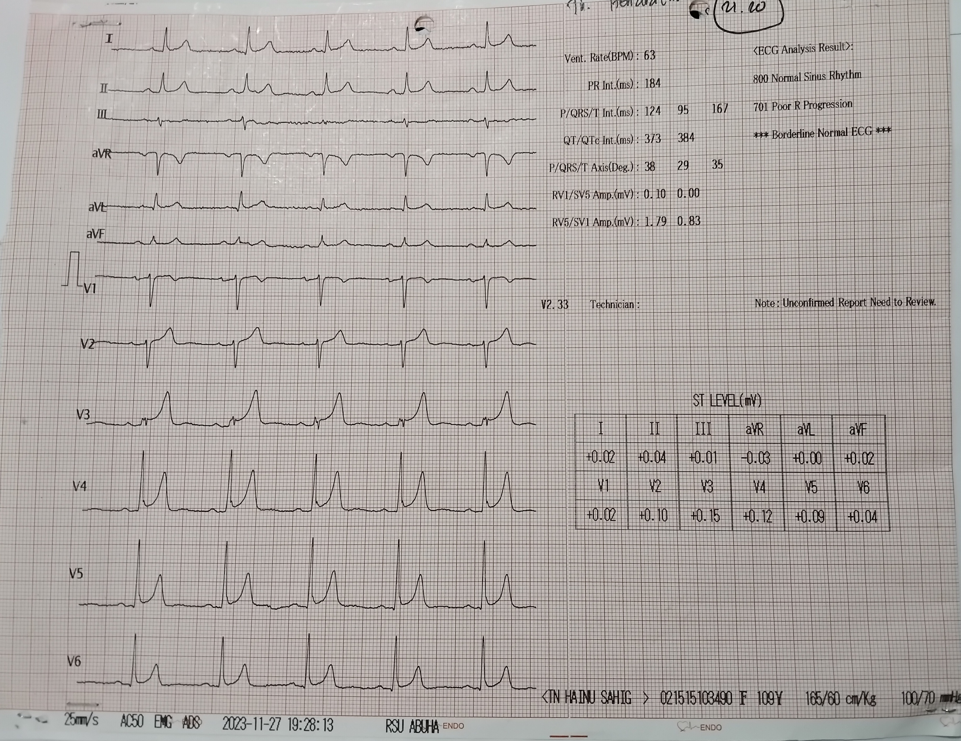

Unboxing The Mystery of New Inferior ST Elevation in Patient with Post Primary PCI of Extensive Anterior STEMI

A. I. R. Paputungan¹, A. F. Muzakkir¹, I. Sudirman¹, P. Tandean¹

¹Department of Cardiology and Vascular Medicine, Faculty of Medicine, Hasanuddin University

Background:
A New ST Elevation in inferior lead after Primary PCI in Extensive anterior STEMI often considered as a new STEMI. However, condition such as Inflammation, infection, and other non ischemic condition can also cause ST Elevation. This circumstances is relatively confusing so that clinicians have difficulty to making a clinical decision. The choice of modality and supporting examinations is very important to confirm the diagnosis

Case illustration:
A 58 year old man was referred to the emergency room with a diagnosis of extensive anterior STEMI. The patient underwent primary PCI with the implantation of 1 DES in the LAD. After pPCI, the patient’s clinically were improved, and patient was transferred to the Cardiovascular Care Unit (CVCU). On the 2nd day of treatment, ECG showed a new ST elevation in the inferior segment, without any significant clinical changes. Coronary Angiography evaluation on the same day showed normal results with a patent stent in the LAD. The patient was then suspected of having myocarditis and was given colchicine therapy and CMR was performed. CMR images showed viable and non-viable transamural scars, microvascular obstruction in the LAD territory, pericardial effusion, and patchy and edema in the inferior segment. T1 and T2 mapping measurements showed an increase both native global T1 and regional myocardial T2 relaxation time. These findings are consistent with myocardial inflammation according to the Lake Louis Criteria. After 8 days of treatment, the patient was sent home in good condition without any complaints, and ST segment was resolved.

Brief conclusion:
New ST Elevation in STEMI can be caused by both ischemic or non ischemic condition. CMR has an important role to distinguish one to another. The increasingly developed CMR parametric assessment can be a mainstay for diagnosing cases that are still confusing and unclear

Keywords: Cardiac Magnetic Resonance, Microvascular Obstruction, New ST Elevation after primary PCI, Myocarditis, T1 T2 mapping

Post Primary PCI ECG image (A). ST elevation in the inferior lead was seen on the second day of treatment (B). ST segment that has resolved on the fifth day of treatment (C). Cardiac MRI image shows Microvascular obstruction (Red arrow), Thrombus (Yellow
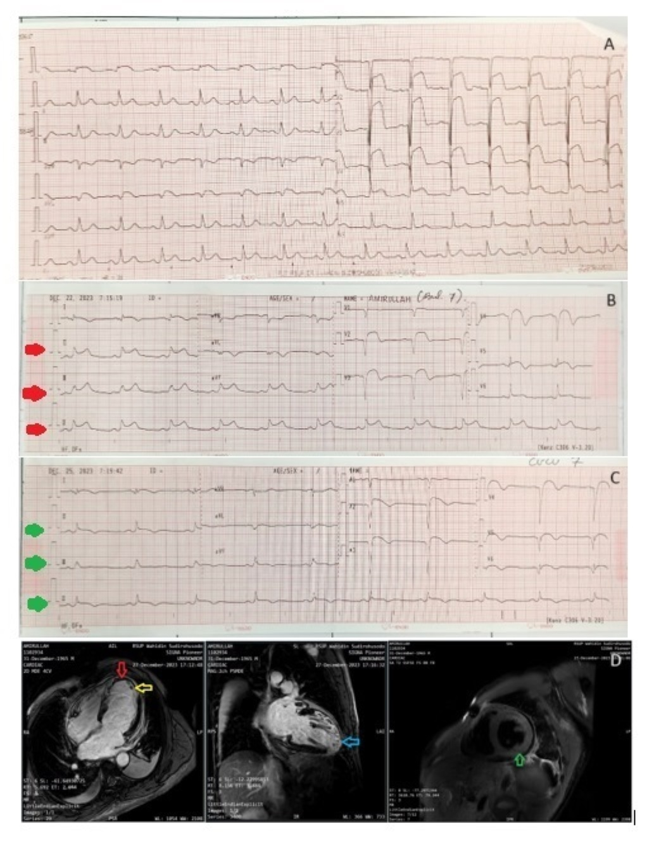

Cardio-cerebral Infarction: To save the Brain or the Heart?

B. A. Marsudi¹, B. Widyantoro¹

¹National Cardiovascular Center Harapan Kita

Background:
Concomitant cardio-cerebral infarction (CCI) poses a great clinical challenge which may result in high mortality and grave morbidity and disability. The clinical conundrum lies in the different management of each disease entity which may potentially aggravate the other by means of direct intervention or simply through treatment delay.

Case illustration:
A 59-year-old presented to a secondary hospital with a chief complaint of chest pain with typical angina characteristics. The patient was then referred to our hospital where upon arrival it was discovered that he had developed a neurological deficit which was confirmed as a medial cerebral artery (MCA) territory infarction by a non-contrast CT scan. Further clinical workup confirmed a concomitant late onset inferior ST-segment elevation myocardial infarction and right ventricle infarct, with pulmonary congestion, and pneumonia. The patient was eventually treated conservatively with a low dose, unfractionated heparin (UFH) due to the risk of haemorrhagic transformation. During hospitalizations, the patient developed episodes of chest discomfort and new onset atrial flutter, supraventricular tachycardia which was managed with antiarrhythmics. On the eighth day experienced ventricular fibrillation and incessant VT.

Brief conclusion:
We presented a patient with CCI, a condition that possessed a great clinical challenge with many learning points and is associated with severe morbidity and mortality. There is a well-established connection via the brain-heart axis that explains the deterioration of the heart and brain when the other is affected. Several cohorts have attempted to address the issue and yielded some promising strategies which include a combination of endovascular therapy with PCI. In patients still presenting within the time window, fibrinolytic therapy can be given followed by endovascular intervention in selected patients with large vessel occlusion. However, both strategies remain inapplicable in our current hospital setting. Further study regarding haemorrhagic transformation risk also needs to be conducted, as there is paucity regarding risk assessment in large artery occlusion with concomitant STEMI requiring PCI.

Keywords: cardio-cerebral infarction, management, haemorrhagic transformation, ACS, stroke
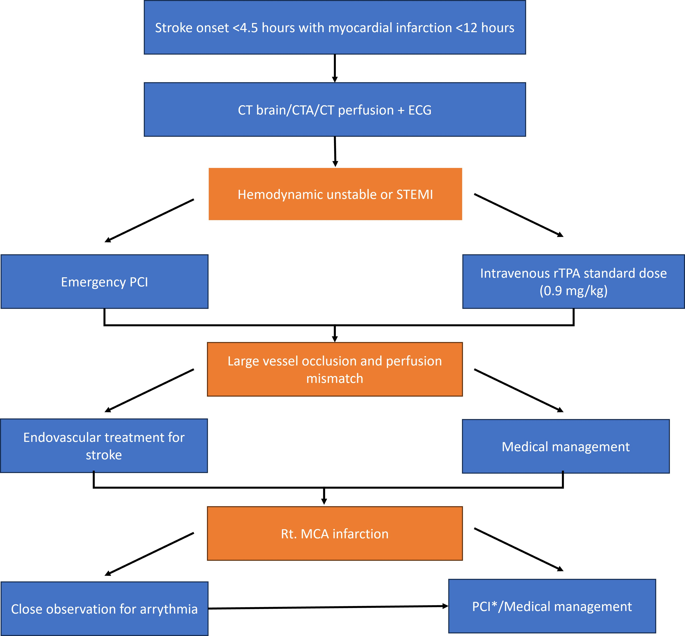

ANTERIOR WALL INFARCTION COMPLICATING TO COMPLETE ATRIOVENTRICULAR HEART BLOCK MANAGEMENT AND PROGNOSIS

B. J. Tando¹, B. Bintoro², R. Sukarya³, C. I. Rahayu², Kornadi²

¹General Practitioner, Ciawi General Hospital, West Java, Indonesia
²Consultant Cardiologist, Ciawi General Hospital, West Java, Indonesia
³Cardiologist, Ciawi General Hospital, West Java, Indonesia

Background:
Ischemic heart disease (IHD) is responsible for 16% of the world total deaths.<sup style="color: black;">1</sup> One of the complications for IHD is Atrioventricular Block (AVB). It is important to understand the management and the prognosis of the disease.

Case illustration:
A 50-years-old-female presented to Emergency Department (ED) for chest discomfort for 2 days. Her blood pressure 140/90 mmHg and heart rate of 55 bpm. ECG showed complete AV-Block (CAVB) followed by ventricular bigeminy. Amiodarone 150mg iv is administered as consulted to our cardiologist. The second ECG showed CAVB with deep T-wave inversion in lead V1-V5. Troponin-T was elevated to 90 ng/ml. She underwent cardiac catheterization with temporary pacemaker (TPM) placement prior to the catheterization. She had total occlusion in proximal Left Anterior Descendent (LAD). Cardiac drug-eluting-stent (DES) was placed and showed TIMI 3 flow. Single right ventricle permanent pacemaker (PPM) implantation was scheduled after two weeks observation without resolution of the CAVB and programed to VVIR at a rate of 70 bpm. She was discharged after 4 days of implantation. One of the causes of AVB is acute IHD.<sup style="color: black;">2</sup> The atrioventricular node is supplied by RCA in about 90% of patient and septal branch of the proximal LAD. AVB is more frequent in inferior AMI than anterior AMI.<sup style="color: black;">3 </sup>CAVB in patients with anterior AMI results from extensive and permanent myocardial damage, with permanent damage to the conduction system,<sup style="color: black;">4</sup> which has extensive septal necrosis involving the His bundle or bundle branches traveling within the interventricular septum that mainly supplied by LAD.<sup style="color: black;">5 </sup>Reperfusion therapy shouldn’t be delayed in patients with AMI and CAVB. However, CAVB related to anterior infarction is more likely to require PPM implantation.<sup style="color: black;">6 </sup>CAVB have been considered a marker of poor prognosis in patients with AMI, the mortality was 18.1% in inferior AMI patients and 50% in anterior AMI patients.<sup style="color: black;">7</sup>

Brief conclusion:
Anterior AMI complicating to CAVB is less frequent than inferior AMI. Reperfusion therapy shouldn’t be delayed and PPM implantation often inevitable in CAVB with anterior AMI. It has the worse outcomes with higher mortality than inferior AMI. Close monitoring is mandatory.

Keywords: Anterior Wall Infarction, Complete Atrioventricular Block, Acute Myocardial Infarction, Permanent Pacemaker

Figure 1. (a) The first ECG Showed Complete Atrioventricular Block with Ventricular Bigeminy, (b) The Second ECG Showed Complete Atrioventricular Block with Deep T-Wave Inversion in V1-V5
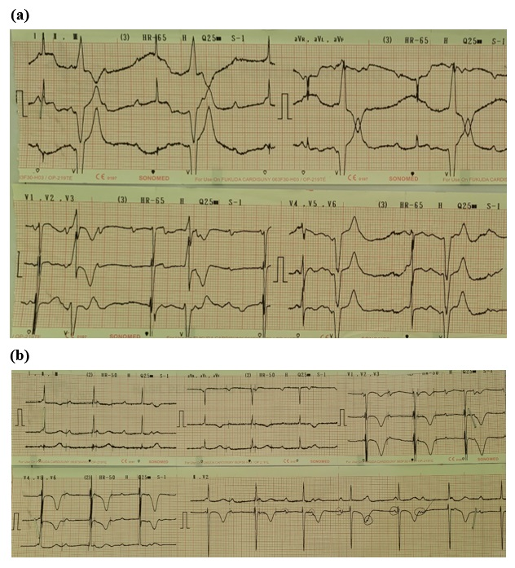

SPONTANEOUS TYPE A AORTIC DISSECTION MASQUERADING AS AN ACUTE MYOCARDIAL INFARCTION: A RARE MIMICKING DISORDER WITH DIFFERENT MANAGEMENT

W. Kwandou¹, M. Luntungan¹, D. U. Djafar¹, A. L. Panda¹, G. E. H. Reppi¹

¹Department of Cardiology and Vascular Medicine Sam Ratulangi University Prof. Dr. R. D. Kandou General Hospital, Manado, Indonesia

Background:
Acute myocardial infarction (AMI) is mainly caused by thrombotic occlusion of atherosclerotic coronary arteries. In such cases with ST-segment elevation on electrocardiogram, thrombolytic therapy is indicated. However, manifestation other cardiovascular disorder such as aortic dissection may mimic AMI and misdiagnosis in such an instance can be catastrophic due to the immediate administration of thrombolytic and antiplatelet agents can increase the risk of further dissection. We present a rare case of AMI with the etiology is not a coronary plaque rupture, but secondary due to acute spontaneous aortic dissection.

Case illustration:
A 56 years old female came to our hospital with chief complaint typical chest pain with diaphoresis since 12 hours before admission. Patient only had history of uncontrolled hypertension without treatment. Electrocardiogram (ECG) showed 1st degree AV block with ST-segment elevation at lead II, III, aVF and V4-V6. Patient then treated as an acute myocardial infarction and sent into the catheterization laboratory for undergoing primary percutaneous coronary intervention. Upon diagnostic coronary angiography, the guiding catheter cannot engage at right coronary ostium and upon contrast injection showed an intimal flap at the ascending aorta with the false lumen occluded the right coronary ostium. Urgent transthoracic echocardiography showed mild aortic dilatation with an intimal flap and hematoma at right coronary cusps. The procedure then was terminated, treatment of antiplatelet and anticoagulation were also stopped. Computed tomography (CT) angiography showed mild dilatation of ascending aorta with intimal flap from ascending aorta to arcus aorta and the false lumen occluded the right coronary cusps area. Patient then consulted to cardiothoracic vascular surgeon, but she declined to undergo emergency surgery. Fortunately, patient was stable during hospital stay and discharged in 2 weeks.

Brief conclusion:
Aortic dissection may indirectly cause AMI. The possibility of aortic dissection should always be considered in patients with AMI and known risk factor of aortic dissection. Prompt diagnostic studies such as bedside echocardiography in these high risk patients should be done before administration of thrombolytic therapy.

Keywords: Aortic Dissection, Myocardial Infarction

(A) ECG (B) Aortography (C) CT-Scan (D) Transthoracic Echocardiography (E) 3D Reconstruction CT-Scan
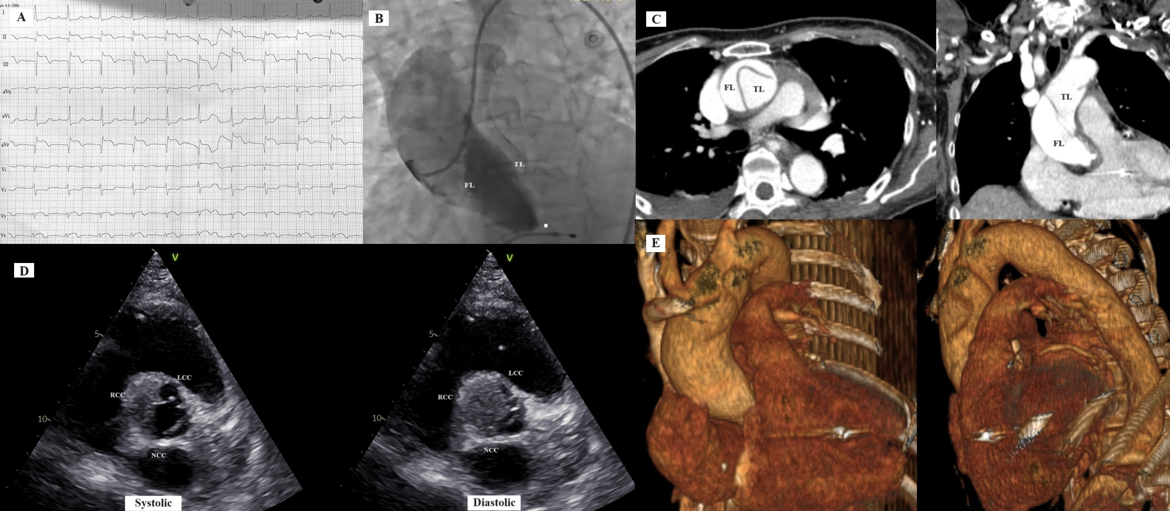

Cardiogenic Shock, Arrythmia, and Hyperglycemic State Complicating STEMI: How to Survive?

C. Ilona¹, M. A. Wijaya¹, D. Idarto¹

¹dr. M. Soewandhie Public Academic General Hospital; School of Medicine, Ciputra University

Background:
STEMI presented with cardiogenic shock has 47.2% mortality anda higher proportion are presented in hyperglycemia with TIMI flow 0 to 1 after primary PCI. The primary goals of therapy in STEMI are to reduce amount of myocardial necrosis, prevent major adverse cardiac events and treat life threatening complication. In patients complicating with cardiogenic shock, arrythmias and hyperglycemic often makes it difficult for the management. A primary PCI strategy is still indicated even in the presence of complications. The management could involve temporary pacemaker, precise fluid management, CVC insertion, echocardiography, and pharmacological support in one index procedure.

Case illustration:
Male, 60 y.o came to the ER with chest pain. He was diagnosed with STEMI inferior, TAVB, high blood glucose and cardiogenic shock. Primary PCI was quickly activated, an echo bedside was performed with EF 40% and low TAPSE. CVC was inserted with supporting inotropic, vasopressor, fluid management, and rapid acting insulin. TPM was also placed to back the procedure. The angiography showed total occlusion with thrombus grade V with TIMI 0 in RCA, The LAD showed significant stenosis on both mid and proximal, The LCx showed mild disease on proximal. Canulation was engaged with GC JR 3.5/6 with workhorse wire to distal PL. Predilatation with SC balloon 2.0/20 mm in proximal with maximum pressure 14 atm for 30 seconds. Thrombuster 6F few times from distal to proximal was done and several thrombus was found. Implantation of stent DES 3.5’40 mm to proximal-distal was expanded. TIMI 3 flow was achieved. Patient was administered to ICCU and went under strict haemodynamic monitoring and treatment of hyperglycemia, cardiogenic shock, and infection. The patient was moved to the ward on 7<sup>th</sup> day of admission and was discharged 5 days later with stable condition.

Brief conclusion:
STEMI with arrhytmia, hyperglycemia, cardiogenic shock and infection complication during admission are fatal combinations and induces high mortality. The need of strong heart team and right implementation of management is necessary from ER, catheterization lab, and CVCU. Primary PCI should not be postponed and must be done to achieve TIMI 3 flow and to improve clinical outcome.

Keywords: TAVB, STEMI, Primary PCI, Hyperglycemic, Cardiogenic shock

Atypical Chest Pain on ST-segment Elevation Myocardial Infarction (STEMI) with Uncontrolled Diabetes Mellitus (DM)

C. A. Maulana¹, A. P. Pratama¹, E. Zulkarnain¹

¹Central General Hospital Dr. Mohammad Hoesin

Background:
Diabetes mellitus (DM), hypertension, dyslipidemia, tobacco smoking and lack of physical activity are common modifiable cardiovascular risk factors. Acute coronary syndromes (ACSs) are life-threatening conditions that can punctuate the course of patients with coronary artery disease at any time. Diabetic cardiovascular autonomic neuropathy contributes to inappropriate perception of chest pain, mostly misrecognized as a disease originated from gastrointestinal or pulmonary sites. Patients with atypical chest pain showed higher 2-year mortality than those with typical chest pain in both DM and non-DM.

Case illustration:
A 64-year-old man was referred from a local hospital to our hospital with a third day of persistent epigastric pain and constant fatigue. His cardiovascular risk profile was uncontrolled hypertension, DM and passive smoker. Electrocardiography (ecg) showed evolving ST segments elevation on inferior leads followed by total atrioventricular (AV) block. After the patient’s hemodynamic had been stabilized, he underwent emergency coronary angiography and 2 stent was successfully implanted from the middle-to-end of Left Anterior Descending artery (LAD) with TIMI 2 flow along with temporary pacemaker. Echocardiography was done a day after stent implantation resulting 45% of ejection fraction and normal heart rates. On the first day onset of epigastric pain, ecg was performed and the clinician said that there was no abnormality on ecg. The patient was withdrawn from the hospital after two hours observation with. Right after three days sustaining the pain, the patient revisited the emergency unit, thus the second ecg was performed showing inferior infarction and total AV block. STEMI was confirmed by elevation of Troponin I enzyme.

Brief conclusion:
In conclusion, atypical chest pain and diabetic neuropathy causing less clinical concern, leading to underdiagnosis and delayed treatment. Therefore, as a clinician it is important to put more care and attention for patient on epigastric pain with multiple cardiovascular risks.

Keywords: STEMI, Diabetic neuropathy, DM

Figure 1. This electrocardiography was taken on patient's second visit in emergency room
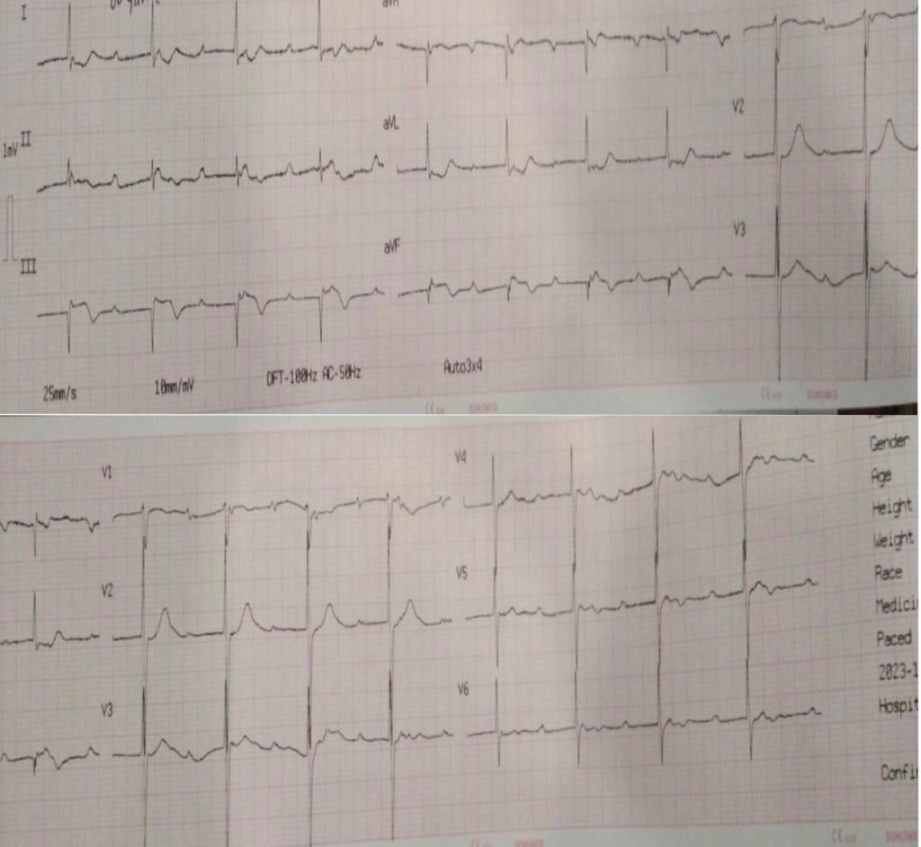

Acute Ischemic Stroke with Acute Myocardial Infarction, Neurologist or Cardiologist First? A Rarely Reported Case

C. A. Maulana¹, S. A. Soesanto², M. I. Nurmansyah ², R. Mulawarman³, M. Trifitriana⁴, R. Yunanda¹

¹Siti Khadijah Islamic Hospital
²Department of Cardiology & Vascular Medicine, Mohammad Hoesin General Hospital
³Prabumulih General Hospital
⁴Faculty of Medicine, Sriwijaya University

Background:
Acute ischemic stroke (AIS) and acute myocardial infarction (AMI) are both life-threatening medical conditions, bringing lethal prognosis if not addressed immediately. One-third of patients with ischaemic stroke with no cardiac history have more than 50% coronary stenosis and 3% are at risk of developing MI within a year.Cardio-cerebral infarction (CCI) term can be used to describe the simultaneous incident of AIS and AMI. However, the approach to immediate management of CCI remains unclear.

Case illustration:
A 51-year-old-man was brought to hospital complaining right-sided paresis without chest pain within 1 hour onset. The National Institutes of Health Stroke Scale scored 4. On initial evaluation, blood pressure was 140/90 mmHg, heart rate (HR) was 120 bpm with electrocardiography (ECG) showing : sinus rhythm, HR 120 bpm and anteroseptal wall infarction. CCI was confirmed by non-contrast head computed tomography (CT) scan, showing temporal lobe infarction , and rising Troponin I level in 2.97 ng/mL (refference value = <0.3 ng/mL) on blood test. Neurologist was contacted first due to the chief complain, ordering : intravenous Actilyse and Manitol; oral Aspilet, Clopidogrel and Atorvastatin; and intensive care unit admission with interspecialty refferal to cardiologist. Cardiologist accepted the therapy given by neurologist without additional advice. After 3 hours observaation, left chest discomfort started emerging, hence Furosemid and Morfin were administered by cardiologist. Patient dropped to somnolen state on second day admission leading to subcutaneous Diviti and oral Carvilol prescriptions by cardiologist. On third day patient regained his conscioussness and chest discomfort were relieved. On day four-to-five, chest dicomfort was minimal, with right-sided muscle strength was almost 5 on both upper-andlower limbs. Physioteraphy was scheduled to train muscle strength and echocardiography was performed showing ischaemic cardiomyopathy with reduced ejection fraction.

Brief conclusion:
In conclusion, the co-occurrence of acute myocardial infarction (AMI) and cerebral ischemic events poses a complex medical challenge, as both conditions share common risk factors and underlying mechanisms, often leading to adverse outcomes. Collaborative efforts between cardiology and neurology specialties are essential for optimizing patient care, improving outcomes, and reducing the overall burden of cardiovascular and cerebrovascular diseases.

Keywords: AIS, Cardio-cerebral Infarction, AMI

Initial Head Non-Contrast CT Scan Showed Temporal Lobe Infarction
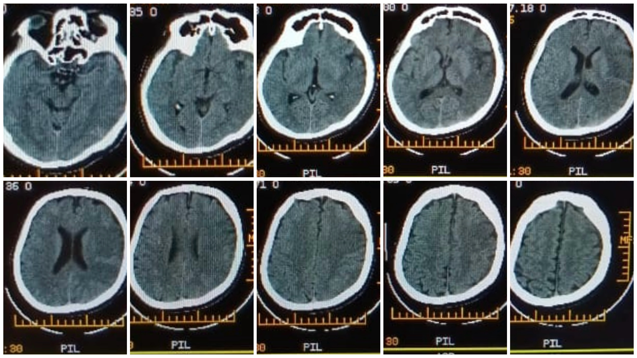

A Case of Inferior ST-Eelevation Myocard Infarc (STEMI) in Young Adult with Uncommon Risk Factor

C. A. Maulana¹, A. P. Pratama¹

¹Mohammad Hoesin General Hospital Palembang

Background:
ST-segment elevation myocardial infarction (STEMI) is associated with significant morbidity and mortality leading to loss of productive life years, especially in very young patients. Coronary artery disease (CAD) is a prevalent condition occurring primarily over the age of 45, and carrying significant morbidity and mortality. Younger individuals can be affected, constituting an important problem for patients and physicians because of the devastating effect of this disease on the quality of life of young patients. It has been suggested that etiopathogenic and prognostic characteristics of acute myocardial infarction (MI) in young patients may differ from those in older patients.

Case illustration:
A 33-year-old man was referred from a local hospital to our hospital with a 3 hours history of new onset chest pain. His cardiovascular risk profile was uncontrolled hypertension. He had previously been well and no history of chronic illness. Electrocardiography (ecg) showed ST segments elevation on inferior leads. After the patient’s hemodynamic had been stabilized, he underwent emergency coronary angiography and 1 stent was successfully implanted in the middle of right coronary artery (RCA) with TIMI 2 flow. An ecg immediately taken after the procedure showing development of pathological Q wave, reduction of ST segment and inverted T wave on inferior leads. Echocardiography was done a day after stent implantation resulting 48% of ejection fraction.This patient only had hypertension as risk factor while some studies stated hypertension was less common than smoking, dyslipidemia, and diabetes melitus in young patients with CAD. However, this patient weight status was overwight with 26 kg/m<sup>2</sup> of body mass index (BMI) in accordance to the same study obtaining 26.4 <img src="//:0"> 4.7 mean BMI score.

Brief conclusion:
In conclusion, STEMI in young patients is quite uncommon but still managing to be life threatening events. Therefore, young adults should be more concern on coronary disease prevention by changing the lifestyle which is more affordable intervention.

Keywords:

Acute Aortic Endocarditis With Spontaneous Acute Upper Limb Ischemic : A Double Jeopardy With Challenging Approach In Nusa Tenggara Timur

C. K. W. R. Lomi¹, H. Y. Nainggolan²

¹Puskesmas Naioni
²RSUP dr. Ben Mboi

Background:
Aortic valve infective endocarditis is a life-threatening disease associated with high mortality and morbidity. We reported a young patient with subtle risk factors for endocarditis presenting with severe dyspnea. Previously, the patient was suspected myocardial infarction based on dynamic ECG findings and positive HS-Troponin I value. However, further examination using Echocardiography revealed vegetation on aortic valve leaflets with an embolic episode leading to upper limb ischemia.

Case illustration:
A 37-year-old man was referred to RSUP Ben Mboi Kupang with clinical suspicion of myocardial infarction based on ischemic ECG pattern and positive HS-Troponin I value. Upon admission, the patient appeared severe shortness of breathing, and we observed cyanosis and pain in the second, third, and fourth fingers of the left hand. A point-of-care cardiac ultrasound revealed vegetation on the aortic valve resulting in acute and severe aortic regurgitation. Considering the vegetation on the aortic valve and its potential association with vascular phenomenon, we diagnosed an infective endocarditis. Ideally, endocarditis with acute heart failure require urgent surgical intervention. However, due to limited facilities, we initiated therapy with empirical antibiotics, including Ampicillin, Gentamicin, and Ceftriaxone, along with a heart failure regimen consisting of diuretics, vasodilators, and the backbone of heart failure, as well as anticoagulant. After 2 weeks of treatment there was significant clinical improvement indicated with no dyspneu, decreased vegetation, and cessation of the ischemic limb process. The patient was discharged on oral antibiotics for endocarditis and prepared for referral.

Brief conclusion:
Acute aortic endocarditis can mimic myocardial infarction thus, a holistic approach is needed. Although urgent surgery is still recommended, according to guidelines, in areas with limited facilities, empirical guided antibiotics, rapid heart failure treatment and enhanced anticoagulation is provenly able to stabilize the patient and potentially improve the condition to non-active endocarditis.

Keywords: Acute Aortic Endocarditis, Infective endocarditis, Acute Limb Ischemic

ECG upon admission ER of RSUP dr. Ben Mboi Kupang, East Nusa Tenggara
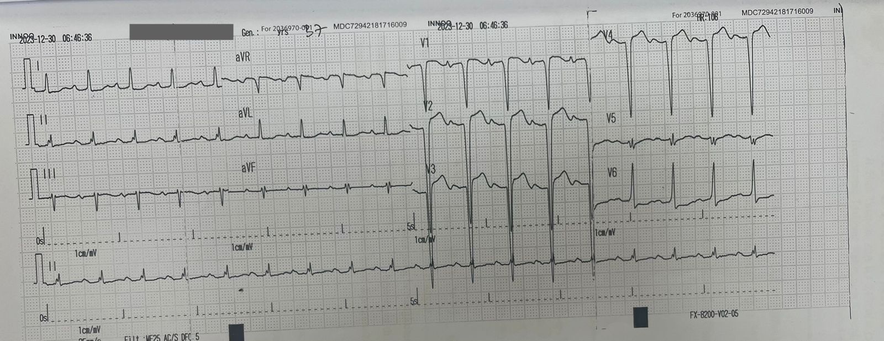

A-59 years-old Female with Supraventricular Tachycardia at dr. Midiyato Suratani Hospital, Tanjungpinang-Indonesia: a case report

D. A. Jeremy¹, Y. Kusuma², T. Adriyanto³

¹Internship General Practitioner, dr. Midiyato Suratani Hospital, Tanjung Pinang, Indonesia
²General Practitioner, dr. Midiyato Suratani Hospital, Tanjung Pinang, Indonesia
³Cardiologist, dr Midiyato Suratani Hospital, Tanjung Pinang, Indonesia

Background:
Supraventricular Tachycardia (SVT) defined as a describes tachycardia, the mechanism affects tissues above the bundle of His. SVT increases patient morbidity, especially when symptoms occur frequently or constantly. In this case, it is included in stable SVT with limited first-line drug of choice for SVT management.

Case illustration:
A Female 59 years old symptoms heartburn that felt suffocating to the left chest, chest felt heavy, shortness of breath cold sweat and chest palpitations. The patient had previous heart disease was SVT, MCI, and functional dyspepsia. The physical exam revealed with normal limit. ECG shows SVT (AVNR) with heart rate at 174 bpm, ST-segment depression in leads V3-6, II and aVF. We gave the metoprolol. Since the rhythm did not covert after 2 times injection. We consulted and used amiodarone as rhythm control. The rhythm did covert into sinus rhythm with 73 bpm. After 3 days treatment, the patient's symptoms improved and discharge from hospital.

Brief conclusion:
Due to not available of adenosine, metoprolol and amiodarone could be used. Metoprolol effective in reducing heart rate but not effective to covert SVT to sinus rhythm. Amiodarone could be used as alternative and could converting SVT (AVNRT) to sinus rhythm.

Keywords: amiodarone, metoprolol, supraventricular tachycardia, AVNR

An Intriguing Inroad: A Rare Case of Pseudoaneurysm Dissecting into Intraventricular Septum

D. J. Pesireron¹, M. S. Dhani¹, D. Nugraha¹, A. Yudha¹, H. H. Satoto¹, D. A. T. A. Wardana¹

¹RSUP dr. Kariadi Semarang

Background:
Sinus Valsalva pseudoaneurysms are rare cardiac anomalies with cases of intraventricular septum (IVS) dissecting pseudoaneurysm an even rarer entities with only 30 cases that have been reported so far. The pseudoaneurysms usually silent clinically for a long time until and unless it becomes large and compresses or dissects adjacent structures or ruptures.

Case illustration:
41-year-old women with a history of hypertension, complaints of pain the chest spreading to the neck and back for 2 weeks prior to hospitalization. The pain worsened in the last 2 days, felt like ‘tearing’ sensation accompanied by complaints of shortness of breath during light activity. Electrocardiogram showed inverted T-waves in lead V1-V2 but no ST-segment elevations. Chest x-ray only showed a left ventricular cardiomegaly. Transthoracic echocardiogram with color Doppler was further performed, demonstrated a clear jet entering the ventricular septum from sinus Valsalva but no signs of jet traversing into the right ventricle (RV). The patient then undergoes an MSCT angiography of the aorta that confirmed the pseudoaneurysm of sinus Valsalva dissecting into intraventricular septum The patient subsequently treated with conservative medications and scheduled to undergo surgery.

Brief conclusion:
Although its occurrence is rare, Sinus Valsalva pseudoaneurysm dissecting into IVS may cause significant anatomical and hemodynamic derangement that made a prompt diagnosis and subsequent treatment is vital to the prognosis of the patient.

Keywords: pseudoaneurysm, dissecting intraventricular septum, cardiac CT, chest pain , Sinus Valsava

MSCT view of Pseudoaneurysm dissecting IVS
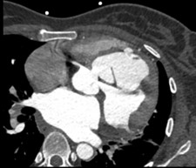

Advanced Heart Failure with Cardiogenic Shock due to Dependent Contractility Drug Therapy in A Man 49 year old: Case Report

D. HS. Putra¹, S. Hedrawansyah¹, M. Yazid¹, D. Fiddin¹

¹Bhakti Medicare Hospital

Background:
Advanced Heart Failure (AdHF) is a clinical syndrome that shows signs and symptoms of severe heart failure, even though the treatment given has been optimal. In this case, we report an advanced phase heart failure condition that is refractory to the drug's maximum dose contractibility so that it enters into a clinical condition of prolonged cardiogenic shock that can't escape and has the consequences of heavy service burden on patients, hospitals and the government.

Case illustration:
A 49-year-old man came to the hospital's emergency facility complaining of shortness of breath while sleeping accompanied by swelling of both limbs. Physical examination obtained blood pressure 80/60 mmHg, breathing rate 28x per minute, heart rate 120x per minut, temperature 37.1 degrees Celsius, peripheral oxygen saturation is 89%. Sign Jugular Vena Pressure increases 5+4 mmHg, regular S1-S2 heart sound, S3 gallops, pansitopanic murmur (PSM) at apex gr 3/6 passes to the axilla, PSM murmur at LLSB gr 3/6. At the examination of the extremity, edema of the limbs was found. Previously, patients had been diagnosed with HF with 17-20% LVEF by cardiologists in previous hospitals and received HF therapy with clinical results of improvement, but patients with non-routine controls resulted in clinical HF deterioration to AdHF and subsequently cardiogenic shock.Laboratory tests obtained leukocytosis and enhanced liver function test. Electrocardiography results results tachycardia sinuses and changes in the LAD axis. Echocardiography results dilated all chambers, severely reduced LVEF and global severe hypokinetic, spotaneous echo contrast at LV. Then the patient was treated at the ICU with contractility drug therapy, but had prolonged treatment because he could not get rid of cardiac support therapy. This led to sepsis complications. Prolonged treatment problems make patients do not resusitate.

Brief conclusion:
Early detection, education and optimization of the four pillars of therapy in cases of HF is crucial. It aims to reduce the morbidity and mortality rates of patients with HF so that the burden on the state and public health budgets can be reduced.

Keywords: Dependent Contractility Drugs Therapy, Keywords: Heart failure, Advanced Heart Failure, Shock Cardiogenic

Stable Oxygen Saturation Improvement in High Risk Patient with Tetralogy Of Fallot Physiology Post Right Ventricular Outflow Tract Stenting

P. P. Halim ¹, E. Ratningpoeti², R. Prakoso³

¹Medical student, Faculty of Medicine, Universitas Indonesia, Jakarta, Indonesia
²Permata Cirebon Hospital, Cirebon, West Java, Indonesia
³Division of Cardiology and Congenital Heart Disease, Department of Cardiology and Vascular Medicine, Faculty of Medicine, University of Indonesia, National Cardiovascular Center of Harapan Kita, Jakarta, Indonesia

Background:
Over the past decade, right ventricular outflow tract (RVOT) stenting has become a widely used palliative treatment preceding surgical intervention for individuals with tetralogy of Fallot (TOF). Studies have shown that RVOT stenting effectively improves oxygen levels in cyanotic patients.

Case illustration:
a three-year-old with TOF and severe cyanosis underwent successful RVOT stenting despite receiving sufficient doses of propranolol, experiencing escalating unresponsiveness, and one to three cyanotic episodes daily. Upon admission to the emergency department, the patient displayed shallow respiration, with an oxygen saturation level of merely 30%. Subsequent to stabilization and endotracheal intubation in the emergency unit, emergent RVOT stenting was undertaken. This emergent intervention was necessitated by the patient's markedly diminished McGoon ratio of 1.2, profound hypoxia, and refractoriness to pharmacological intervention. Prior research on RVOT stenting has demonstrated an 87% success rate among patients exhibiting 63% (44-80%) pre-procedural oxygen saturation levels, with a notable enhancement observed in oxygen saturation from 75% (60-85%) pre-procedure to 94% (90-98%) post-procedure (p=0.008). Compared to the Blalock-Thomas-Taussig (BT) shunt, RVOT stenting carries a lower risk of mortality, does not require a McGoon ratio of 1.5, and improves oxygen saturation and right pulmonary artery dimensions more effectively than the modified Blalock-Tausig shunt (mBTS). Consequently, given the superior outcomes and reduced prerequisite criteria associated with RVOT stenting, it was favored over the BT shunt in the present case Predilatation maneuvers were performed to prevent stent fracture. After stent deployment, oxygen saturation in the descending aorta surged significantly from 42% to 95%. Follow-up echocardiography revealed complete resolution of pulmonary stenosis, and after extubation, the patient's oxygen saturation stabilized at 92%.

Brief conclusion:
RVOT stenting is a secure and effective palliative intervention for severe cyanosis and recurrent spells of TOF, especially in cases unresponsive to pharmacological therapy. This case highlights the significant improvement in stable oxygen saturation following RVOT stent placement. Keywords include right ventricular outflow tract stent, severe pulmonary stenosis, severe desaturation, and tetralogy of Fallot.

Keywords: severe desaturation, tetralogy of Fallot, severe pulmonary stenosis, right ventricular outflow tract stent

Challenging in Management of Ventricular Septal Rupture : A Catasthropic Complication of Late onset STEMI

Effendi¹, W. Mubarok¹, M. Wirawan¹, Safir¹

¹Department of Cardiology and Vascular Medicine, Faculty of Medicine, Diponegoro University – Dr. Kariadi Central General Hospital, Semarang, Indonesia

Background:
Ventricular septal rupture (VSR) is a rare but highly lethal mechanical complication of myocardial infarction (MI) with important hemodynamic consequences. Without rapid diagnosis and appropriate management, short-term mortality is higher than 90% Management involves many aspects, including hemodynamic status, timing of defect closure, and surgical closure with concomitant coronary artery bypass grafting (CABG). We described case of VSR complicating an anterior MI that treated successfully by surgical VSR closure and CABG.

Case illustration:
A 46-year-old male with anterior STEMI, 10 days of onset, came to our ER department with chief complain of shortness of breath and chest discomfort. He came with weak appearance and from physical examination his blood pressure was 98/63 mmHg, heart rate 103 bpm, respiratory rate 26 times per minute, pansystolic murmur grade IV/VI heard at apex area, with rales at both lungs. Echocardiogram showed ejection fraction 53%, hypokinetic at anterior segment with 8 mm interventricular septum (IVS) gap at apex area, shunt from left to right. Patient admitted to our cardiovascular care unit, intraaortic balloon pump (IABP) inserted to stabilize the hemodynamic and coronary angiography were done 1 day prior to surgery and showed total occlusion at ostial part of left artery descending. After surgery, there was no residual shunt but patient developed into septic shock and acute kidney injury, then proceed to continuous renal replacement therapy (CRRT) as soon as possible. After 14 days of hospitalization at CVCU, patient was clinically and hemodynamically stable and can be discharged.

Brief conclusion:
VSR is a rare condition with high mortality rate. Closure of VSR with CABG are the definite treatment in our case. Despite high mortality in VSR patient, closed hemodynamic monitoring, use of mechanical circulatory support and also appropriate timing of treatment can increase survival rate dramatically compared to medical therapy alone.

Keywords: myocardial infarction, mechanical complication, Ventricular septal rupture

VSR
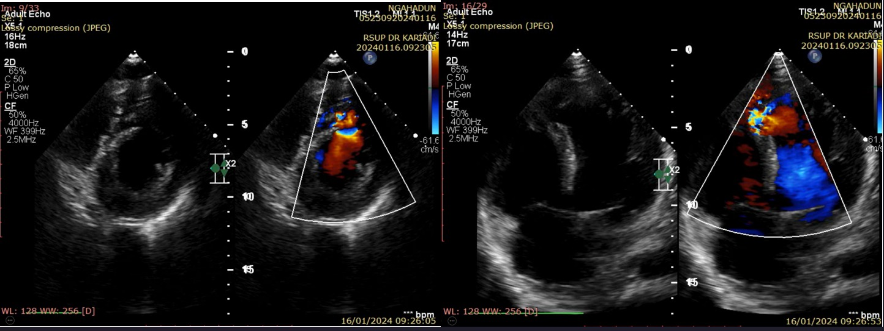

A Case of Successful Modified Valsava Maneuver in Patients Presented with Supraventricular Tachycardia following by Wolff Parkinson White Syndrome in Emergency Room

F. R. Agfata¹, F. W. Nugroho²

¹RS Fastabiq Sehat PKU Muhammadiyah Pati
²Department of Cardiology and Vascular Disease, RS PKU Muhammadiyah Fastabiq Sehat

Background:
Supraventricular tachycardia (SVT) defined as rapid rhythms originated and sustained in atrial or atrioventricular node tissue above the bundle of His. Modified valsava maneuver (MSM) used for termination of SVT, stimulates the baroreceptors in the aortic arch, resulting in increased parasympathetic tone, which blocks the AV node. Wolff Parkinson White syndrome (WPWS) is most common form of ventricular pre-excitation, may remain undetected until manifests as paroxysmal SVT. We report a case of WPWS that was diagnosed following successful termination of SVT using modified valsava maneuver.

Case illustration:
A 17 year-old teenager presented with a sudden onset of palpitation and left chest pain for the past hour. The chest pain creep to left shoulder, back, and left arm. The palpitation was associated with mild shortness of breath and reduced effort tolerance. She was previously well with no syncopal attack, denied smoking, taking alcohol, or being involved with illicit drug use. She was diagnosed with stunting when toddler, with low birth weight baby history, although there was no history of congenital heart disease. She was referred from primary health care to our ER with heart rate of 204bpm. Upon arrival in ER, her ECG shows supraventricular tachycardia with a heart rate of 205bpm. The P waves can best be seen embedded in the ST segment of lead III and aVF with a short PR interval. Patient then performed modified valsava maneuver, when patient is placed in a semi-recumbent position and instructed to exhale forcefully into a syringe to generate a pressure for 15 seconds, then followed by supine repositioning and passive leg raising to 45 degrees for 15 seconds. ECG performed after MSM, shows a sinus rhythm tachycardia of 128bpm, short PR, broad QRS complex, and presence of delta wave, identified as WPWS. Chief complaint of chest pain and shortness of breath are significantly reduced after MSM performed.

Brief conclusion:
Modified valsava maneuver best perform in SVT patient whom hemodynamically stable. This case is a typical presentation of SVT, successfully managed with modified valsava maneuver, following which delta waves are detected in the ECG suggestive of pre-excitation in WPW syndrome.

Keywords: Wolff Parkinson White Syndrome, Supraventricular Tachycardia, Modified Valsava Manuever
ECG performed after modified valsava maneuver, shows sinus tachycardia with heart rate of 128 beats per minute, short PR, broad QRS complex, and presence of delta wave, identified as WPW syndrome.
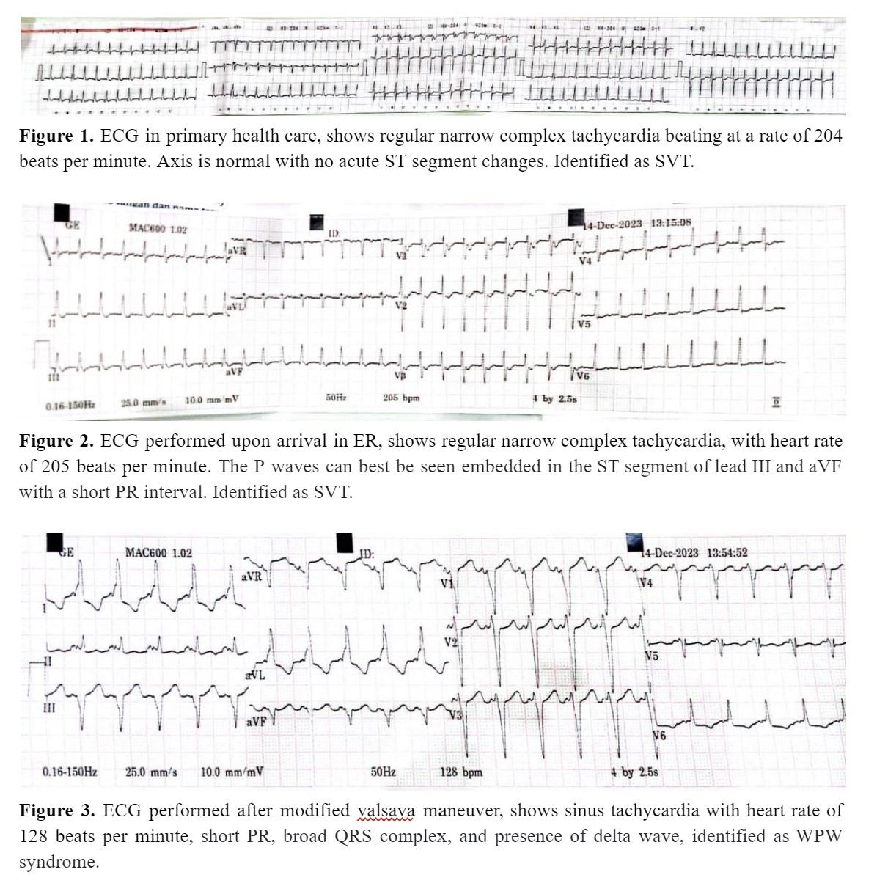

Hypertensive Emergency with Acute Kidney Injury a Case Report: Blood Pressure Monitoring and Regulation for Improving Kidney Function

F. Manuputty¹

¹RS Eka Hospital Permata Hijau

Background:
We describe the case of an 82 years old Female that come to EMD with chief complaint Fatigue for one week and get diagnosed with hypertensive emergency and acute kidney injury.

Case illustration:
An 82 years old Female came to EMD with fatigue for at least one week. She looked ill, her blood pressure was 200/120, pulse rate 108 beats/min, oxygen saturation 98%.The ECG showed Sinus tachycardia with LAD and right bundle branch block. Chest X-ray showed dextrocardia with cardiomegaly. The laboratory result showed urea 68mg/dl, creatinine 5.56mg/dl with glomerular filtration rate (GFR) 8.7 ml/minute/1.73m<sup style="color: black;">2</sup>. Patient get diagnosed with hypertensive emergency and acute kidney injury. Patient then treated with IV nicardipine 0,5 mcg/kg/min, with titration 0,5mcg/kg/min with targeted reduce systolic blood pressure 20%-25% from initial systolic blood pressure in 1 hour. Patient blood pressure successfully reduced to 160/100. Patient then admitted for hospitalization in high care unit (HCU) for strict monitoring of blood pressure. On the next day patient blood pressure is 140/90. Patient laboratory showed increasing of renal function with urea 54mg/dl, creatinine 3.40mg/dl with GFR 11.9 ml/minute/ 1.73m<sup style="color: black;">2</sup>. Patient then treated with oral hypertensive drugs bisoprolol 5mg, amlodipine 10mg and candesartan 16mg overlapping with IV nicardipine. On the third days, patient blood pressure is 130/80 without IV nicardipine (only with oral hypertensive drugs). The laboratory showed urea 35 mg/dl, creatinine 1.35 mg/dl. Patient then get transferred to inpatient ward. On the fourth days patient was discharged home. After that patient was monitored from the outpatient clinic.

Brief conclusion:
Blood pressure monitoring and regulation is recommended for patient with hypertensive emergency with targeted organ damage, in this case acute kidney injury. Well controlled blood pressure monitoring and regulation can lead to improvement of kidney function

Keywords: Blood pressure regulation., Hypertensive Emergency, Acute kidney injury, Blood pressure monitoring

ECG showed Sinus tachycardia with LAD and right bundle branch block
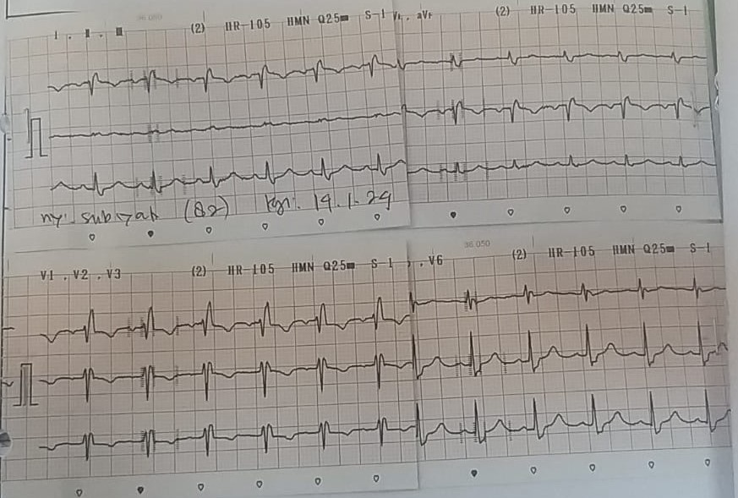

Thyrotoxicosis-Induced Periodic Paralysis on Hypokalaemia Condition: A Rare Presentation

H. P. Riswati¹

¹Department of Cardiology and Vascular Medicine, Faculty of meidicine Brawijaya University, Malang

Background:
Hypokalemia, a frequent electrolyte imbalance in clinical practice, may often be overlooked when mild but presents with noticeable symptoms like muscle weakness when moderate to severe. Herein, we discuss a case of hyperthyroidism-induced hypokalemic periodic paralysis.

Case illustration:
We describe a 25-year-old male who presented to the emergency with muscle weakness in all his limbs. Notably, his muscle power was diminished in all limbs. He also displayed signs of faintness, and an ECG demonstrated a total atrioventricular block. Laboratory assessments identified severe hypokalemia (Potassium level 1.5 mmol/L), which led to potassium infusion treatment. However, thyroid function tests signaled hyperthyroidism with thyroid stimulating hormone (TSH) < 0.01 mikroIU/mL (reference range 0.27-4.2 mikroIU/mL) and free thyroxine (FT4) 4.92 ng/dL (reference range 0.93-1.7 ng/dL) total T3 3.17 ng/mL (0.8-2.0). Consequently, he was initiated on a therapeutic regimen of methimazole, propranolol, and potassium supplements. His condition improved considerably, and he was subsequently discharged on the fifth day.

Brief conclusion:
Hypokalemia often appears as part of another underlying condition, such as hyperthyroidism. Accurately diagnosing hypokalemia in patients with unknown previous history could be challenging, but merely treating hypokalemia in patients with underlying diseases could be potentially fatal. Early recognition of hyperthyroid in hypokalemic paralysis patients is important to provide appropriate treatment and avoid the risk of rebound hyperkalemia from excessive unrequired potassium replacement.

Keywords: hyperthyroidism, hypokalaemia, Keywords: paralized

Figure 1. A. ECG when hypokalemia condition (potassium level 1.5 mmol/L) B. ECG when the symptoms improved (potassium level 4.31 mmol/L) C. CXR with in normal limit
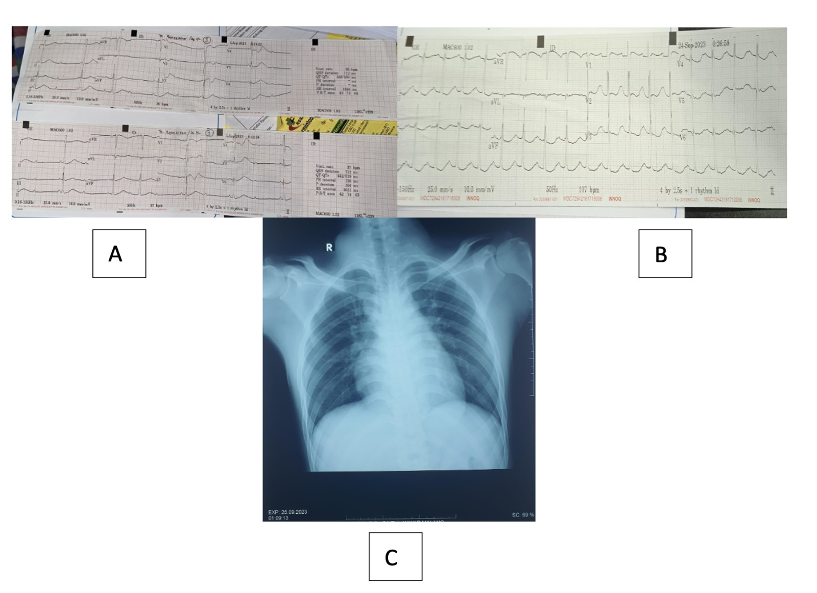

Successful Management of Patient with Ventricular Septal Rupture Complicating STEMI Whole Anterior

H. Filman¹, P. Kabo¹, A. F. Muzakkir¹, J. Kusumanegara¹

¹Department of Cardiology and Vascular Medicine, Faculty of Medicine Hasanuddin University

Background:
Ventricular Septal Rupture (VSR) post Acute Myocardial Infarction (AMI) is rare but potentially life treatening. Before the era of reperfusion therapy, the incidence of VSR ranged from approximately 1% to 3% of all infarctions. With aggressive use of antithrombotic drugs and primary percutaneous coronary intervention, the incidence of VSR has decreased to less than 1% in individuals with myocardial infarction. The incidence of VSR in AMI patients increases with age, hypertension, myocardial infarction with lack of collaterals. However, there is no official data regarding VSR incidents in Indonesia. Depending on the infarct size, degree of shunt, and RV dysfunction, patients with VSR may present with either relatively stable hemodynamics or cardiogenic shock.

Case illustration:
A 60-year-old female was referred to our department with a recent STEMI of the whole anterior wall. The electrocardiogram showed: sinus tachycardia of 115 bpm, LAD, STEMI whole anterior wall. Chest radiography proved lung edema and cardiomegaly. Laboratory analysis showed elevated Hs-Troponin I (1173,6). Echocardiography showed : moderately abnormal LV systolic function, EF 35.7% (Biplane), normal RV systolic function, TAPSE 2.04 cm, akinetic and hypokinetic segmental (akinetic basal mid anterior, mid anteroseptal, apicoanterior, hypokinetic basal anteroseptal, apicoseptal), moderate TR (TR Vmax 3.43 m/s, TR Max PG 47.0 mmHg, TR VC 6.1 mm), mild MR, eccentric LVH with LV aneurysm, Abnormal LV diastolic function, VSR left to right shunt, size 8.54 mm, VSR gradient 14.6 mmHg. The patient underwent coronary angiography with a normal left main, proximal total occlusion at Left Anterior Descending, normal left circumflex artery and Mid stenosis 20 % at right coronary artery. During treatment at CVCU for 3 weeks, the patient was stable with hemodynamic echocardiography monitoring, so the patient received AMI therapy without IABP support. The patient then underwent CABG and VSR repair with the DOR procedure.

Brief conclusion:
It is very important to maintain the patient’s hemodynamic stability during treatment at the CVCU until surgery. Delayed surgery seemed to be associated with better survival. Age, preoperative cardiac arrest and percutaneous revascularization, intra-aortic balloon pump requirements and extracorporeal membrane oxygenation were independently associated with early mortality.

Keywords: Ventricular Septal Rupture, CABG, Post AMI, IABP, Dor Procedure

THE BLUE ZONE OF AORTIC DISSECTION WITH TOTAL ATRIOVENTRICULAR BLOCK : MIRACLE OR MYSTERY?

I. J. Ahmad¹, A. H. Alkatiri¹

¹Department of Cardiology and Vascular Medicine, Faculty of Medicine, Hasanuddin University, Makassar, Indonesia

Background:
Aortic dissection (AD) is a rare and life-threatening challenging condition in clinical practice. The incidence of ascending AD from the total incidence of AD reaches 58-62% of cases with a mortality rate of 73%.

Case illustration:
We report a 62-year-old man with the risk factor of smoking who presented with typical angina for two weeks accompanied by inferolateral ischemia on electrocardiography (ECG) and regional wall motion abnormality (RWMA) on echocardiography. However, there was an incidental finding in the form of aortic dissection. The patient then experienced an atrioventricular (AV) block and underwent temporary pacemaker (TPM) installation accompanied by angiography with slow flow right coronary artery (RCA) results showing an intimal tear suspicious of an RCA dissection accompanied by an intimal tear in the ascending aorta. Then, the patient underwent multislice computerized tomography (MSCT) and found Stanford type A, DeBakey type I aortic dissection with thrombus in the false lumen of the ascending aorta. The patient was then discharged for his not consenting to undergo surgery. At the 6-month post-treatment control, the patient had sinus rhythm on ECG, followed by control MSCT. Typical complaints of angina with three coronary risk factors accompanied by changes in ECG and echocardiography make the clinical diagnosis more likely to lead to coronary causes even though there is suspicion of an aortic dissection, particularly with the presence of an AV block. Angiography results showed that there were no significant stenotic lesions, making the symptoms and signs experienced by the patient tend to be of aortic dissection and RCA dissection nature, resulting in malperfussion syndrome. Thrombus in the false lumen of the ascending aorta and remodeling of the aortic wall provide a better prognosis, allowing them to pass the acute phase with pharmacological therapy without surgery, even though the mortality rate continues to increase.

Brief conclusion:
Several complications generally occur in coronary heart disease with extensive AD. The process of aortic wall remodeling and false lumen patency can be a determining factor in the progression of this disease.

Keywords: Total atrioventricular block, Aortic dissection, Chronic coronary syndrome

Dissection of the ascending and descending aorta with thrombus in the false lumen of the ascending aorta
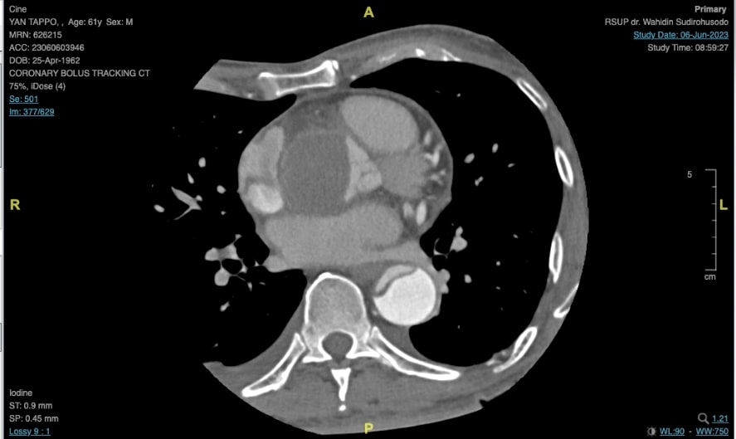

Subarachnoid Hemorrhage Mirroring Myocardial Infarction in 46-Year-Old Patient: The Importance of Clinical Findings

I. Yoseph¹, V. Chairiadi², Hasannudin², S. Rahmawati³

¹Cardiology Intern, Undata Regional General Hospital, Central Sulawesi
²Cardiologist, Undata Regional General Hospital, Central Sulawesi
³Neurology Intern, Undata Regional General Hospital, Central Sulawesi

Background:
Subarachnoid hemorrhage (SAH), is associated with many cardiac effects including cardiac rhythm abnormalities, ischemic electrocardiographic (ECG) changes, elevated cardiac troponin levels, and regional wall motion abnormalities on the echocardiogram. The increased sympathetic tone with excess circulating catecholamines seen in conjunction with the bleeding is most likely the cause of cardiac events after SAH. These findings can lead to misdiagnosis and incorrect therapeutic decisions in SAH patients, such as thrombolytic therapy and percutaneous coronary intervention. In this article we report a case of SAH mimicking myocardial infarction (MI) findings.

Case illustration:
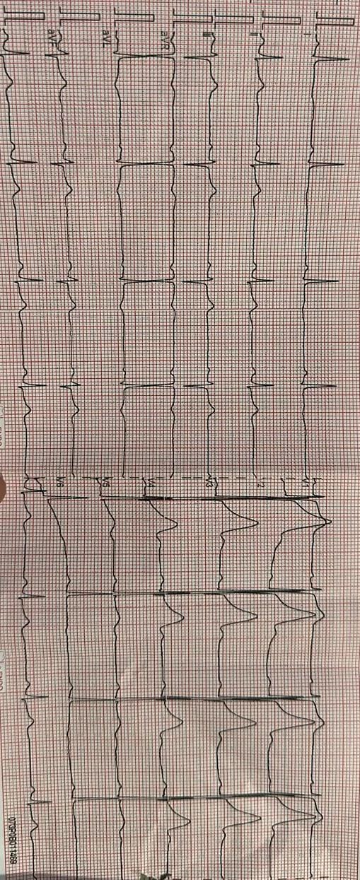
A 46-year-old man was admitted with chief complaints of non-radiating chest pain. Prior to this complaint, there were sudden severe headache, neck tension, vomiting, followed by syncope. There was no sign of neurological deficit on arrival. Electrocardiogram showed T inverted in leads I, aVL, V5, V6. Troponin I level was increased (0.22 ng/ml). Echocardiography showed normal findings. Patient was initially diagnosed with NSTEMI, therefore receiving anticoagulant and antiplatelet therapy. Follow up examination found worsening headache, hearing loss in right ear, right side paralysis (strength 4), and positive meningeal signs. Patient underwent CT scan and revealed subarachnoid hemorrhagic at prepontine and premedullary cisterna to pontocerebelli. Coronary angiography revealed non-significant coronary artery disease with mid-stenosis only 30% in the left anterior descending. Anticoagulant and antiplatelet therapy was discontinued, and mannitol, nootropics, and antihypertensives were administered. After two weeks of hospitalization, patient was discharged home in good condition without neurological deficits.

Brief conclusion:
Hemorrhagic stroke misdiagnosed as ACS are common and associated with poor clinical outcomes. Clinical symptoms and signs of neurological disorder should not be ignored despite the presence of ischemic on emergency ECG.

Keywords: myocardial infarction, subarachnoid hemorrhage

Figure 1. ECG shown T inverted I, AVL, V5 and V6

Challanges in The Management of Acute on Chronic Pulmonary Embolism in a Resource-Limited Setting: A Case Report

I. N. Hardani¹, B. D. Dohar¹, B. E. Putra²

¹General Practitioner, Berkah Pandeglang District General Hospital
²Cardiologist, Berkah Pandeglang District General Hospital

Background:
Acute pulmonary embolism (PE) is a potentially life-threatening cardiovascular disorder. Patients presenting acutely to the emergency room (ER) with signs of PE may already have unresolved prior clots leading to chronic thromboembolic pulmonary hypertension (CTEPH), decompensated by the new PE episode resulting in fatal right ventricular (RV) failure. Identifying this condition is a formidable clinical challenge in resource-limited contexts due to constrained access to computed tomographic pulmonary angiography (CTPA) as the imaging method of choice.

Case illustration:
A 39-year-old woman with a history of contraceptive implant use for 5 months referred to our ER due to worsening dyspnea for 7 hours before admission. The patient had previous exertional dyspnea and orthopnea for months but had no known history of prior PE or deep venous thrombosis (DVT). The physical examination showed tachycardia (103 beats per min), tachypnea (28 breaths per min), desaturation (SpO2 64-74% with NRM at 15 lpm) with clear lungs and holosystolic tricuspid murmur on auscultation, and also elevated jugular venous pressure (JVP). No signs of haemodynamic instability were found. The ECG showed the S1Q3T3 pattern. A simple bedside echocardiography was done by the ER doctor in charge, revealing RV enlargement with D-shape, indicating RV dysfunction. We initiated anticoagulation treatment with IV UFH without delay, while awaiting the result of D-dimer testing. The result confirmed an increased D-dimer level, that was 2990 ng/mL. During intensive observation in ICU, the patient's oxygen saturation level remained dropping despite heparinization. Acute PE on CTEPH was suspected. She was planned to be referred for further evaluation.

Brief conclusion:
A timely identification of acute PE on CTEPH, while challenging, is an important consideration as it will determine the patients' acute and long-term management. In resource-limited settings, we encourage an advanced clinical skill of emergency doctors to perform a simple imaging bedside echocardiography for early detection of RV dysfunction in suspected acute PE patients as it is also crucial to prevent treatment delay.

Keywords: pulmonary embolism, right ventricular dysfunction, chronic thromboembolic pulmonary hypertension, bedside echocardiography

Figure 1. Parasternal short axis view echocardiography showing RV dilatation with “D-sign” indicating RV dysfunction. RV = right ventricle; LV : left ventricle.
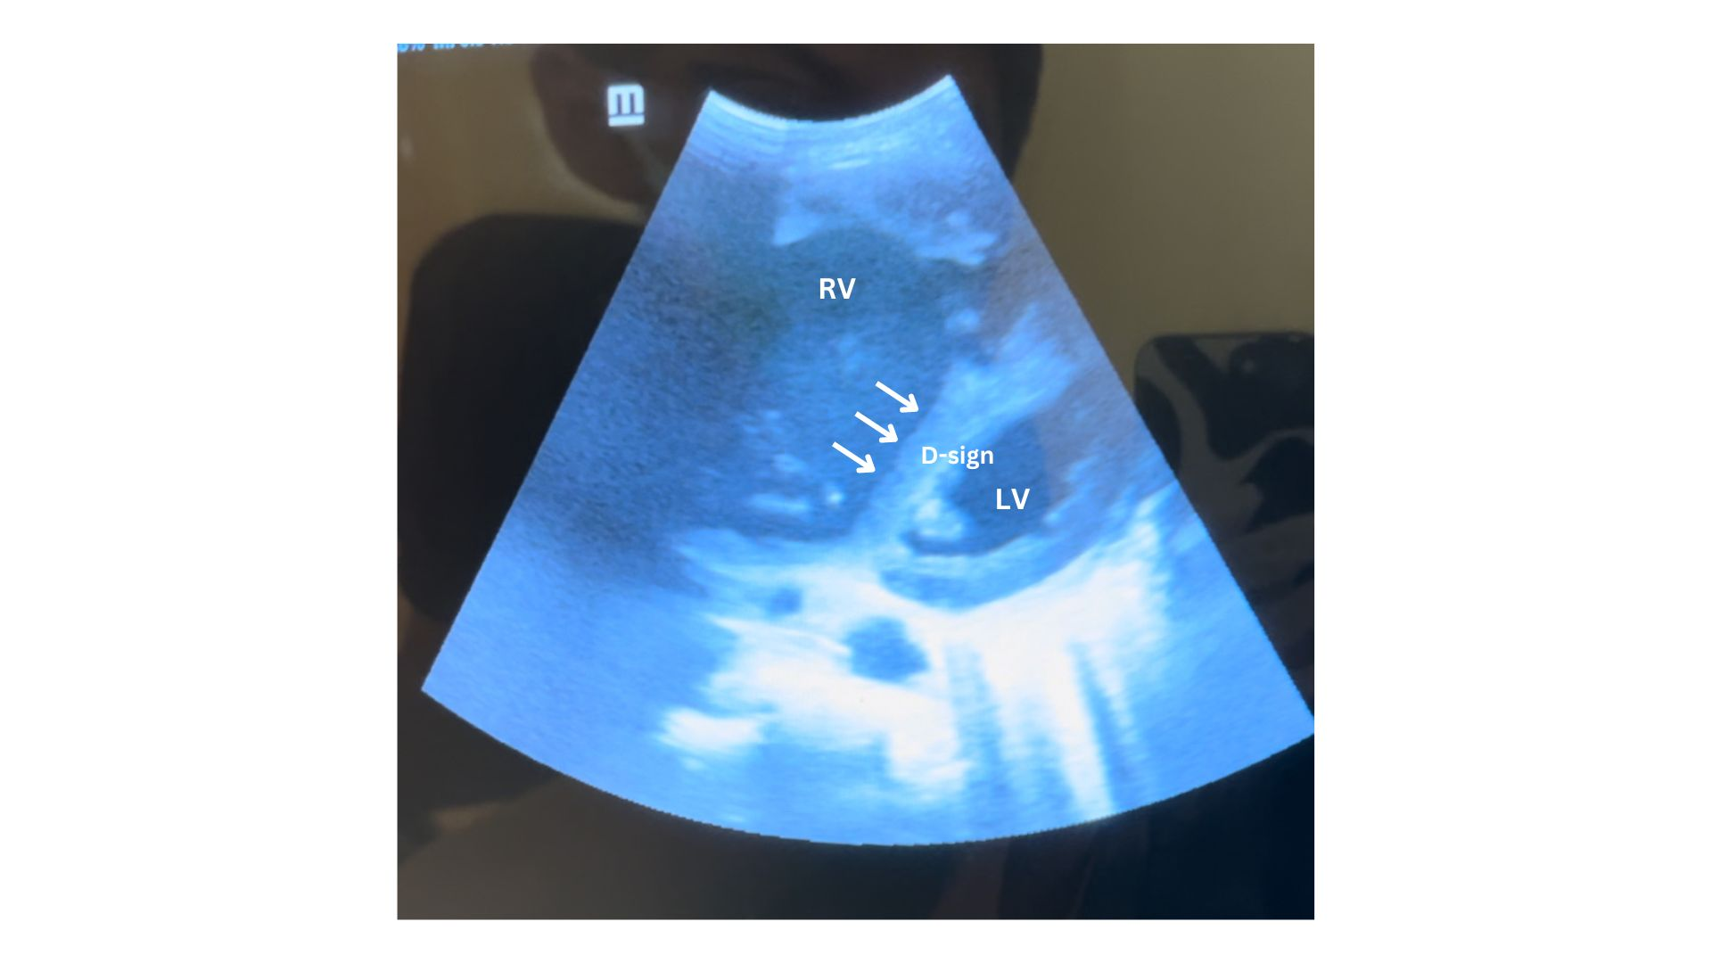

Revealing “Hidden” Isolated Posterior ST-segment Elevation Myocardial Infarction with Posterior Electrocardiographic Leads: A Case Report

I. N. Hardani¹, B. D. Dohar¹, B. E. Putra²

¹General Practitioner, Berkah Pandeglang District General Hospital
²Cardiologist, Berkah Pandeglang District General Hospital

Background:
Isolated posterior ST-segment elevation myocardial infarction (STEMI) is rare, accounting for 3-11% of all MIs. It is likely to be underdiagnosed due to the absence of typical ST-elevation seen in standard 12-lead electrocardiography (ECG). Without additional posterior leads (V7-V9), anterior ST-segment depression as the initial change in ECG may be misinterpreted as ischemia rather than posterior infarction, which may contribute to the delay in receiving reperfusion therapy. Here we present a case about the essential use of posterior leads in early detection of isolated posterior STEMI.

Case illustration:
A 47-year-old man presented to our emergency room with typical chest pain for about 4 hours along with nausea and cold sweat. He was a smoker and had uncontrolled hypertension. Physical examination revealed high blood pressure 170/110 mmHg. The 12-lead ECG showed downsloping ST-depression and dominant R-wave in leads V1-V3. We obtained additional posterior leads which revealed ST-elevation in leads V7-V9. He was diagnosed with isolated posterior STEMI Killip class I. He was treated with standard initial therapy, then was referred for primary percutaneous coronary intervention (PPCI).

Brief conclusion:
Several findings in standard 12-lead ECG which should raise our suspicion of posterior STEMI are ST-segment depression and prominent R-wave limited to leads V1-V3, and R/S wave ratio >1.0 in lead V2. Our patient’s ECG pattern fulfilled initial ECG findings. With additional posterior leads, we confirmed the presence of ST elevation of ≥0.5 mm in leads V7-V9 as defined by the European Society of Cardiology (ESC) 2017 guidelines. Isolated posterior STEMI remains under-recognized due to its “hidden” ST-elevation change in standard 12-lead ECG. We highlight the importance of performing additional posterior leads to detect an isolated posterior STEMI in the earlier stage, preventing a delay to reperfusion therapy, thus resulting in better outcomes.

Keywords: posterior leads, electrocardiography, Isolated posterior myocardial infarction

Fig.1 A. 12-lead ECG showed ST-segment depression and dominant R-wave in leads V1-V3. B. Posterior leads V7-V9 revealed ST-segment elevation.
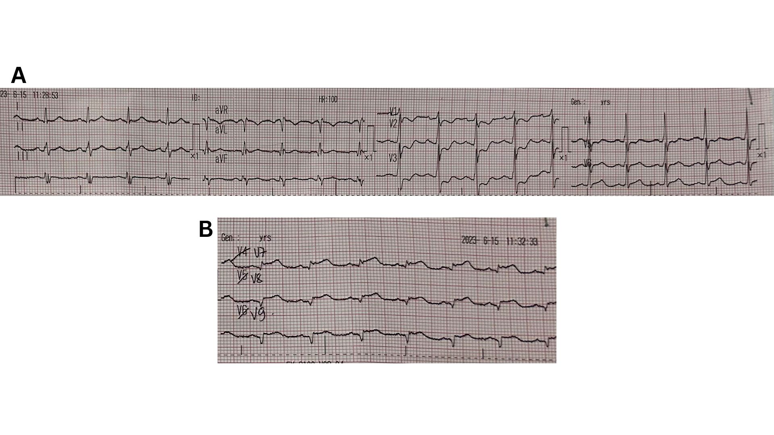

SEVERE AORTIC STENOSIS MIMICKING STE-ACS AT HOSPITAL IN REMOTE AREAS: A CASE REPORT

I. H. Abas¹, F. A. Fabanyo², Fikri³, M. Abubakar³

¹Tidore General Hospital
²Istiana Hairiah Abas
³Cardiology Department, Tidore General Hospital

Background:
Aortic valve stenosis (AVS) is a narrowing of the aortic valve that inhibits blood flow from the left ventricle to the ascending aorta during systole, which can cause symptoms such as chest pain and angina pectoris.

Case illustration:
A 46-year-old man was admitted to the hospital with chest pain and anterior ST segment elevation on electrocardiogram. Given the limited drugs and equipment in remote hospitals, initial treatment for ACS was given immediately. However, no significant improvement was seen with this treatment. An echocardiogram was performed right away and the results showed a severe AVS. B-blockers, ACE-I, diuretics, and MRA antagonists were administered, and the patient had good clinical results, and was recommended for immediate referral to a hospital with primary facilities for valve replacement surgery. This case highlights the need for a comprehensive and accurate physical examination in patients with angina pectoris. Severe AVS can cause subendocardial ischemia, so the clinical findings may correspond to ACS. A thorough physical examination allows us to provide more accurate treatment.

Brief conclusion:
Given this case is quite rare to happen, it is necessary to evaluate additional tools such as echocardiography in the emergency room, especially in remote hospitals, to avoid errors in diagnosis and treatment implementation.

Keywords: interventional cardiology, aortic valve stenosis, left ventricular hypertrophy, coronary artery disease

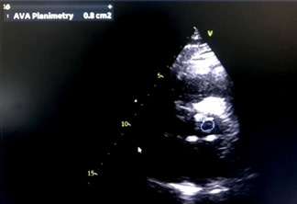

Management Dilemma in Saving Both Mother and Fetus: Deep Vein Thrombosis Due To May-Thurner Syndrome in an Obese Pregnant Patient

K. Paramastri¹, M. L. Benly¹, E. R. Kaminto¹, R. G. Aurora¹

¹Department of Cardiology and Vascular Medicine, FMUI, NCCHK

Background:
May-Thurner syndrome (MTS) is present in over 20% of the population, and is estimated to cause 2-5% of all deep vein thrombosis (DVT) among other risk factors like obesity and pregnancy, but is rarely considered. Studies have shown conflicting results regarding rivaroxaban use in pregnancy.

Case illustration:
A 20-year-old woman, G1P0A0 first trimester, presented<em> </em>with left lower extremity swelling and pain for three months prior. The pain was aggravated after walking and improved with rest.<sup> </sup>No history of lower limbs trauma, neurological deficit, long distance travel, immobilization, surgery, hypertension, and diabetes mellitus. On examination, the patient was grade II obese. Her left lower leg was swollen, tender, erythematous, with varicose veins. She also had an elevated D-dimer. Lower extremity Duplex Ultrasound (DUS) showed partial thrombosis (common femoral vein, superficial femoral vein, left popliteal vein), moderate Chronic Venous Insufficiency (CVI) on both legs, severe CVI (right great saphenous vein (GSV) above the knee). Computed tomography angiography (CTA) revealed compression of left common iliac vein by the right common iliac artery, thrombus (left external iliac vein - left GSV). She was diagnosed with MTS, partial DVT, CVI, obesity, and G1P0A0 1 week gestation and was prescribed clopidogrel and rivaroxaban, with recommendation to consult Obstetricians. Percutaneous Transluminal Venoplasty was unsuitable due to radiation risk. Understanding pregnancy’s physiological and hemodynamic changes is crucial to predict potential complications due to anticoagulant choice.

Brief conclusion:
Patients with complicated DVT with May-Thurner syndrome may require complex decision making regarding pregnancy termination and management, in particular anticoagulant choice. Understanding the physiological and hemodynamics changes in pregnancy is very important, especially in predicting possible complications due to pregnancy that may occur.

Keywords: Chronic Vein Insufficiency, Anticoagulant, May-Thurner Syndrome, Deep Vein Thrombosis, Pregnancy

A Challenge in Managing Heart Failure Associated Hyponatremia: Is It Depletional or Dilutional?

K. V. D. Firondy¹, N. Y. Sari¹

¹Siloam Silampari Hospital

Background:
Hyponatremia is the most common electrolyte abnormality found in heart failure (HF) patients and has been associated with an increased risk of readmission or mortality if left untreated, either it is depletional or dilutional hyponatremia. Therefore, adequate hyponatremia management remains a challenge for clinicians to prevent further deterioration and decrease hospital length of stay.

Case illustration:
An 82-year-old male was admitted to the ED with shortness of breath 1 week before admission. The dyspnea is worsened by physical activities. He is known to have long-standing chronic obstructive pulmonary disease with a history of Coronary Artery Bypass Grafting (CABG) and permanent pacemaker (PPM) insertion 13 years ago, and has been hospitalized several times in the last few months with persistent hyponatremia. Vital signs showed BP 100/60 mmHg, HR 85 bpm, RR 30 times/minute. Rales were found, associated with distended jugular vein and bilateral leg edema. ECG recorded an atrial fibrillation with RBBB. Chest X-ray showed an enlarged heart with pulmonary congestion, aortic elongation, and bilateral pneumonia. The laboratory showed a low hematocrit of 32.7%, creatinine serum of 1.53mg/dL, and severe hyponatremia of 114mmol/dL. Echocardiography revealed heart failure with reduced LVEF 8%, decreased RV function, and severe wall motion abnormality. Serum osmolality and volume status were measured to determine the cause of hyponatremia. Considering the low serum osmolality of 272 mOsm/L and hypervolemic state in this patient, he was then treated with tolvaptan combined with continuous diuretics infusion, fluid restriction of 1500 ml/day, and levofloxacin for pneumonia. An electrolytes examination was undertaken every day. After 5 days of optimal treatment, the laboratory showed a significant increase in sodium level to 135 mmol/dL with clinical improvement in leg edema. Afterward, the patient then discharged with no dyspnea and suggested to control routinely for continuous oral GDMT.

Brief conclusion:
Differentiating the type of hyponatremia in HF is an important step to guide treatment choices because these two types of hyponatremia have different pathomechanisms. A combination of diuretics, fluid restriction, and vasopressin antagonists is a promising treatment for HF patients experiencing persistent hyponatremia who are unresponsive to standard therapy.

Keywords: hyponatremia, heart failure, vaptan

Figure 1. CXR on admission depicting cardiomegaly with pulmonary congestion, aortic elongation, and bilateral pneumonia
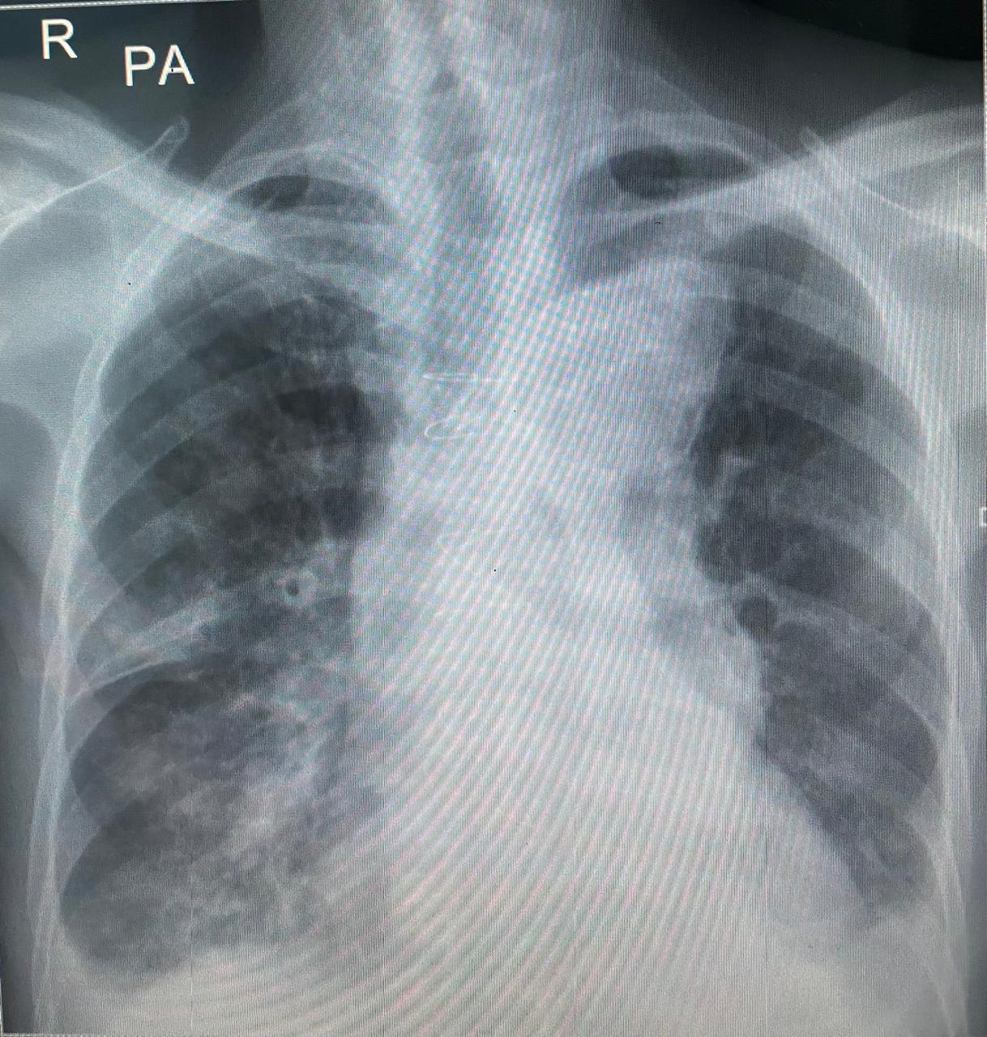

Myocardial Injury After An Electrical Injury : A Rare Complication

K. B. Ginting¹, A. Sitepu²

¹Faculty of Medicine Universitas Sumatera Utara, Medan, Indonesia, Grandmed Hospital, Lubuk Pakam, Indonesia
²Department of Cardiology, Faculty of Medicine Universitas Sumatera Utara, Medan, Indonesia, H. Adam Malik General Hospital, Medan, Indonesia, Universitas Sumatera Utara Hospital Medan, Indonesia, Grandmed Hospital, Lubuk Pakam, Indonesia

Background:
Electrical injuries are a widespread threat in the job and at home. The heart is frequently impacted since the chest is positioned along the path that links the entrance and departure locations because, along with nerves, vascular axes offer the least resistance to electric current flow. Arrhythmias and myocardial tissue damage are the two main cardiac problems found in electrical shock patients. One of the rarest but most deadly effects of electric shocks is myocardial injury. Most patients who experienced myocardial injury after receiving an electric shock had normal coronary arteries found. Therefore, in these circumstances, the etiology of myocardial injury is considered to be unrelated to coronary atherosclerosis but is a direct thermal effect of electrical injury. In our case report, we described a patient who following an electric injury, experienced ventricular fibrillation and myocardial injury.

Case illustration:
We reported a 23-year-old man admitted to our emergency facility with loss of consciousness following an electric shock at his workplace. Patient was diagnosed with electrical burn injury with cardiogenic shock and fell into cardiac arrest. During resuscitation, the patient was also given DC shock due to the presence of ventricular fibrillation. After several attempts of resuscitation, sinus rhythm with ST segment elevation in leads V2-V5 was recorded. Chest x-ray shows cardiomegaly and congestion. On cardiac enzyme examination, there was an increase in CKMB and Troponin T which indicated myocardial injury due to electric shock.The patient was given amiodarone 900 mg to be completed within 24 hours due to a previous history of ventricular fibrillation. The patient was admitted to the Intensive Care Unit (ICU) and required ventilatory support for 3 days, ultimately succumbing to deteriorating condition.

Brief conclusion:
Injuries caused by electric shocks can lead to severe outcomes like irregular heart rhythms and heart attacks. Direct thermal effect should be taken into account as a potential cause of myocardial injury following an electric shock.
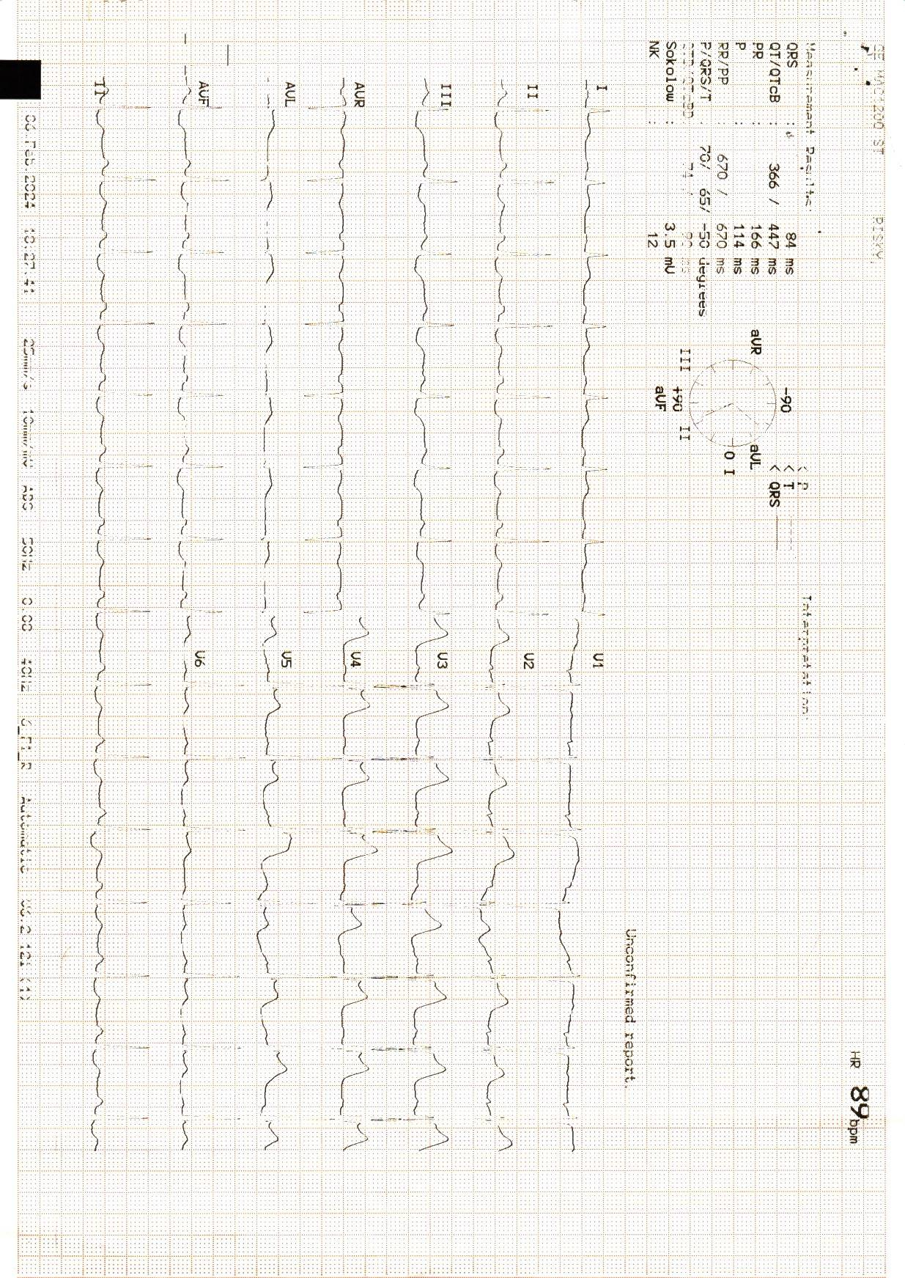

Keywords: Cardiac Arrest, Electrical Injury, Myocardial Injury

ECG revealed sinus rhythm with ST segment elevation in leads V2-V5

A CASE OF CARDIOGENIC SHOCK ET CAUSA INFECTED ENDOCARDITIS ON 19 YEARS OLD WOMAN

L. O. A. Langi¹, A. L. Panda², F. E. N. Wantania¹

¹Department of Internal Medicine, Faculty of Medicine, Sam Ratulangi University
²Division of Cardiology, Department of Internal Medicine, Faculty of Medicine, Sam Ratulangi University

Background:
Cardiogenic shock can be caused by endocarditis. Infective endocarditis is an infection that is localized on the endocardial surface and mostly attacks the heart valves. The prevalence of infective endocarditis is 1.9 to 10 per 100,000 people/year in developing countries. Bacterial colonies in the heart cause valve damage and leakage. Typical lesions are vegetation, namely masses consisting of platelets, fibrin, microorganisms and inflammatory cells. This study aims to report the case, treatment, and outcomes.

Case illustration:
A 19 year old woman came with a complaint of shortness of breath , history of fever, and chest pain. She had a cavity infection in her molars for about 1 month before. Physical examination showed blood pressure 84/55 mmHg with pulse 107 x/minute, respiration 24 x/minute, with normal body temperature, oxygen saturation 99% with oxygen via nasal cannula 3 lpm. Another physical examination revealed a positive heart murmur. Based on the echocardiography performed, an EF of 40% was obtained with severe TR, severe MR, and visible vegetation in the AML. The patient underwent a Transesophageal Echocardiography (TEE) in preparation for valve replacement. During surgery, mitral valve replacement with bioprostetic valve, tricuspid valve repair and vegetation evacuation were performed. After surgery EF is 60-65%. The patient was given the antibiotic Vancomycin for a total of 28 days. The patient experienced complications from Pneumonia and Micosis but then improved with antibiotics and antifungal, and was outpatient after 2 months of treatment.

Brief conclusion:
Infective endocarditis was diagnosed using Duke's criteria. With the main symptom of fever, physical examination reveals a heart murmur in 80-85% of patients. Echocardiography examination reveals decreased valve function and vegetation can be found. Therapy includes surgery and antibiotics. Ejection fraction has been shown to improve after valve replacement. Further observation was needed to determine the long term outcomes.

Keywords: cardiogenic shock, infective endocarditis, valve replacement

PH Crisis Prevention Management in After PDA Closure with Bidirectional Shunt

M. Herbani¹, S. Anjarwani², H. Martini³

¹Cardiology Resident – Dr. Saiful Anwar General Hospital – University of Brawijaya, Malang, East Java, Indonesia
²Intensive Cardiologist – Dr. Saiful Anwar General Hospital – University of Brawijaya, Malang, East Java, Indonesia
³Pediatric Cardiology & Congenital Cardiologist – Dr. Saiful Anwar General Hospital – University of Brawijaya, Malang, East Java, Indonesia

Background:
Pulmonary hypertension still become the most abundant complication of congenital heart disease. PH crisis threatened after bidirectional shunt PDA closure in this patient. Meanwhile, PH crisis therapy itself still not much discussed specifically. This case report will explain how to prevent PH crisis after bidirectional shunt PDA closure.

Case illustration:
A woman, 21 years old with marked limitation of physical activities and relieved by rest, were admitted for transcatheter PDA closure. Right heart catheterization result 3 months prior to admission was PDA type A Bidirectional Shunt, severe pulmonary hypertension with high flow high resistance, and non-reactive to oxygen test. According to ESC 2022 Pulmonary Hypertension guideline four strata risk assessment tool, she was classified to intermediate-high risk. She took Sildenafil (Revatio) 3x20 mg, ramipril 0-0-2.5 mg, bisoprolol 2.5 mg-0-0, spironactone 0-25 mg-0, furosemide 40 mg-0-0 for her routine treatments. PDA closure protocol was undergone with local anaesthesia. After successful closure, pulmonary hypertension were worsen. The PA pressure (169/74/111 mmHg) was higher than AoD pressure (142/108/126 mmHg), even after 60 minutes device occlusion test. PFO dilatation improved pulmonary hypertension condition (PA 129/100/111 mmHg, AoD 114/86/99 mmHg), and procedure was considered successful without clinically fluctuating hemodinamic. For close hemodynamic monitoring, she was admitted to CVCU, and got Iloprost nebulizer 2.5-5 mcg every 2-3 hours for 2-3 days to prevent PH crisis. Peroral Sildenafil dose also increased to 4x20 mg along with other treatment. Two days later, PO Beraprost 2x20 mcg was added. After 5 days down titrate Iloprost nebulizer and stable hemodynamic, the patient were transferred to ward. She done well in her SMWT, and then discharged successfully.

Brief conclusion:
Prostacyclin inhibitor like Iloprost nebulizer and Beraprost peroral should be considered in intermediate-high risk patient. This agent can be advantageous especially combined with Phospodiesterase 5 inhibitor in preventing PH crisis after PDA closure.

Keywords: sildenafil, PDA closure, iloprost, PH crisis, intermediate-high risk

A rare case of acute perimyocarditis following herpes zoster infection

M. A. W. Utomo ¹, I. Noersyid¹

¹RSUD Kabupaten Bekasi

Background:
Perimyocarditis is an inflammation of both pericardial layer and muscular layer of the heart. Both can appear together in clinical practice and viral infection is the most common etiology. The term perimyocarditis is used when pericarditis symptoms occur simultaneously with marked evidence of reduced ventricular function and regional wall motion abnormalities. Diagnostic work-up in rural areas is challenging due to variable clinical presentation resulting in frequent misdiagnosis with subsequent increased morbidity and mortality.

Case illustration:
A 63-year-old woman presented to the emergency room of Bekasi District General Hospital with complaints of worsening chest pain and shortness of breath since one day prior. She also had a high-grade fever and erythematous skin lesion in her left inner thigh since 3 days prior which was thought to be caused by cellulitis. Her ECG showed diffuse ST elevations in precordial leads and the laboratory result showed leukocytosis and thrombocytopenia. Echocardiography found reduced LVEF of 32%, global hypokinetic wall motion, pericardial effusion and thickening. The patient was admitted to ICU because of worsening dyspnea and decreased consciousness caused by hypoxia. Further skin examination by a dermatologist suggests that the erythematous skin lesions were most likely a herpes zoster infection. A diagnosis of viral perimyocarditis was made, followed by treatment with NSAID and antiviral medications. After 11 days of treatment, the patient was discharged with significant improvements.

Brief conclusion:
Early diagnostic work-up integrating clinical judgment and concurrent tests is as important as starting immediate empirical therapy for a patient’s improvement and prognosis of myocarditis. Echocardiography is pivotal as a first-line imaging test, especially in rural areas.

Keywords: myocarditis, rural, Pericarditis, acute, herpeszoster

Echocardiography showed pericardial thickening, pericardial effusion with reduced left ventricular ejection fraction and global hypokinetic wall motion.
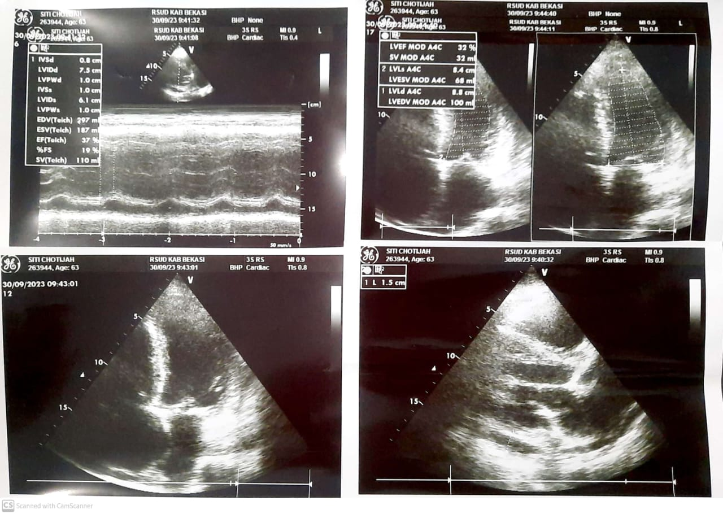

Reversibility of Total Atrioventricular Block with Pharmaco-invasive Reperfusion Strategy in Acute Inferior ST- Segment Elevation Myocardial Infarction with Cardiogenic Shock in Rural Hospital

M. A. R. M. Sitepu¹, A. Resdiani², T. M. Aprami³

¹RS Bhayangkara Setukpa
²RS Kartika Kasih
³RS Primaya Sukabumi

Background:
Total Atrioventricular Block (TAVB) is a common complication of ST-Elevation Myocardial Infarction (STEMI). This complication has been decreased significantly (up to <5% in incidence rate) in the era of PCI with early reperfusion. TAVB that associated with acute inferior STEMI is usually originate from supra-Hisian and may be related to increase vagal tone (Bezold-Jarisch reflex) or transient AV nodal ischemia. Patients who develop AV block in the setting of STEMI have higher mortality rates compare to STEMI without AV block. Reperfusion as early as possible remain the gold standard and is associated with early recovery of AV block. In this case report, we presented a patient with acute inferior STEMI with complication of Total AV Block and cardiogenic shock and how to manage despite limitation in hospital’s facility.

Case illustration:
A 58-year-old male heavy smoker had sudden onset of severe retrosternal chest pain (VAS 7/10) 2 hours before admission. He appeared lethargic with blood pressure was 80/60 mmHg, heart rate was 37 bpm, and cold extremities. Evidence of inferior ST-segment elevation, lateral ST segment depression and TAVB was revealed on his electrocardiogram (ECG). Streptokinase was given as part of a pharmaco-invasive reperfusion strategy and deemed as successful fibrinolytic. He was then referred to higher center for early PCI. The patient’s angiography revealed subtotal occlusion at proximal with thrombus and 50% stenosis at distal in the right coronary artery which was successfully stented. His hemodynamic was stable post angiography.

Brief conclusion:
Early reperfusion therapy is related to early recovery and very important to improve outcome in patients with acute inferior STEMI with complication of TAVB. Primary Percutaneous Coronary Intervention (PCI) is the preferred reperfusion strategy for STEMI and has been shown to reduced mortality, reinfarction, and stroke. However, in the case of limited facility, pharmaco-invasive strategy was a potential complement for primary PCI.

Keywords: Complication of Inferior STEMI, Total Atrioventricular block, Pharmaco-invasive strategy., Inferior ST-elevation Myocardial infarction

Upper picture : Inferior STEMI with TAVB. Lower picture: post fibrinolytic ECG
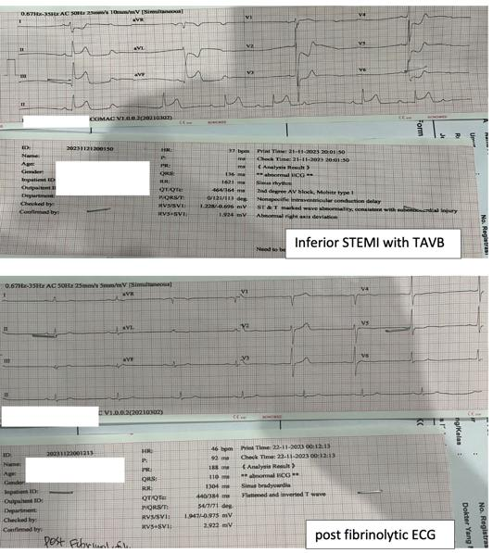

Fibrinolytic therapy in ST-segment elevation myocardial infarction with T2DM hyperglycemic state: a case report

M. D. Prakasa¹, R. Handayani¹

¹RS Urip Sumoharjo

Background:
ST-segment Elevation Myocardial Infarction (STEMI) is the most serious type of Acute Coronary Syndrome (ACS). Fibrinolytic Therapy (FT) is the recommended guideline in STEMI if the primary Percutaneous Coronary Intervention (PCI) cannot be performed. Acute hyperglycemia on admission with Acute Myocardial Infarction (AMI) is shown worse prognosis.

Case illustration:
A 58-year-old man, an active smoker, arrived at ED with 11 hours of progressive typical chest pain before admission, accompanied by diaphoresis and nausea. He had a history of heart attack and T2DM 5 years ago and has poor compliance in therapy. Examination showed stable vital signs and no signs of kusmaul breathing. The electrocardiogram revealed anterolateral STEMI, laboratory data showed an increase of CK-MB at 1075 U/L and blood glucose level of 416 mg/dL. Fibrinolytic was chosen due to the hospital’s incapability for Primary PCI and the golden period remaining time. Aggressive and careful treatments in managing coronary reperfusion, blood glucose level, and preventing serious adverse events were given simultaneously. After the treatments in intensive care, the patient showed adequate responses, the typical chest pain and ST-segment elevation decreased significantly suggesting successful reperfusion and the blood glucose level decreased progressively, the patient was transferred to the cardiac center in the central hospital.

Brief conclusion:
The main goal of STEMI management is rapid reperfusion.Hyperglycemic STEMI patients on admission had a higher mortality rate. There are numerous potential pathophysiological mechanisms by which hyperglycemia may impact toxicity during myocardial ischemia. Aggressive, simultaneous, and careful treatments in hyperglycemic STEMI are important and need more attention due to higher mortality rates and worse prognoses.

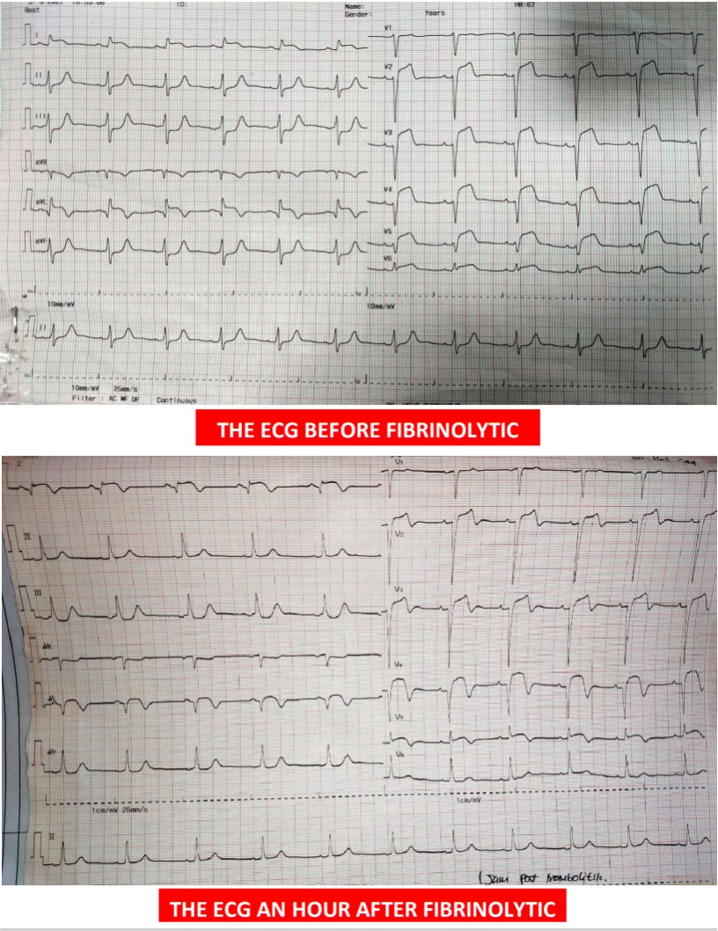
Keywords: Fibrinolytic, Hyperglycemia, STEMI

The evolution of patient's 12 lead ECG before and after the fibrinolytic

ST Elevation Myocardial Infarction in Young Adult With High Thrombus Burden : A Case Report

N. M. Kumawardhani¹, H. Zulkarnain¹

¹Helsa Jatirahayu Hospital

Background:
ST segment elevation myocardial infarction (STEMI) is associated with significant mortality leading to loss of productive life years, especially in younger patients. The incidence of AMI in young people has recently begun to rise by increased prevalence of risk factors such as smoking. The incidence of thrombosis during myocardial infarction is known as high thrombus burden. This case report revealed that STEMI can occur in young adult leading to high thrombus burden.

Case illustration:
A 32-year-old man Came to our Emergency Department (ED) due to chest pain in the left side radiating to the back. This symptoms occurred 5 hours before arrived at ED. They were severe, continuous, and with cold sweat. The patient complained for a second episode of left side chest pain. Since junior high school, the patient had a history of smoking one boxes of cigarettes every day and e-cigarette, with family history of a cardiac arrest. A physical and laboratory examination were conducted with cholesterol LDL resulted high. The first showed a sinus rhythm without any evidence of ST elevation, the second ECG was taken after the second symptom occurred, revealed ST elevation in V2-V3, T-Inverted in I, aVL, V2-V5. Echocardiograph resulted in <em>Regional Wall Motion Abnormality </em>(RWMA) at anterior segmen. Coronary angiography revealed total occlusion at proximal LAD with high thrombus burden, After performing a thrombus aspiration five times with a thrombuster, total occlusion at the proximal LAD with a high thrombus burden was discovered. Two doses of a GPIIb inhibitor (ebatid 7,3 ml) were then administered, and stenting implantation using DES 3,5X32 mm with TIMI 3 flow was carried out.

Brief conclusion:
STEMI in young adult is rare, but the incidence of AMI in young people has recently begun to rise by increased prevalence of risk factors such as smoking and STEMI in young adult still requires PCI.

Keywords: Risk Factor, High Thrombus Burden, ST Myocardial Infarction, Young adult

Figure.1 Coronary angiogram findings, caudal view. (a) Pre-PCI. A 100% occlusion at proximal LAD is confirmed. (b) Post-PCI. PCI: percutaneous coronary intervention.
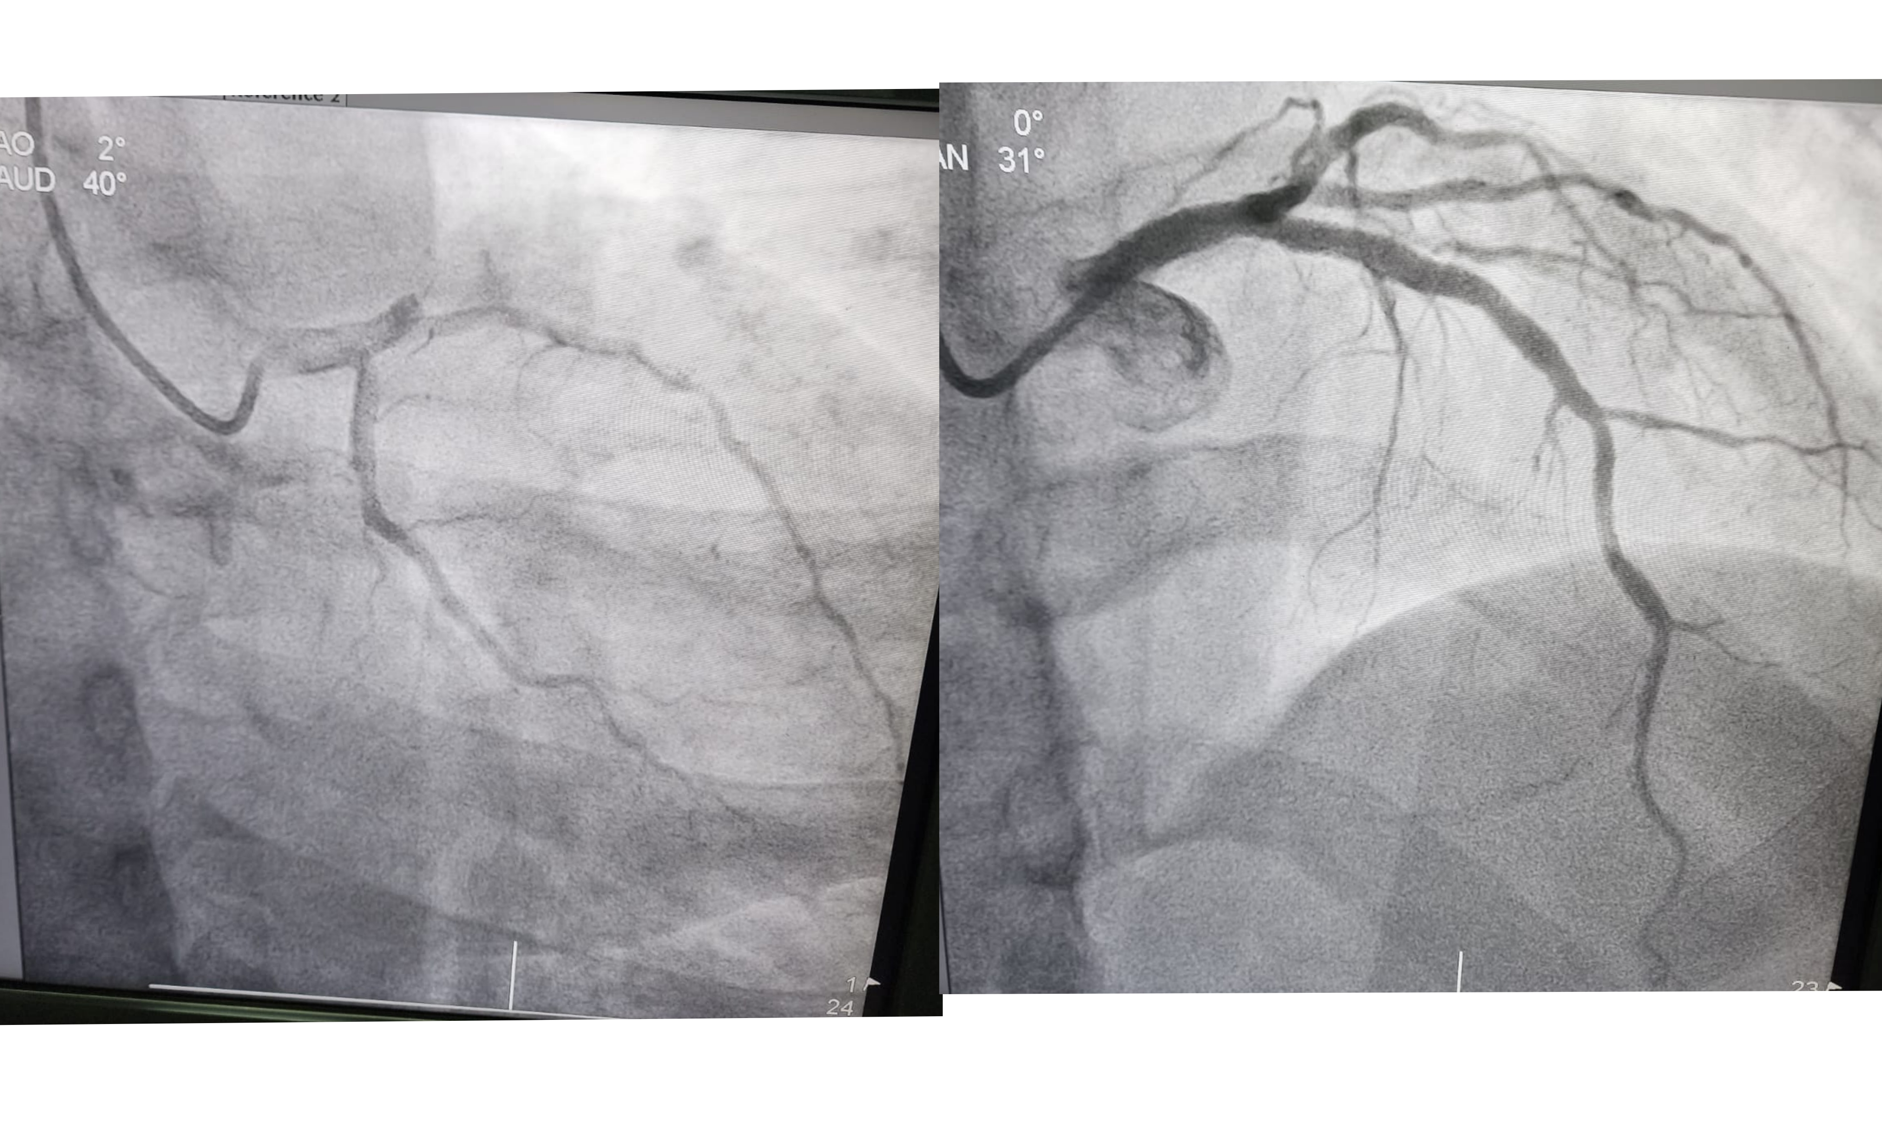

New Onset of Conduction Disturbance in Antero-Extensive ST Elevation Myocardial Infarction : How Lethal It Would be?

N. V. Riana¹, A. P. Suwirya¹

¹RSUP Prof IGNG Ngoerah

Background:
ST-elevation myocardial (STEMI) is frequently associated with conduction disorders. New right bundle branch block is associated with multi-vessel disease. Most conduction disorders associated with STEMI are reversible with reperfusion therapy, but may still impair prognosis because they indicate large area at risk, extensive myocardial infarction or severe coronary artery disease.

Case illustration:
A 52 years old male referred from private hospital with chest pain since 4 hour prior to admission. Initial ECG at the private hospital showed ST elevation in lead V2-V6, I, avL, indicating antero extensive. Evaluation ECG in Prof Ngoerah Hospital showed new onset RBBB. The patient diagnosed with STEMI Antero-extensive Killip I, Onset 4 hr, TIMI 5/14, EF BP 49%, RWMA (+). We decided to do fibrinolytic for the patient, with successful result. But in the morning, the patient complaint recurrent chest pain and we decided to do rescue PCI. After the patient got stabilized, we admit the patient to ICCU ward.

Brief conclusion:
A new or presumably new left bundle branch block or right bundle branch block may reflect a large territory of acute ischaemia involving the proximal conducting system or diffusely damaging the ventricular myocardium leading to delayed conduction, while at the same time due to the bundle branch block the STE may be concealed. The occurrence of new permanent RBBB in patients with new onset STEMI may serve as a significant warning sign and be applied as a useful risk stratifier for a new high risk onset STEMI in patients who underwent PCI. Patients with RBBB showed more obvious clinical manifestations such as angina, tachycardia, higher Killip and New York Heart Association class. The presence of RBBB in patients with AMI is associated with an increased risk for mortality, makes it a potential marker of prognosis in coronary atherosclerotic disease.

Keywords: Right Bundle Branch Block, Acute Coronary Syndrome, Conduction Disorders

AMI-CS With Right Bundle Branch Block Pattern in A Patien with Total Occlusion of LMCA: A Case Report

N. Prananda¹, A. Sitepu²

¹Faculty of Medicine Universitas Sumatera Utara
²Department of Cardiology, Faculty of Medicine Universitas Sumatera Utara, Medan, Indonesia, H. Adam Malik General Hospital, Medan, Indonesia, Grandmed Hospital, Lubuk Pakam, Indonesia

Background:
ST-elevation myocardial infarction (STEMI) patients with right bundle-branch block (RBBB) have worse prognosis than those without RBBB. The RBBB itself is more vulnerable to damage due to its anatomic nature as a superficial branch with limited blood perfusion compared with the left bundle branch block (LBBB) This case presents the significance of the association of new RBBB with total occlusion of LMCA complicated by development of cardiogenic shock.

Case illustration:
We present a case of a 49-year-old male who admitted with pain on his left chest that he had 5 hours before he entered Emergency Departments. Upon arrival, the patient appeared anxious and diaphoretic. On primary survey, His vital signs were as follows: blood pressure 73/47 mmHg, heart rate 104 bpm, respiratory rate 26/min, and oxygen saturation 95% on room air. Due to his worsening condition, the patient was then put on a ventilator. Cardiac auscultation revealed regular rhythm with RBBB pattern on electrocardiogram (ECG). His ECG on arrival showed complete RBBB with ST-segment elevation in V4-V6 . Cardiac biomarkers showed an initial CK-MB value of 444,90 ng/mL, and troponin I value of >2000 ng/mL. The patient was taken for an Primary PCI that revealed a 100% obstruction in his Left Main Coronary Artery. The procedure was complicated by the development of cardiogenic shock. A successful primary PCI was performed with Drug Eluting Stent from ostial LM to proximal LAD and Eptifibatide (GPIIB/IIIA Inhibitor) 15 mg intracoronary injection. Although the primary PCI was success, patient was declared death in the afternoon due to his worsened condition.

Brief conclusion:
STEMI with RBBB presents a diagnostic and therapeutic challenge due to the atypical ECG findings. However, prompt recognition and treatment with reperfusion therapy, such as PCI, are essential for improving outcomes in these patients. The role of Mechanical Circulatorry Supprot (MCS) is also very important to reduce mortality in these patients, unfortunately the health facility where the patient was treated did not yet provide it.

Keywords: electrocardiogram, total occlusion, STEMI, AMI-CS, RBBB

Double-edged sword for management of acute coronary syndrome coincides with an acute cerebrovascular incident: cardio-cerebral infarction syndrome.

N. N. Triatmojo¹, L. H. Zunardi¹, S. Anjarwani¹, I. Prasetya¹

¹Saiful Anwar Hospital

Background:
Acute ST-elevation Myocardial Infarction (STEMI) and acute Cerebrovascular Accident (CVA) are both very serious medical conditions that can be life-threatening if they are not handled right away. A very small chance of 0.009% for this event to happen at the same time has been recorded. There is a lot of information in the literature and standards about how to treat each illness separately. However, when both illnesses happen at the same time, it makes therapy more difficult. Because of the higher chance of making the bleed worse, the standard treatment for STEMI (revascularization and antithrombotic therapy) shouldn't be used on people with CVA especially CVA haemorrhage. There is a chance that directly treating one illness could make it harder to treat the other or even be damaging.

Case illustration:
An abrupt obstruction of blood flow due to STEMI inferior and RV infarction was encountered by a 70-year-old male. Less than a week ago, he had an acute CVA with an aphasic presentation. It is very important to determine whether the CVA is an infarction or a haemorrhage, because it will influence the decision to use anti-platelets and anti-coagulants. Because this illness is so rare, no treatment techniques were suggested. After ensuring the patient did not experience CVA haemorrhage using a CT scan, he was given a loading dose of DAPT, an intravenous anticoagulant, and then underwent primary PCI. Following an acute cardio-cerebral infarction, utilizing the PCI method for mechanical reperfusion may be the optimal approach to restoring normal blood flow. The patient's chest pain was relieved, and there was no worsening of CVA symptoms after treatment.

Brief conclusion:
The occurrence of both STEMI and CVA at the same time is uncommon, but when these two prevalent disorders do occur together, it poses a distinct therapeutic difficulty. it is essential to carefully assess the patient's condition, weigh the risks and benefits of different treatment options, and tailor the treatment plan to the patient's requirements. PCI should be reasonable approach in treating patients with simultaneous cardio cerebral infarction Despite being rare, this demanding situation warrants greater acknowledgment and deliberation among the medical professional.

Keywords: cerebrovascular accident, Acute coronary syndrome, Cardio Cerebral Infarction

Hyperkalemia, The Great Imitator, Mimicking de Winter T-Wave and ST-Segment Elevation in pseudo-STEMI Patient: Which Treatment Strategy to Use?

N. A. Pratiwi¹, T. Srimulyo¹

¹Nirmala Suri Hospital

Background:
De Winter ECG pattern is considered an equivalent risk to ST-elevation myocardial infarction (STEMI), requiring immediate revascularization. The peaked T-waves can be confused with hyperkalemia, an electrolyte abnormality necessitating urgent intervention.Though infrequent, untreated hyperkalemia may present as ST-segment elevation on an ECG. The proposed mechanism is that elevated levels of potassium shorten the action potential in phase three repolarization resulting in ST-segment elevation.This study aims to raise awareness of symptomatic acute hyperkalemia with ECG findings mimicking myocardial infarction in order to administer correct therapy and prevent unnecessary coronary interventions.

Case illustration:
A 52-year-old male was admitted to our emergency department of type C hospital with a complaint of crushing chest pain persisting for 3 days worsening an hour prior, accompanied by nausea, cold sweats, and vomiting. The ECG upon admission showed ST-segment elevation in V1-V3. Upsloping ST-depression and peaked T-waves were present in V5-V6 which resembled de Winter pattern, and potentially concealed hyperkalemia. Downsloping ST-depression were seen in the inferior leads. Cardiac enzyme examinations were not carried out due to inadequate facilities.Abnormal laboratory findings were hyperkalemia (7.72 mmol/L) and increased creatinine (8.98 mg/dl). Primary PCI or angiography can not be performed because of elevated creatinine levels. We made approaches to treat this patient with unstable angina and hyperkalemia. He was given dual antiplatelet therapy of aspirin and clopidogrel, intravenous anticoagulant, nitroglycerin, and statin. We admitted him in our ICU and consulted the internist. Serum potassium levels was being corrected and creatinine levels returned back to normal (0.79 mg/dl). On serial ECG, ST-elevation and peaked T-waves were resolved. Echocardiography showed no sign of wall motion abnormalities. The patient covered 504 meters on 6 minutes walk test. We carefully discharged him after another serial ECG disclosed no worrying pattern.

Brief conclusion:
Quick evaluation of serum potassium levels in this scenario saved the need for unnecessary catheterisation lab activation and more importantly, averted the patient from malignant arrhytmia in case of treatment delay. Aggressive treatment of hyperkalemia resulted in successful reduction of serum potassium level. Notably, ECG pattern reverted back to baseline without any evidence of pseudoinfarction pattern.

Keywords: ST-segment elevation, Pseudo STEMI, de Winter, peaked T-wave, Hyperkalemia

ECG upon admission and after potassium correction
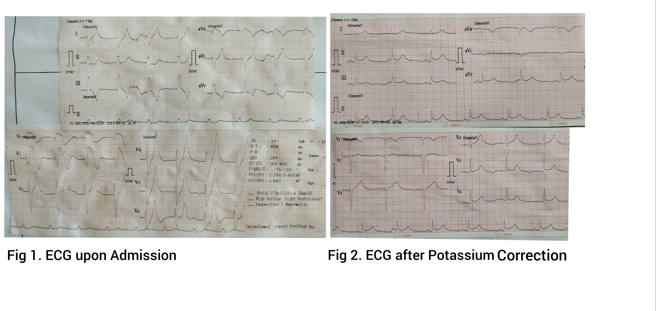

The Yin and Yang of Acute Thrombosis and Acute Bleeding : NSTEMI Complicating with Hypovolemic Shock due to Acute Gastrointestinal Bleeding

N. R. Ma'shum¹, A. F. Muzakkir¹, Z. Djafar¹

¹Department of Cardiology and Vascular Medicine Faculty of Medicine, Hasanuddin University, Dr.Wahidin Sudirohusodo Hospital

Background:
Acute Coronary Syndrome (ACS) is caused by plaque rupture, platelet activation, and thrombus formation leading to coronary occlusion and heart muscle damage. Patients with NSTEMI usually have more cardiac and non-cardiac comorbidities. Recent analyzes and randomized controlled trials have demonstrated an independent association between bleeding complications, blood transfusion, and poor outcomes in ACS patients. Identifying patients at high bleeding risk is also very important in reducing bleeding complications in the treatment of ACS. The occurrence of bleeding complications has been shown to be an independent predictor of death from ACS. Active gastrointestinal bleeding can cause large blood volume loss and can lead to a condition of hypovolemic shock.

Case illustration:
Our patient is 61 years old man was admitted to Cardiac Center Emergency Room with typical chest pain felt since 3 days ago. The patient has a history of taking anti-pain medication for 2 years to relieve back pain due to Lumbar Spinal Spondylosis. The patient history has treated from previous referral hospital with loading aspilet 160 mg, clopidogrel 300 mg. From physical examination we found conjunctiva anemic, BP 80/50 mmhg, HR 110 bpm, Rectal Touche: black stools with soft consistency. Laboratory examination showed a decrease in hemoglobin from 13.5 g/dl to 5.9 g/dl. We decided to administer of fluid resuscitation with Nacl 0.9% 2000 cc + Gelofusin 500 cc loading/intravenous, blood transfusion and postponed of antithrombotic and anticoagulant drugs. Atorvastatin 40 mg oral, Lansoprazole 60 mg intravenous, maintenance 6 mg/hour/Syringe Pump also given. Gastrointestinal bleeding still occurs, the patient does not undergo definitive treatment in the form of endoscopy or surgery.

Brief conclusion:
Through this case, we can know how important to manage ACS patients who are accompanied by acute gastrointestinal bleeding with manifestations of hemodynamic disorders. Mortality due to acute bleeding in NSTEMI cases is reported to be quite high and is associated with a poor prognosis.

Keywords: NSTEMI, Hemodynamic Disorders, Acute Gastrointestinal Bleeding, Hypovolemic Shock

Early Mobilization Using 6-Minutes Walking Test Method to Reduce Length of Stay in Post PCI Patients

B. Nugroho¹, D. Puspita²

¹RS Awalbros Pekanbaru

Background:
The quality of life and prognosis of patients with cardiovascular disease is importand, and recommended to be evaluated, which is evaluated through measuring fungtional capacity of the pasients. The 6-minutes walking test is a simple and reliavle non-invasive method fot measuring the fungtional capacity which has previously been widely applied for people with lungdisease and heart failure. Currently, its use continues to be developed to patients after Acute Coronary Syndrome (ACS). This exercise can be done early, besides its effectivity to determining the type of activity and what exercise can be done for patients at home. It can also provides predictions of motbidity and mortality in certain cases of acute coronary syndrome.

Case illustration:
Early mobilization using 6-minutes walking test method inpost PCI patients in CVCU ward to reduse length of stay.

Brief conclusion:
6-minutes walking test is recommended for every stable post-ACS patient who has no contraindications before discharge from the hospital. This method is a safe, simple, cheap and useful test for measuring funtional status, response to therapy and as a predictor of morbidity and mortality in Post ACS patients.

Keywords: PCI, length of stay, Acute coronary syndrome, 6-minutes walking test

Polymorphic ventricular tachycardia triggered by negative emotion and acute severe pain: a case report

P. Siregar¹, A. E. Prasetia²

¹General Practitioner, Putri Hijau Hospital
²Cardiologist, Putri Hijau Hospital

Background:
Pain is an unpleasant sensory and emotional experience associated with actual or potential tissue damage. Severe or acute pain can activate the body's stress response, leading to the activity of the sympathetic nervous system and the release of stress hormones like adrenaline (epinephrine). These hormones can affect the heart's electrical activity and lead to an increased heart rate and changes in heart rhythm, potentially triggering arrhythmias in susceptible individuals. The relationship between pain and arrhythmia may vary with each individual. Some people may be more sensitive to the stress caused by pain, while others may have a higher threshold before an arrhythmia is triggered. Catecholaminergic PVT is typically presented with syncope and is more common in adolescents and children. This arrhythmia is triggered by emotional or physical stress and is usually familial.

Case illustration:
A 50-year-old man, came to the emergency room with complaints of heart palpitations accompanied by chest pain. The patient was undergoing tooth extraction which previously local anesthetized using 1 ampoule lidocaine. At the time of the tooth extraction process, the patient suddenly complained of severe pain in the extraction wound so the patient felt anxious, frightened, and panicked. The patient felt heart palpitations, cold sweat, lightheadedness, left chest pain, and nausea. The electrocardiography was performed and showed a polymorphic ventricular tachycardia waveform as shown in Figure 1. After spontaneous return, the ECG did not show any QT Prolongation. Electrolytes and Troponin I were within normal limits. The history of heart disease in the patient and the family was denied and there was no history of previous drug use.

Brief conclusion:
This case demonstrates that patients without even a history of heart disease can still experience brief episodes of polymorphic ventricular tachycardia. The catecholamine response as a result of severe pain and acute stress, is suggested to be the underlying mechanism of the polymorphic ventricular tachycardia in this case. Doctors need to be aware of the potential impact of severe pain and stress on patients, especially individuals with known heart conditions, or those at risk of arrhythmia.

Keywords: Polymorphyc Ventricular Tachycardia, pain, case report, negative emotion

Figure 1. Electrocardiogram showing during PVT (1) and after spontaneous return. (2)
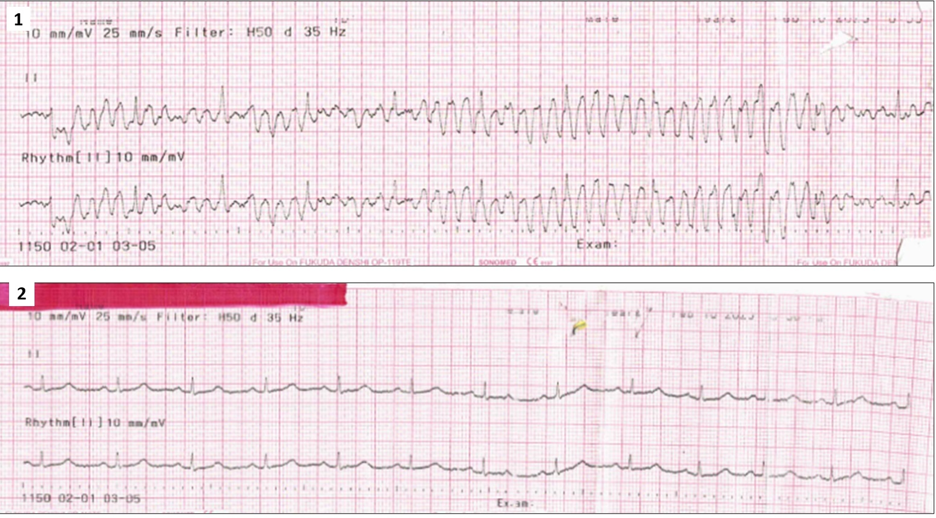

Rapid, New-onset Atrial Fibrillation Following Noncardiac Surgery in A 70-Year-Old Male with Decreased Left Ventricular Ejection Fraction and Insulin-dependent Diabetes Mellitus: A Case Report

P. T. P. Pinatih¹, H. Wirawan²

¹Resident of Cardiovascular Medicine, Department of Cardiology and Vascular Medicine, RSUP Prof. dr. I.G.N.G. Ngoerah/FK Universitas Udayana, Denpasar, Indonesia
²Department of Cardiology and Vascular Medicine, RSUP Prof. dr. I.G.N.G. Ngoerah/FK Universitas Udayana, Denpasar, Indonesia

Background:
Atrial fibrillation (AF) is the most common arrhythmia in clinical practice. Postoperative AF (POAF) could happen after cardiac or noncardiac surgery, and is associated with adverse cardiovascular outcomes.

Case illustration:
A 70-year-old male was consulted from orthopaedic surgery department for pre-operative evaluation, following a fractured left femur and planned for cephalomedullary nailing. The patient had no history of exertional chest pain, dyspnea nor edema. No history of diabetes, hypertension, nor smoking. Physical examinations were within normal limits. Laboratory results were remarkable for a blood glucose of 351 mg/dL and HbA1c of 11.4%. Electrocardiogram showed normal sinus rhythm without ST-T changes. Echocardiography found decreased ejection fraction of 40.3% with regional wall motion abnormalities, grade I diastolic dysfunction and mild aortic regurgitation. The patient was assessed with chronic heart failure due to suspected coronary artery disease, and treated with ramipril, bisoprolol, spironolactone, simvastatin, as well as subcutaneous insulin. Aspirin was planned after surgery. The patient then underwent surgery as planned. The morning after surgery the patient was found to have a rapid, irregular heartbeat. 12-lead ECG showed AF with rapid ventricular response (~178 bpm) and episodes of abberancy. A rhythm control strategy was initiated with amiodarone IV bolus, followed by IV infusion as per protocol. The hemodynamics and ECG were closely monitored. Electrolyte testing found mild hypocalcemia (8.3 mg/dL corrected for hypoalbuminemia), hypokalemia (3.46 mmol/L) and hyponatremia (130 mmol/L). Thyroid function was normal. The AF was resolved into sinus ryhthm the following morning. The patient was then given oral amiodarone, discharged and planned for cardiology outpatient visit, for further diagnostic testing as well as initiation of oral anticoagulation. Patients with POAF after noncardiac surgery had worse prognosis than after cardiac surgery. In contrast with POAF after cardiac surgery, which is mostly caused by local inflammation and injury following surgery, the mechanism underlying POAF after noncardiac surgery is less well-defined, and is most likely multifactorial and systemic in nature.

Brief conclusion:
POAF after noncardiac surgery carrie a significant adverse outcome. Proper diagnosis and management is required to prevent adverse cardiovascular events in these patients.

Keywords: postoperative, rhythm control, atrial fibrillation, noncardiac surgery

ECG of the patient on the morning following surgery, showing rapid atrial fibrillation with episodes of abberancy.
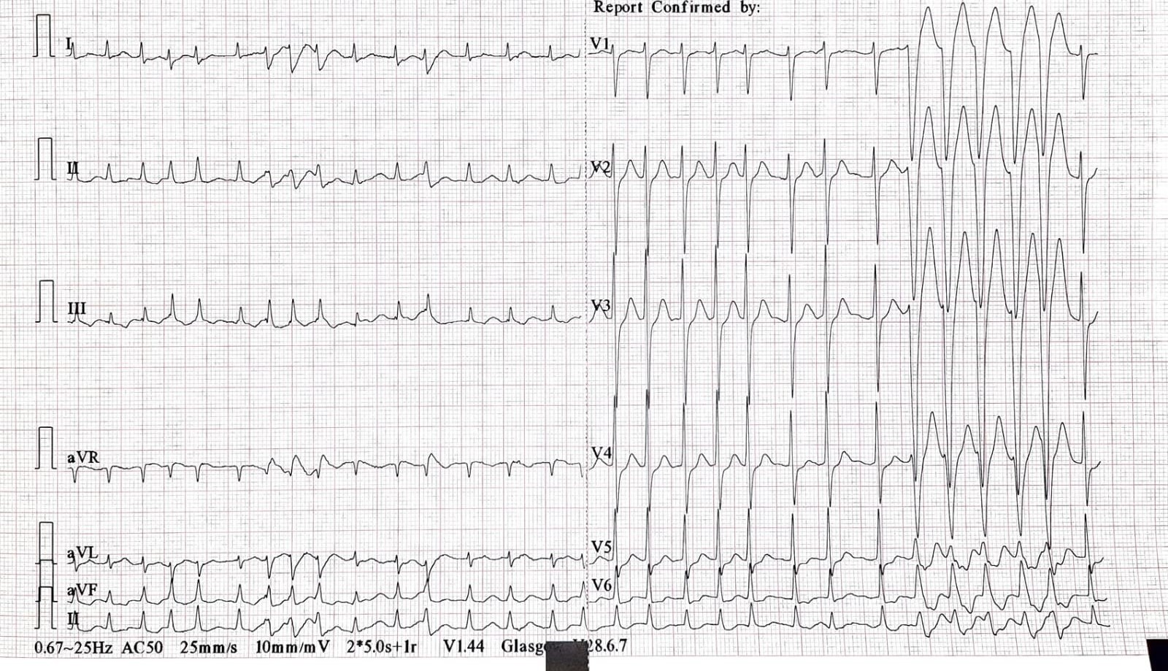

A Judicious Decision in Dealing Ventricular Septal Rupture After Late Onset of STEMI with Cardiogenic Shock in 44-Year-Old Man

S. Rahma¹, E. Ruspiono², A. Wibisono², T. Astiawati², A. W. Nugraha², F. S. Laitupa²

¹General Practitioner of Dr. Iskak General Hospital, Tulungagung, Indonesia
²Cardiologist of Dr. Iskak General Hospital, Tulungagung, Indonesia

Background:
ST-elevation myocardial infarction (STEMI) with dyspnea presentation and murmur should be ruled out promptly whether it’s a structural disease or mechanical complication after myocardial infarction. We present a rare case of anterior extensive STEMI with deadly complications which highlight our decision as a workup treatment.

Case illustration:
A-44-year-old overweight Javanese man was referred to our hospital with shortness of breath dating back 4 days and gradually worsened in 4 hours prior. He also had ongoing typical chest pain within 4 days and cough. He was a smoker and had hypertension. The physical examination revealed unstable hemodynamic, basal bilateral rales, and grade 4/6 holosystolic murmur over the left sternal border. Electrocardiogram showed ST-segment elevation in lead V1-V5. The laboratory test was leukocytosis, increased D-Dimer and positive cardiac enzyme, with Chest X-Ray indicating heart failure. The transthoracic echocardiography (TTE) revealed 43% LVEF and Ventricular Septal Rupture (VSR) 1-1.3 cm. He was diagnosed with STEMI Anterior extensive Killip IV and VSR. Percutaneous coronary intervention (PCI) and surgical repair wasn’t performed. He got injected of Enoxaparin 2x60mg for 5 days, Furosemide 3x40mg, Dobutamine, Norepinephrine, and oral Aspirin 1x80mg, Ticagrelor 2x90mg, Atorvastatin 40mg, Diazepam 1x2mg, and Lactulose syrup. Unfortunately, the patient died on day-15 of hospitalization. High mortality rate in VSR following myocardial infarction (MI) is around 20-50%. Earlier TTE is important to recognize whether the holosystolic murmur is a Mitral Regurgitation or left to the right shunt due to VSR following STEMI. The PCI and surgical closure for VSR must be in good hemodynamic. Therefore, the wise decision for this patient is to maintain the hemodynamically stable with adequate treatment to improve the survival rate and deter poor outcomes.

Brief conclusion:
Late onset and massive STEMI are risk factors for mechanical complication after STEMI. Earlier TTE is important to recognize VSR following MI. Hence, it’s a challenge to choose appropriate and wise-treatment for VSR after STEMI whether surgical repair or palliative care, which suit patient hemodynamic stability and to improve survival rate

Keywords: Mechanical complication, Cardiac Intensive Care Unit, ST-Elevation Myocardial Infarction, Ventricular Septal Rupture

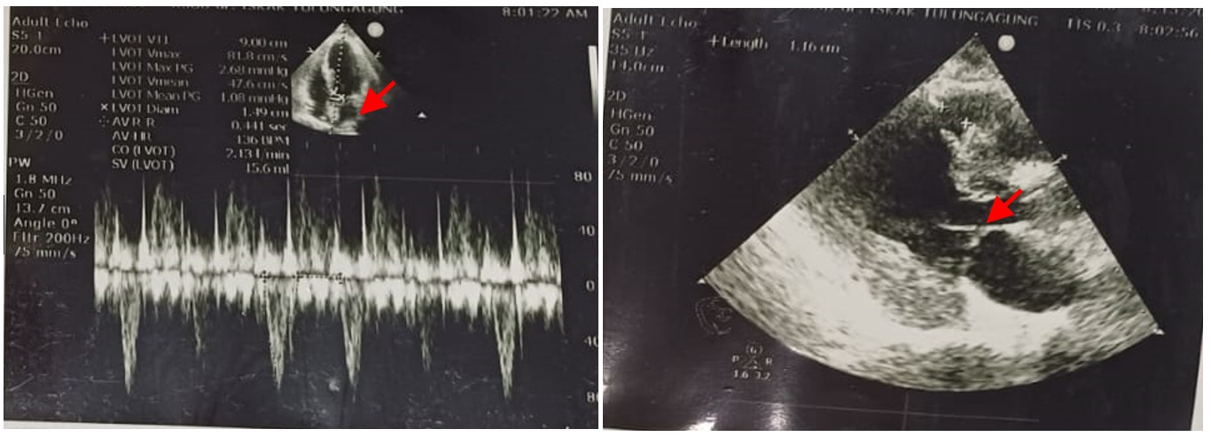

Rotablator Use with or without IVUS in Patients with Significant Stenosis and Severe Calcification: A Case Report

S. Qonitah¹, M. P. L. Toruan¹, Irwan¹

¹Mohammad Hoesin Hospital Palembang

Background:
Severe coronary artery calcification (CAC) increases the complexity of percutaneous coronary intervention (PCI) by inhibiting optimal stent expansion, leading to an increased risk of death, myocardial infarction, repeat revascularization, and stent thrombosis. Coronary atherectomy modifies and debulks calcified plaque to facilitate PCI. RA can be performed with or without IVUS, based on previous study use of IVUS is associated with lower long-term mortality, MI, and repeat.

Case illustration:
A 63-year-old male with Stable Angina Pectoris CCS III, EF 39%. LM stenosis 70% at distal to LAD, LAD stenosis 70-80% at proximal to mid and diagonal stenosis 90% proximal, circumferential calcium > 270; length of calcium > 5 mm; calcified nodule; diameter 1.83 mm, IVUS calcium score 4. Rotbalation was performed from distal LM to LAD using rotapro 1.5 mm, 3 run, speed 180.000 rpm. PCI 1 stent at osteal LAD-LM 3.0 x 38 mm and 1 stent at proximal – mid LAD 2.5 x 32 mm. A 66-year-old male with Sateble Angina Pectoris CCS III and CHF Fc II with EF 42%. LM distal stenosis stenosis 60%, LAD Stenosis 80% at mid, 60% at distal, LCx stenosis 40% at osteal, circumferential calcium > 270; length of calcium > 5 mm; calcified nodule; diameter 3,5 mm IVUS calcium score 3. Rotbalation was performed using burr 1.75, 3 run, speed 180.000 rpm PCI 1 stent at mid LAD-osteal LM 3,5 x 38 mm.A 72-year-old male with Stable Angina Pectoris CCS III and EF 51%, LAD multiple Stenosis 80-90% at proximal to mid; stenosis 80% at distal and severe calcification using fluoroscopy technique. we performed rotablation with 1.5 mm burr, 3 run, speed 180.000 rpm. PCI 1 stent distal to proximal LAD 2.5 x 24 mm and 1 stent osteal LAD to proximal LAD 3.0 x 38 mm.

Brief conclusion:
In this case, we showed that a PCI using rotablator for lesion preparation with IVUS in IVUS calcium scoring system 2 and rotablation without IVUS in non-LM patient had a good outcome without major cardiovascular event after procedure.

Keywords: PCI, CCS, Rotablator, IVUS
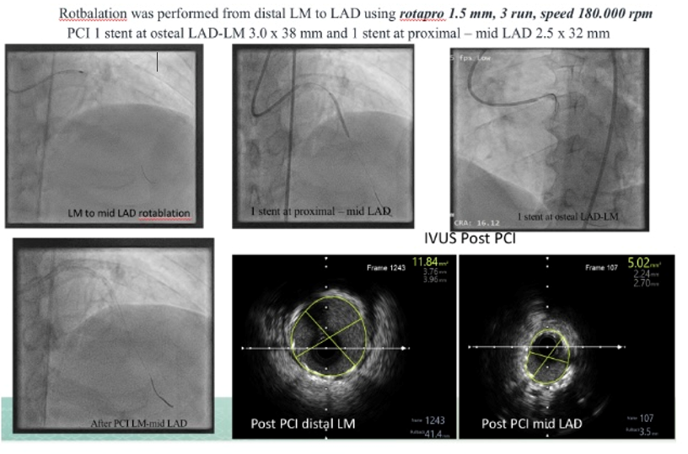
Is catheter extension system guidance needed in Inferior STEMI with total RCA occlusion? : A Case Report

Septo Andry Soesanto¹

¹Rumah Sakit Mohammad Hoesin

Background:
Percutaneous coronary intervention (PCI) is the favorable approach to treat coronary artery disease (CAD). However, certain complicated target lesions pose challenges due to insufficient backup support from the guiding catheter, especially in vessels with high calcification and tortuosity. Guide extension catheter (GEC) was created to simplify complicated PCI procedures by effectively delivering interventional tools, such as balloons and a stent when additional backup support is required. GEC can be utilized in radial or femoral approaches and may be useful in PCI involving native coronary arteries, grafts, or peripheral interventions.

Case illustration:
A 77-year-old male with 6-hour onset chest pain and cold sweat. ECG is st elevation in II III AVF. CAG results are heavy calcification in proximal-distal LM, heavy calcification in proximal LAD, 60-70% stenosis in proximal, 80% stenosis in mid LAD, heavy calcification osteal-proximal LCX, 70% stenosis proximal LCX. RCA shephred's crook. heavy calcification in proximal-distal. total occlusion in proximal RCA. PCI with guiding AL 3.5/6F, difficult to perform due to turtous A. Femoralis interna dextra. Re-action was performed through A. Radialis dextra using JR 3.5/6F guiding catheter. The guiding extension Guidezilla 6F was inserted, then DES Xience Xpedition stent was inserted in the mid RCA, followed by the second stent insertion with DES Promus Premier stent in the proximal-mid RCA overlapping with the first stent. Angiographic evaluation showed TIMI III flow, 0% residual stenosis, no dissection and thrombus.

Brief conclusion:
Guide extension catheter demonstrates satisfactory effectiveness and safety in the management of challenging coronary lesions. This catheter increases backup support, thereby enabling successful balloon or stent delivery via a radial approach. As a result, it improves the overall success rate of interventions for a variety of complex lesions, including those characterized by calcification, tortuosity, angulation, and chronic total occlusion (CTO).

Keywords: RCA, PCI, GEC, CTO

RCA with Guide Catheter Extension (Guidezilla 6F)
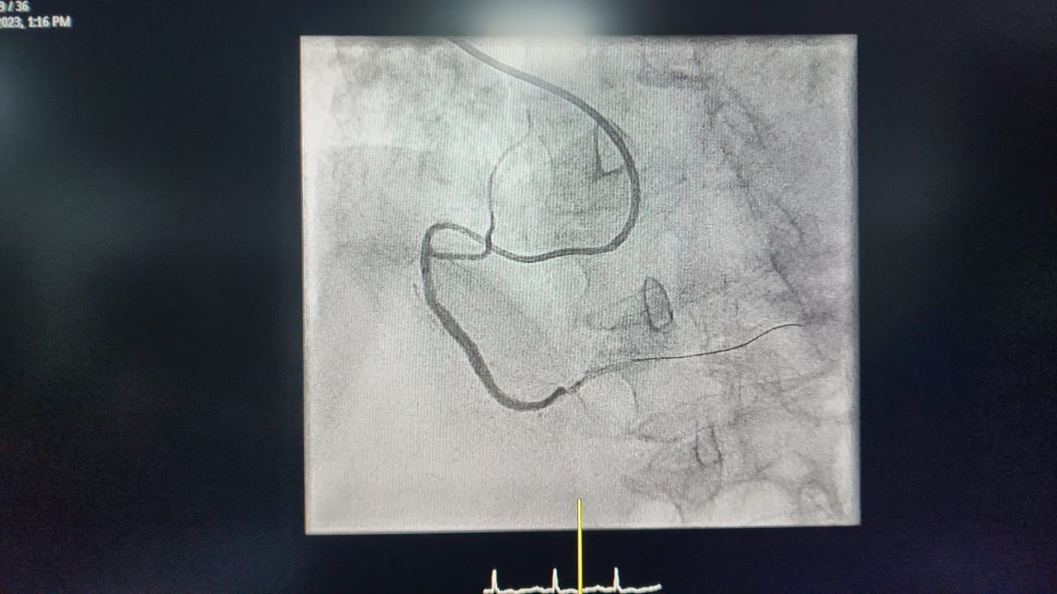

Mechanical Ventilator-assisted in Percutaneous Coronary Intervention in Acute Coronary Syndrome with Major Adverse Cardiovascular Events: Case-Series Report

S. Lazwardi¹, Y. R. Ilhami¹, W. Erlanda¹

¹Dr. M. Djamil Padang Hospital

Background:
During the last decade, Percutaneous Coronary Intervention (PCI) provides a better outcome in patients with Acute Coronary Syndrome (ACS). In ACS, complicating with Major Adverse Cardiovascular Events (MACE) requiring advanced life support, such as mechanical ventilation, vasopressor therapies and mechanical circulatory devices.

Case illustration:
We presented two patients with ACS that needed ventilatory support due to hemodynamically instability. First patient, a 62-year-old man with increased of shortness of breath 20 hours before admission. He was severely-ill with BP 170/98 mmHg, heart rate 116 times/min, respiratory rate 35 times/min. A 12 lead ECG revealed lateral STEMI with ST elevation in leads I, aVL, V5-V6. Shortly, he went into VT with pulse with unstable hemodynamic. He had 100 J cardioversion and rhythm was convert to sinus tachycardia. He was still agitated so we decided to do PCI under sedation with mechanical ventilator. Second patient, a 68-year-old woman came to ER with worsened of shortness of breath since 14 hours ago. The oxygen saturation was 88% room air with respiratory rate of 38 times/min. There were fine rales at both lungs. The ECG showed ST depression in V4-V6, and T inverted in leads III, aVF, V4-V6. We assesed the patient with acute pulmonary edema and NSTEMI. Both patients were performed PCI with mechanical ventilator support. They underwent successful percutaneous intervention with drug eluting stent. Post revascularization, both patients remained hemodynamically stable, were awake and following commands appropriately. Due to these reasons, we extubated them immediately. The extubations were successful. Both patients were discharged at day 6 and day 11.

Brief conclusion:
Mechanical ventilator support before PCI in high risk patient and immediate extubation will lead to significant outcome and prognosis in these patients.

Keywords: Mechanical ventilation, Major adverse cardiovascular events, Percutaneous coronary intervention, Acute coronary syndrome

Major Bleeding Complication in Elderly with Triple Antithrombotic Therapy after Percutaneous Coronary Intervention: What Should We Consider?

Suciana¹, S. Murdiati², A. Purnawarman², M. Muqsith²

¹RSUD Zainoel Abidin
²Department of Cardiology and Vascular Medicine, RSUD Zainoel Abidin

Background:
The use of dual antiplatelet therapy and an anticoagulant is known as triple antithrombotic therapy (TAT) . These regimen often prescribed to reduce the risk of thromboembolism with atrial fibrillation and stent thrombosis or myocardial infarction after percutaneous coronary intervention (PCI). However, TAT is associated with an increased risk of bleeding.

Case illustration:
A 77-year-old man complained of melena and hematemesis since 3 days before admission. He had history of PCI about 3 weeks ago with the result Coronary Artery Disease with 2 Vessels Disease (CAD 2VD) and In Stent Restenosis (ISR) at Left Anterior Descending Artery (LAD), placed 1 Drug Eluting Stent (DES) at LAD and Percutaneous Balloon Angioplasty (POBA) at proximal LAD. Echocardiography showed low left ventricle ejection fraction (LVEF 37%) with Spontaneous Echocardiographic Contrast(SEC). He consumed triple antithrombotic regimen afterward: Aspilet, Clopidogrel, and Warfarin. On physical examination, he appeared pale. Hemodynamics were generally stable. Hemoglobin level was 2.8 g/dl, Partial thromboplastin time (PTT) 89.7 seconds, and INR > 6.0. Those Laboratory findings resulted from bleeding due to TAT regimen. The treatment target of this patient were based on etiology and symptomatic condition. All antithrombotic regimen was hold and patient got transfusion of 1250 cc Packed Red Cell (PRC) and 300cc Fresh Frozen Plasma (FFP)

Brief conclusion:
In this case, the underlying cause of massive gastrointestinal bleeding was antithrombotic drug induced. Discontinuing the antithrombotic regimen and improve the patient condition will prevent fatal complication.

Keywords: Major Bleeding, Triple Antithrombotic, Severe Anemia

Patient’s Trend of Hemoglobin
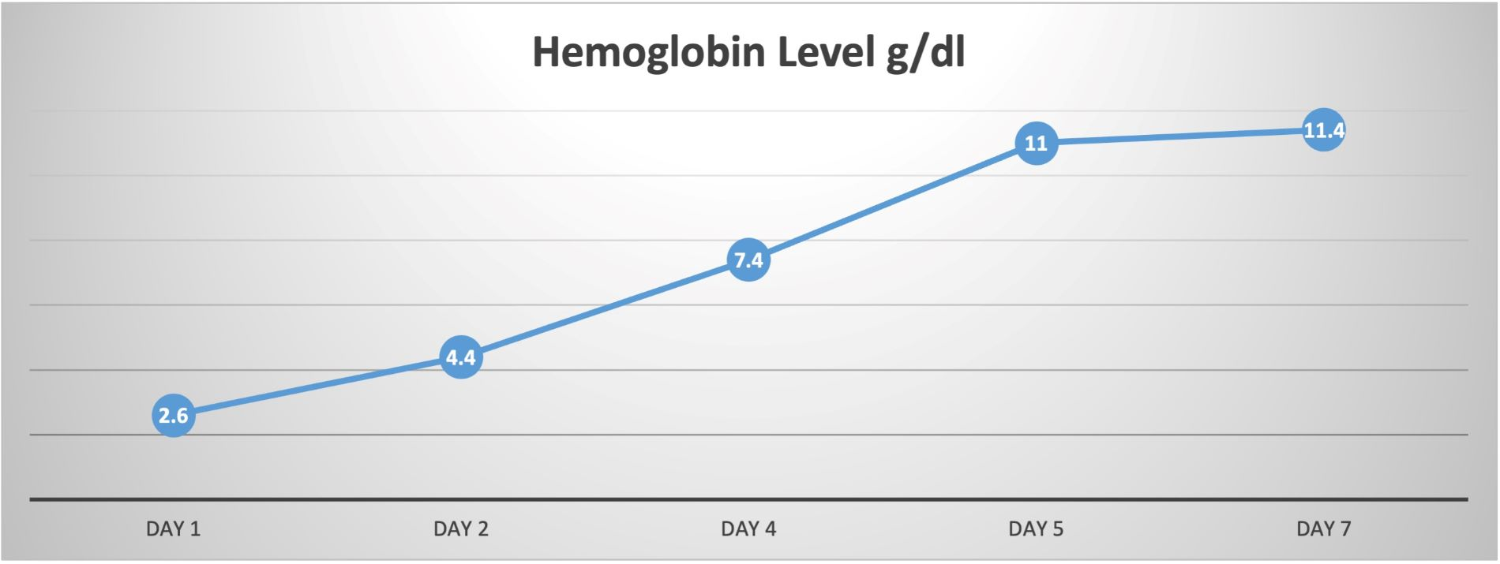

When Antibiotic and Antidepressant Medication Weren’t Enough: Recognizing Peripartum Cardiomyopathy

T. Febriati¹, D. Arara¹

¹Primaya Hospital

Background:
Peripartum cardiomyopathy (PPCM) is a rare but potentially life-threatening form of heart failure affecting women toward the end trimester of pregnancy, during delivery, or early postpartum period. Infection with tuberculosis (TB) in pregnant women is always difficult. A mother’s mental anguish might be increased by a TB diagnosis or exposure to active TB. We present a rare case which was first misinterpreted but had a continuous progressive recovery.

Case illustration:
A 28-year-old woman, P1A0, 4-weeks postpartum, was admitted to emergency unit reported having dyspneu which developed 3 weeks after delivery. This patient had cough for 2 weeks, gen expert and IGRA were negative. Her husband on tuberculosis treatment. Patient already seeking pulmonologist and psychologist for cough, difficulty of sleep, fatigue, low appetite and diagnosed with post-partum depression. From clinical examination were found BP 130/100mmHg, HR 122x/min, RR 20x/min, SpO2 78% Room air. Vesicular breath decreased, crackles in both lungs, hepatomegaly. In blood tests AST 253U/L, ALT 472U/L, PO2 61mmHg, D-dimer 2.5ug/mL, NT-Pro BNP 7322, CRP : 57mg/L, chest x-ray was lung oedema with pleural effusion bilateral. Echocardiography showed dilated all heart chambers, LVEF 25%, global hypokinetic at rest, LVH eccentric hypertrophy, MR moderate ec uncoaptation, TR mild, low probability PH, PR mild, TAPSE 2.0, LV SEC (+), LV thrombus (-). Patient diagnosed as AHF ec PPCM treated with furosemid 40mg tid decreased to 40mg od, Rivaroksaban 20mg od (7days), bromociptine 2.5mg bid (7days), Candesartan 4mg, Spironolakton 25mg. On the 5<sup>th</sup> days of hospitalization, patient discharged in stable condition with heart failure medication.

Brief conclusion:
Diagnosis PPCM is often delayed because its symptoms resemble those within the normal spectrum of pregnancy and postpartum period. PPCM requiring the appropriate management and routine follow up to improve the clinical condition.

Keywords: Peripartum Cardiomyopathy (PPCM), Heart failure, Post Partum Depression

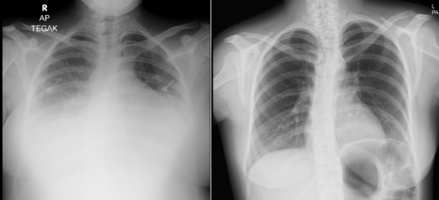

ULTIMATE CATASTROPHY IN STEMI WITH MECHANICAL COMPLICATION : DOUBLE CULPRIT, DOUBLE JEOPARDY, DOUBLE TROUBLE!

T. E. O. Rante¹, A. F. Muzakkir¹

¹Rumah Sakit Wahidin Sudirohusodo

Background:
Double culprit lession are extremely rare, with an estimated prevalence of approximately 2.5%. Clinical manifestation is often unstable hemodynamics and cardiogenic shock (CS). The other complications of acute myocardial infarction (AMI), such as life-threatening arrhythmias and mechanical complications, lead to increased mortality.

Case illustration:
A 64-year-old man was admitted with typical chest pain 17 hours ago, accompanied by shortness of breath. The patient history has been treated at a previous referral hospital with aspilet and clopidogrel loading dose, fondaparinux 2.5mg, dobutamine 7 mg/kgBW/min, norepinephrine 0.05 mg/kgBW/min. From the physical examination, BP was 97/66 mmHg (on support), HR was 144 bpm and SpO2 was 78% with an NRM of 10 l/min. JVP R+4 cmH2O, rales in hemithorax bilateral. ECG showed AMI inferior, and anteroseptal wall, with an RBBB pattern. Laboratory examination showed leucocytosis (20,400) and HS Trop I > 40,000. Thorax imaging showed pulmonary pneumonia, cardiomegaly and bilateral pulmonary oedema. Echocardiography showed LVEF of 24% (TEICH), TAPSE of 1.03cm, acute severe mitral regurgitation. We diagnosed the patient with STEMI Inferior et Anteroseptal Wall KILLIP IV, Cardiogenic Shock SCAI Stage C, acute mitral regurgitation due to mechanical complications, and impending respiratory failure. The patient was planned for a mechanical ventilator, intra-aortic balloon pump (IABP) implantation, and coronary angiography. Coronary angiography showed LAD: proximal total occlusion, distal filled from contralateral, severe calcification (+), TIMI 0 flow, RCA: proximal-mid diffuse stenosis 70-80%. Mid-total occlusion, severe calcification (+), TIMI 0 flow. We decided to perform plain old balloon angioplasty (POBA) on the LAD. After that, the ECG showed total AV block, and it was decided to do TPM insertion. We decided to POBA at the RCA then. However, the ECG showed PEA, resuscitation was performed, but the patient never had RoSC, and the patient was declared dead.

Brief conclusion:
Through this case, we can learn how important it is to make quick and appropriate decisions for the management of AMI accompanied by multiple complications. The mortality rate in STEMI patients was reported to increase with the presence of complications related to AMI.

Keywords: Cardiogenic Shock, Mechanical Complication., STEMI

Coronary Angiography
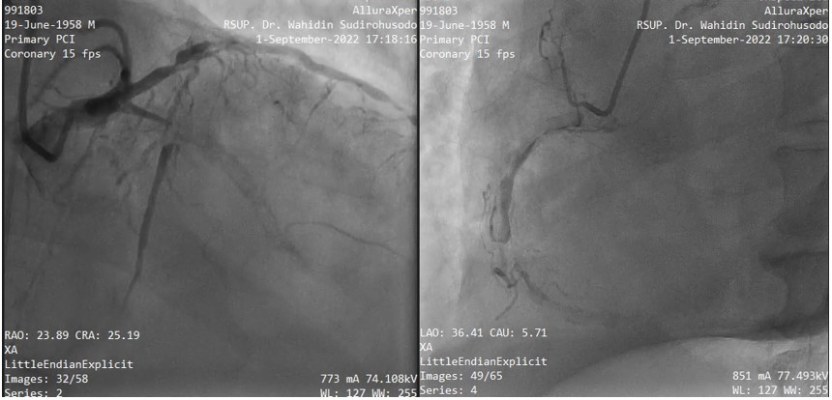

Ruptured Aneurysm of Sinus Valsava : A Rare Case Report

V. P. Wiana¹, I. E. Hermawati², N. G. A. P. L. S. Dewi³

¹Faculty of Medicine, University of Surabaya
²Cardiologist, Department of Cardiology and Vascular Medicine, RSUD Prof. Dr. Soekandar, Mojosari
³Resident in Cardiology and Vascular Medicine Department, RSUP Prof. dr. I.G.N.G. Ngoerah, Udayana University, Denpasar, Bali

Background:
The ruptured sinus of Valsalva Aneurysm is a fatal complication arising from a rare cardiac condition anomaly sinus of valsalva aneurysm with a prevalence of less than 0.09% of the population in general. Sinus of valsalva aneurysm (SVA) is defined by the enlargement or dilatation of one or more sinus of aortic roots between the aortic valve annulus and sinotubular junction, it can be caused by congenital or acquired. This report presents the case of a patient with SVA ruptured into the right ventricle and progressing with aorto-right atrial fistula.

Case illustration:
An 18-year-old man with no other significant comorbidities presented to the cardiology clinic with sudden dyspnea while resting and heavy chest palpitation for two weeks. He also reported persistent cold sweats for 4 days, and intermittent cough for 1 month worsened with bed rest position without any sputum, however no chest pain, fever, nausea, and vomiting. Family history of congenital heart disease, hypertension, diabetes mellitus, and smoking is not found in the patient. Transthoracic echocardiography (TTE) showed a ruptured one of the sinus valsalva with a diameter of 1.05 cm, it shows additional continuous flow to the right ventricle forming a tunnel, revealed dilatation on the left atrium, left ventricle, and right atrium (LVIDd 5.43 cm). There's evidence of abnormal left ventricle diastolic function while left ventricle and right ventricle systolic function are normal. From TTE investigation, our conclusion was a ruptured sinus of valsalva aneurysm with diastolic dysfunction grade 2 (Figure 1). The investigation data concluded that the choice of treatment is it needs an open-heart surgery.<p>

Brief conclusion:
SVA is a rare cardiac anomaly, in this case, it reported a case of ruptured right coronary cusp into the right ventricle in adolescence. Common symptoms of SVA rupture include dyspnea, palpitations, fatigue, and decreased exercise tolerance even in a young patient without comorbidities. TTE is used for early diagnosis of the rupture of SVA. Ruptured SVA are usually managed surgically, but long-term follow-up studies are necessary.

Keywords: Ruptured Aneurysm, Heart failure, Sinus of Valsalva Aneurysm, Transthoracic Echocardiography

Transthoracic echocardiography (TTE) showed ruptured of RCC (Right Coronary Cusp) to right ventricle
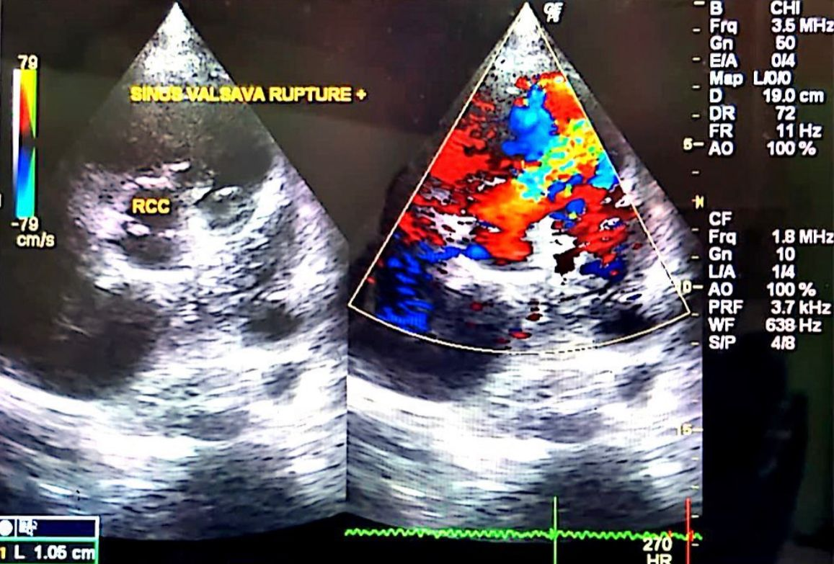

Ischemia in Military Cadet

W. Akbar¹, B. Pamungkas²

¹General Practitioner, Kesehatan Akademi Militer, Magelang
²Cardiologist, Magelang Military Hospital

Background:
Ischemia is characterized by inadequate blood supply or circulation to heart muscle that caused myocardial damage. Oxygen supply and demand miss match in whose heart have a structural, functional and electrical adaptation during vigorous physical activity led to ischemia.

Case illustration:
A 23-yeas-old male patient was evacuated to emergency department of Magelang Military Hospital due to syncope. He had finished Cross Country (7.5 km distance, 5 kg load) with vigorous run 300m to finish line to be the fastest one. Patient is a military cadet, has a regular physical activity. No history of syncope and cardiac disease previously and no family history of cardiac disease. He suffered heat exhaustion, vital sign:somnolen, hypotension(71/57),tachycardia(113x/menit),temperature 39.9<sup>0</sup>C. He had immersed in cold water for 20 minutes and then admitted to ICU. His heart sound was regular,S1=S2, P2 = A2, sound S3(+),S4(+). His ECG revealed signs of left ventricular hypertrophy and T-wave inversion in III,avF,V1,V3-V4. Biomarker cardiac enzyme, Troponin T was positive(38.5) suggestive of Myocardial infarction NSTE/ ischemia. Thorax radiology revealed cardiomegaly(CTR 66%). Echocardiography showed dilatation cardiac chamber (EDD=5.79,LAD=4.07,RVD= 4.5,RAD=402), concentric LV remodeling and with normal EF(55.98%). The other laboratorium abnormality were an elevated creatinin and ureum level (creatinin 2mg/dl,ureum 34 mg/dl). Patient was given resuscitation fluid (in emergency situation) continued with aminofluid, antiplatelet (clopidogrel 70mg), β-blocker (bisoprolol 1.25mg), loop diuretic (lasix 20mgIV), vitamin B1 and antioxidant suplement. In the third days, patient moved to medical ward, no symptom, normal vital sign, normal level of creatinin and ureum. In the sixth days, patient discharged and adviced to take total bed rest for 2 weeks.Young military cadet with mild-moderate physical activity caused adaptation in cardiac structure, in this patient found left ventricular hypertrophy, concentric LV remodeling, cardiomegaly with normal EF. Inadequate oxygen supply in vigorous activity is a sign of failure in cardiac adaptation, which is damage cardiomyocyte leading to myocardial infarction.

Brief conclusion:
Ischemia in young military cadet is a sign of myocyte damage caused by failure in cardiac adaptation to supply oxygen in vigorous activity. Adequate treatment, recovery phase, regular monitoring and evaluation are needed to prevent re-ischemia and other MACE (Major adverse cardiovascular event) including sudden cardiac death.

Keywords: Ischemia, myocardial infarction

A23-year-old military cadet with ischemis: (A) ECG: LVH, visible signs of ischemia in the form of T-wave inversion in III, avF, V1, V3-V4; (B) Thorax X-ray: cardiomegaly CTR 66% (C) Echocardiography: concentric LV remodeling and normal EF
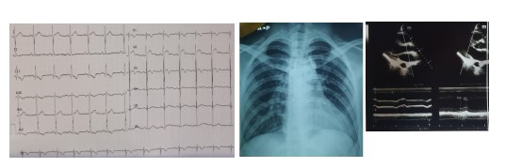

Complicated Case of Infective Endocrditis After Successful Transcatheter Closure in Patients with Ventricular Septal Rupture: A Never Ending Catastrophe

Y. F. Sandy¹, V. Y. S. Putri², S. Anjarwani², L. Hafiz², A. P. Wulandari²

¹Department of Cardiology and Vascular Medicine, Faculty of Medicine Brawijaya University
²RSUD dr Saiful Anwar Malang

Background:
Ventricular septal rupture (VSR) is a rare but possibly catastrophic mechanical issue. Despite advancements in medicinal and surgical treatments, it still affects less than 1% of patients after a myocardial infarction and is linked to substantial morbidity and mortality. Infective endocarditis (IE) is a complex disease with a high death and morbidity rate. Right-sided IE, which accounts for 5% to 10% of all IE occurrences, is more commonly related with IVDU, intracardiac devices, and central venous catheters than left-sided IE. The decreased frequency of right-sided IE compared to left-sided IE can be explained by the comparatively low prevalence of clinical diseases affecting right-sided valves, including congenital abnormalities, and changes in the characteristics and vascularity of the right-sided endothelium.

Case illustration:
A 60-year-old male with hypertension who had not received appropriate treatment for his STEMIexperienced shortness of breath. The transthoracic echocardiography (TEE) examination revealed the presence of VSR with a length 18 mm in the apicoseptal region of the interventricular septum. Hence, the VSD closure followed by a PCI procedure was chosen as a management for this patient. After 3 months of follow-up, the patient was
evaluated with echocardiography. It showed a mobile vegetation of about 11 × 10 mm. Those findings supported a diagnosis of late infective endocarditis associated with VSR closure by device. This case highlights that infective endocarditis can be a risk of VSR closure by device.

Brief conclusion:
Ventricular septal rupture following STEMI is infrequent but can be a severe mechanical consequence. Appropriate antibiotic treatment can help avoid infective endocarditis in patients with ventricular septal rupture. Patients at high risk of infective endocarditis are immediately given prophylactic antibiotics as a precaution. In this case, we'd like to emphasize that clinicians should be mindful of late-infective endocarditis. Hemodialysis IE is a healthcareassociated infection that occurs in people who have a high number of comorbidities. Central venous catheters and AV fistulae are significant causes of infection. Mortality and relapse rates are extremely high, much higher than in non-HD IE patients. This scenario and the catastrophic consequences of IE, suggest that HD patients must strictly adhere to cleanliness regulations and prevention protocols in order to avoid infectious problems. As a result, in addition to basic skin washing and access care, other infection-prevention methods are required.

Keywords: infective endocarditis, Ventricular septal rupture, percutaneous closure

